Curriculum Vitae
WALEED QURESHI  +92333-9728451  Shaheer.wisal@gmail.com | 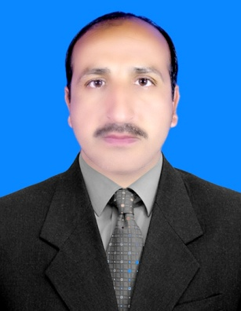

Bio data Father’s name: Inam Ul Haq Qureshi
Date of Birth: 13-09-1983
Domicile: Bannu (Khyber Pakhtunkhwa)
Nationality: Pakistani
Religion: Islam
Marital status: Married
C.N.I.C#: 11101-4576311-7
Mailing address: Village Akhundan Kakki P/O. Kakki,
Tehsil Kakki District Bannu (Khyber Pakhtunkhwa) Pakistan
Profile I am young and talented man of 39 years. I have two masters
i.e. one in Urdu (Literature) and the other in Arabic. I have
good qualities of Management and Administration. I also have
excellent experience in teaching. I feel myself able to work as
an individual or be part of a team.

Experience ● Served in PBC (Pakistan Broadcasting Corporation) from
08.09.2005 to 09.10.2010 as Junior Clerk. Was allotted
additional responsibilities of Administration, Accounts,
Transport, Purchasing, Programming, and Store Keeping.
● Served for 3 years in PBC as News Caster and Compare.
● Teaching in Various Public Schools.
Key Responsibilities
I have been teaching the following subjects and got the sublime results.
● Urdu (language and Literature)
● Urdu grammar
● Arabic
Key Qualifications
● Master in Urdu Literature & Language
Gomal University, D. I. Khan.
● Master in Arabic
University of Science & Technology, Bannu.
● Bachelor in Urdu (English compulsory + Urdu elective)
Gomal University, D. I. Khan.
● Higher Secondary School Certificate (Humanities)
Govt. Higher Secondary School Kakki, Bannu KP.
● Secondary School Certificate (Science)
Govt. Higher Secondary School Kakki, Bannu KP.
Professional Qualifications
● Master Of Arts in Education (M. Ed.)
Sarhad University Of Science & Technology Peshawar.
● Bachelor in Education (B. Ed.)
Allama Iqbal Open University, Islamabad.
● Primary Teaching Certificate
Allama Iqbal Open University, Islamabad.

Computer Skills
Microsoft Windows, Microsoft Word, Microsoft Excel,
Microsoft PowerPoint, Urdu Typing, English typing,
Internet Browsing, Inpage, Networking.
Language Skills
Language Level
Urdu Excellent
English Good
Pashto Excellent

