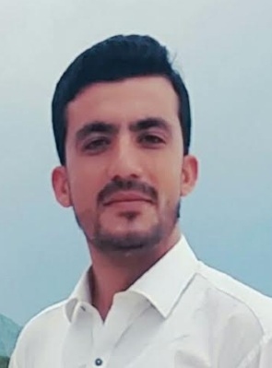

**Waqas Khan**

***Father Name: Rahat Gul***

***CNIC: 21202-8302707-7***

***Date of Birth: 12/05/1997***

***Religion: Islam***

***Nationality: Pakistani***

***Marital status: Married***

***Domicile: Khyber Agency***

**Permanent Address: *koki khel manya khel haji Sardar kally Jamrud District Khyber Peshawar***

***Cell No: +923085400821***

**Education**

**B.Sc Computer year 2018 (Board of Intermediate & Secondary Education Peshawar)**

**F.Sc Computer year 2015 (Board of Intermediate & Secondary Education Peshawar)**

**S.SC Science year 2013 (Board of Intermediate & Secondary Education Peshawar)**

**Work Experience**

**TEACHING**

**From Year 2016 up to 2022**

**UNIT REPRESENTATIVE**

**Work in Rehman medical institute Peshawar as a Unit Representative from 31-january2022 till now. Responsibilities:**

* **Front Desk Management**
* **Patient Orientation**
* **Prepare New Patient File**
* **Admitted Patient File Management**
* **Online sheets Management**
* **Ward Rooms Management**
* **Helping in discharge and Patient clearing**
* **Patient Feedback**

**Computer Skills**

**Sound knowledge of MS. Word, Excel, Power Point with good type writing speed.**

**Well experienced in the use of internet.**

**Extra-Curricular Activities**

* **Participated in inter- college competitions**
* **Participated in various cultural activities.**

**Hobbies and Interest**

* **Reading books, Newspaper and magazines.**
* **Cricket, Football and Swimming.**

**Languages: I have good communication skills in the following languages.**

* **English speaking writing listening**
* **Urdu speaking writing listening**
* **Pashto speaking writing listening**