| **YASIR BUKHARI** |
| --- |

Passport No: DG3343642 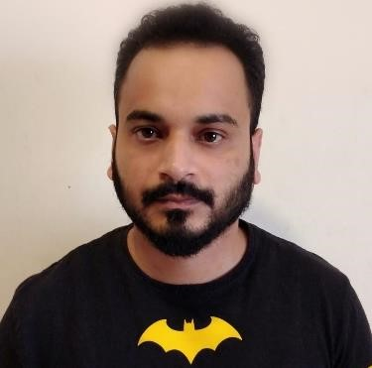

CPR: 840673248

Nationality: Pakistani

Passport Issue Date: 15-05-2018

Passport Expiry Date: 14-05-2023

Email # Yasirbukhari667@gmail.com

Cell # whatsapp +973-39177324… 0344-5501599….03145286154..

# Job Objective

To work will full strength in dynamic organization which provides new challenges that help to add value of the organization and individuals, seeking a challenging career to value on time performances, where I can enhance my working skills, strength and experience which helps achieving target.

# Employment Experience

* Two years’ work experience as a Receptionist in Best Western Hotel in Islamabad. (Pakistan)
* Three years’ work experience as salesman in Shaheen Chemist /Cosmetics shop in Islamabad. (Pakistan)
* Five years’ work experience as sales distributor with unilever company in Islamabad (Pakistan).
* One-year work experience as a Security Guard, (Speed Time Security Service Bahrain)
* Four years ‘work experience as a CCTV Controller/Assistant mall Supervisor in Seef Mall.

(Al Enma’a House for Security Services W.L.L. Bahrain**)**

* Document Controller inBahrain Avenues Mall (Al Enma’a House for Security Services W.L.L. Bahrain).
* One year experience as food delivery in Talabat..

**Training & Certification**

* Licensed by Guard Training School, (Ministry of Interior Kingdom of Bahrain)

# Skills

* Honest and Reliable
* Highly Devoted and Motivated
* Able to follow instructions
* General Orders for Guard Duty
* Confident and Deep observer
* Safety Conscious
* Maintaining a tracking facility to enable documents to be updated easily
* Scanning in all relevant new documents. Checking dispatch documents are accurate.
* Presentation and filing of documents
* Responsible for maintaining hard copy information.
* Issuing and distributing controlled copies of information
* Ensuring all documents are as up to date as possible within electronic filing systems.

**Education**

* Intermediate, Board of Intermediate and Secondary Education, Rawalpindi, (Pakistan)

**Reference**

* Available upon request.

**Driving License**

* Valid Bahrain Driving License from(2017)to present day.
* Valid Motor Bike Driving License.

# Declaration

⮚ I hereby certify that the above information is true and correct to the best of my knowledge and belief.

**Yasir Bukhari**

**Applicant**

**Date: ……………**