**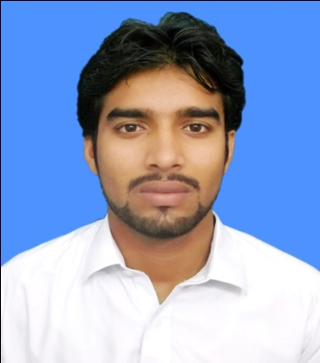*CURRICULUM VITAE***

**YASIR KHAN**

**FATHER NAME : FAZLI RABI**

NIC # : 17301-1658858-5

### D.O.B : 02-01-1996.

Nationality : Pakistani

Marital Status : Single

Postal Address : Kandy Payan Pelosi Authozai P/O University Peshawar

Languages : Pashto, Urdu, English.

Cell : +92 3159862809

Email :[www.yasirkhan031578@Yahoo.com](http://www.yasirkhan031578@Yahoo.com)

***OBJECTIVES***

Self actualization as an enthusiastic professional motivated to work as a team member in the challenging environment, with an organization that nurtures the competencies of its members

***ACADEMIC QUALIFICATION:***

|  |  |  |  |  |
| --- | --- | --- | --- | --- |
| **BA** | **Political Science** | **239** | **2022** | **I C U P Pakistan** |
| **F A** | **ARTS** | **45.0** | **2015** | **B.I.S.E Peshawar** |
| **S S C** | **ARTS** | **52.0** | **2013** | **B.I.S.E Peshawar** |

***CO-CURRICULAR ACTIVITIES***

1. Playing Cricket and football.
2. Badminton

***COMPUTER SKILL.***

1. MS Office. 2. Windows. 3. Internet. 4.Typing + DIT

***LANGUAGES***

1. Pashto (Native) 2. Urdu 3. English

***EXPERIANCES***

* 2 year experience in Medicine shop
* Mother cycle Mechanic

### ***REFERENCES:***

Dr.Zahid Khan

Assistant professor

Biochemistry section, institute of chemical science

University of Peshawar

Tele: 03329181715

Email: zahidkhan@upesh.edu.pk