Curriculum Vitae 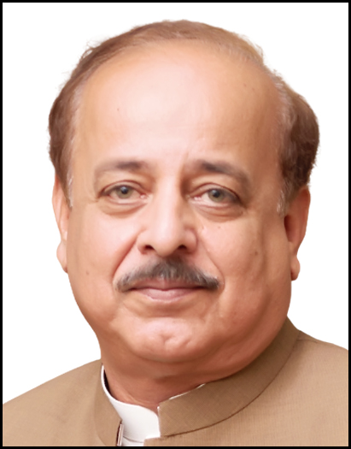
Name: Dr. Zahir Qazi
Father’s Name: Qazi Abdul Sattar Khan
Date of Birth: 27th July 1959
CNIC No: 16102-2329462-1
Cell No: +923009178859
Email Address: drzqazi@gmail.com
Present Address: House No 29, Street No 2, Green Cottage, Warsak Road, Peshawar.
Permanent Address: Village Kazi Kali, PO Jehangirabad, Tehsil Takht Bai.

PROFILE:
- Medical Superintendent, Prime Teaching Hospital, Warsak Road, Peshawar from 26th October 2022 till date.
- Manager Institution Based Private Practice, MTI, Lady Reading Hospital, Peshawar (23rd June 2020 till 31st December 2021).
- Medical Director, MTI, Qazi Hussain Ahmad Medical Complex, Nowshera (15th March 2018 till 31st March 2020).
- Incharge & Administrator Jinnah Hospital and Faiz Maternity Home Mardan (16th January 2013 till 14th March 2018)
- Incharge & Administrator Mardan Surgical Centre Pvt Ltd (01st June 1996 till 15 January 2013).
- Assessor (Manager) Khyber Pakhtunkhwa Health Care Commission since 29-1-2023

EDUCATION:

- Masters in Public Health & Hospital Management from Khyber Medical University, Peshawar.
- Professional Diploma in Hospital Management from Health Services Academy Islamabad.
- Professional Diploma in Health Care & Hospital Management from Pakistan Institute of Management, Islamabad.
- MBBS from Khyber Medical College Peshawar 1983.
- Certification in Health Care Quality Management from Rawalpindi Medical University. 2019
- Certification in Quality Management System for HealthCare Facility.
- Certification in Health System Strengthening from the University of Melbourne.
- Certification in Improving Global Health from Harvard University, USA
- Certification in Health Futures from Murdoch University, Australia
- Certification in Communication and Interpersonal Skills from University of Leeds, England
- Certification in Internal Quality Auditing ISO 2001-2015.
- Certification in PPRA Rules from Pakistan Institute of Management, Islamabad.
- Intermediate from Government College Mardan 1977
- Matriculation from Presentation Convent High School, Risalpur 1975

SERVICE:
- Served twice as Medical Officer BHU Dheri Likpani, Katlang, Mardan.
- Medical Officer CD Baghdada & Kaskoruna, Mardan 1991-1996
- Served as Medical officer General Surgery at Khyber Teaching Hospital Peshawar 1989-91
- Served as Medical Officer General Surgery at Lady Reading Hospital, Peshawar 1986-89
- House Job in General Surgery and Internal Medicine at Lady Reading Hospital, Peshawar 1984.

Medical Superintendent:
As an MS I was the overall administrative and co-coordinative in charge of hospital functioning. I would exercise administrative and financial powers allocated to me under delegation of administrative and financial Powers / Rules. I was responsible to the higher management for all the functions of the hospital. I would achieves my goals by planning, budgeting, organizing, staffing, directing, coordinating, delegating, monitoring, controlling, regulating various functions. I would also ensure best possible medical services within the available resources. Evolves strategies to develop/improve financial resources of the hospital and optimizes patient satisfaction.

Medical Director:
As a MD at MTI Qazi Hussain Ahmad Medical Complex Nowshera, in performance of my functions, I was responsible to the Board. All clinical department heads would report to me. I was required to attend each Board meeting as co-opted member with no right to vote, to make presentations of my respective activities and update the Board on any functions or activities as required by the Board. I had no conflict of interest with my position. I would ensuring clinical excellence in all aspects of hospital function; ensuring timely, appropriate management of patients; ensuring the best outcomes for all patients; undertaking clinical governance for quality control; assessing and auditing existing clinical programs and developing new programs; and develop an annual clinical budget, including capital medical equipment requests for presentation to the Hospital Director and the Board.

Manager Institution Based Private Practice:
As a manager IBPP at MTI LRH I was responsible to manage IBPP in the evening and to provide facilities for the most efficient services to allow the Consultants to perform their services at the highest level of excellence, including space, equipment, nursing, ancillary or clerical staff, laboratory, imaging and inpatient and surgical services as needed.

Vision/ Mission Statement:
Vision: To provide a unique experience as the most trusted partner for health care. To bring healthcare of International standards to Peshawar and to feel the lives of the people we serve through excellence in clinical care, quality, and commitment.
Mission:
To inspire hope, care, and cure. To provide compassionate, accessible, high-quality, cost-effective healthcare to patients. To serve with a patient and to work toward patient-centred care. To develop, share and apply new knowledge and technology in the delivery of patient care through research and technology integration. To play an active role in promoting and improving health within our community and to build a strong, integrated system for regional healthcare delivery. To hold ourselves accountable to high standards that is SMART and applies to all departments and employees of the hospital. To bring honesty, mutual respect, equality, and ethics. To work continuously to improve medical care to sustain and further improve clinical outcomes, patient safety & patient satisfaction. To cultivate an environment of trust among our staff to enhance their morale by focusing on their strengths, appreciating them, connecting with our staff, allowing them to make meaningful contributions, and building a positive, motivational work culture. If possible appraisals are to be complemented by promotions, bonuses, extra annual leave, certificates, and pay rises. Staff satisfaction will end up in patients' contentment.

REFEREES:
- Professor Dr. Aamir Bilal, Ex. Head of Department of Cardio-Thoracic Surgery Lady Reading Hospital, Peshawar. Cell No:+923008598959, email address: aamirct@hotmail.com,
- Professor Dr. Aamir Ghafoor, Professor of Gastroenterology & Ex Medical Director MTI LRH, Peshawar. Cell No: 03008580105, email address: profaamirkhan@gmail.com, draamirkhan@hotmail.com
- Mr. Zafeerullah Khan, ex-Chairman BoG, Qazi Hussain Ahmad Medical Complex, Nowshera. 0316-9872835/ 0321-9871593/+1201-266-4609/ email: zafeerullah@gmail.com

