**Curriculum Vitea**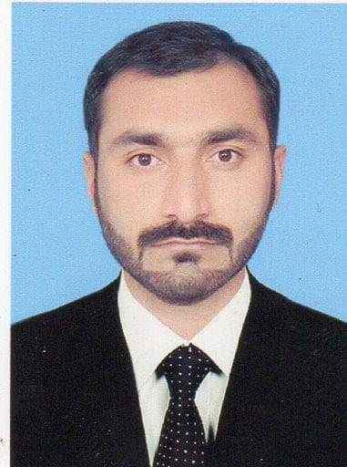

**Name Zahir ullah**

**F**ather Name Nazif ullah

CNIC#; 11101-6074827-7

Passport No. PY2784271

Mobile No. +923339295985

+92341-1097940

Email Address;. Zhrnr_313@yahoo.com

Religious;. Islam

Nationality Pakistani

Date of birth. 05.04.1989

Address;. Village;Karab KillaP/O;

Kotka Mohammad

Khan Bannu,K.Pk.,Pakistan

**OBJECTIVE**______________________________________________________________________________

***To acquire a challenging career in a world class organization to apply the academic potential and job experience of my past in a better form in my new service. This should add to my strength and become a base in my struggle for a healthy and polished survival.***

# **Academic Record**__________________________________________

**• SSC** had been done in 2006 from a Local High School In Science Subject.

• **FSC** had also been done in 2008 from a Local Collage.

• **BA**  from a USTB bannu university in **Art**s in 2012.

• **MA** in **Political Science has been done from USTB bannu in 2016.**

**• English** speaking Course has been done from **NUML** Islamabad in 2018.

Theme; knowledge is power and lights,to explore your's abalities

and to build up your's inner and outer personal qualities and

to know about everything of the world,knowledge is necessary(power),and

to defeat every exploitation or ignorance of the world by the knowledge(light)

# **Professional SKILLS**

# **Experiences (7 Years).**

# **.** Social Mobilize one year with PRCS.

# • Viable Village Loan Officer two year with Khwendo KorNGOs.(IFLProject)

# • Team Leader for two years(UNICEF).

# **• Supervisor one year( Merlin international).**

**• Social Organizer with (Care Organization 1year).**

**● Field Supervisor One Years with(WAEO).**

Theme; experiences are the theme of accumulative or collective abalities and

capacities of the right doing activities for furnishing and improving

your's inner and outer skills.

**Local Organization Activities(5Years)..**

CEO of Community Orgs “Ranra” 2year.

* Manager Of Village Orgs ”Ranra” 1year.
* Team Leader of Local supports Orgs 1year.
* Monitoring and Evaluation Officer of Wazir Youth Orgs oneyear.

Theme; due to my professional and social activities our organization push me,

from bottom to top;means that from organization to NGOs.

# Volunteer Works (3.5 years)...

* Worked as Volunteer (with Khwendo Kor NGO oneyear).
* Polio worker (With WHO volunteer 6month).
* Social activities With CMDO OneYear.
* Social Activities With NCHD OneYear.

Theme; this three or four years were very kindful and helpful to me for

the knowing and understanding of the social societies and being

a volunteer i attached myself with the NGOs world.

# **Trainings...**

# • One Week IFL Project Training with KK NGOs.

# • two weeks wash training with UNDP.

# • one week SAP training with British council.

# • two weeks survey training with BISP.

• Three Days CMAM Programme Training (With MerlinInternational).

• UNDP three day training about gendersensitization.

• Community Management & Skill Trainings (With CMDO ThreeDays).

• Social Action Plan (Three Days Trainings With BritishCouncil).

• Hygiene Three Days Trainings (With MerlinInternational).

Theme; Training are vey essential for social activists.

to make you an appropriate and suitable one for the appropriate position.

and trainings explore your's social abalities and capacity and

trainings gives you alot of energy of socialities.

**Personal Capacities.**

* Peaceactivist.
* Challenger
* Social Minded OR BroadMinded
* QuickLearner
* WellPresenter
* Well SocialDebater.
* Social DeepThinker
* WellCourageousness
* WellHelper
* Well Respectfuland,
* Well Communicationskill.

Theme; i can do...

# **Computer Experience**...

. MS Office (MS Word, MS PowerPoint, MSExcel)

* Windows OperatingSystem
* Internet
* One year Diploma of Information Technology(2017)

Theme; Computer is very essential for the daily offices works.

and to knowing about the use of computer is a very helpful skill for everyone and everywhere.

# **Languages ...**

* English Good
* Urdu Excellent
* Pashto ExcellentTheme;
* Theme,;English Language's performe best role to find a good job in everywhere.