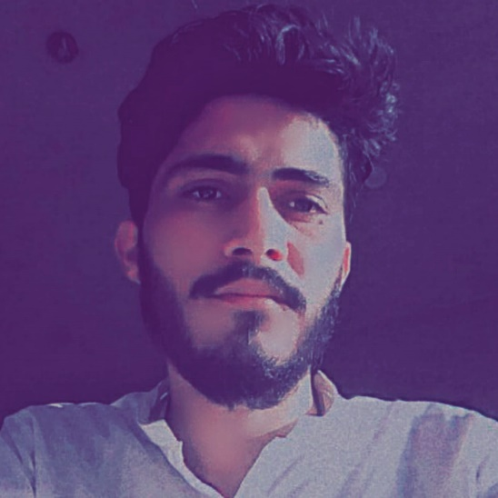

**Zeeshan Ali**

Contact

**Address:**

Kumbhar Muhalla ward no#1

**Date of Birth**

06/06/2003

**Phone:**

+923133848360

**Email:**

[Aqsazeeshan851@gmail.com](mailto:Aqsazeeshan851@gmail.com)

Languages

English

Sindh

Urdu

Hobbies

* Writing
* Photography
* Design
* Use computer

Summary

I want to succeed in a stimulating and challenging environment that will provide me with advancement opportunities. I want to excel in this field with hard work, perseverance and dedication. I want a highly rewarding career where I can use my skills and knowledge for organizational and personal growth.

Experience

* MS OFFICE (word, excel, outlook, power point) in 2 year experience.
* Photoshop and Illustrator 3 year Experience.
* Safety warden at Shell Company from Sep/2022 till continue.

Education

* Matriculation from BISEH
* Intermediate from BISEH
* B.com from University of Sindh (Continue)