October 07, 2024

The ADMIN

HR DEPARTMENT

**Subject: APPLICATION FOR IMMUNIZATION OFFICER MASTUNG**

Respected Sir,

With due veneration, it is humbly stated that I have come to know through a reliable online source that some administrative posts are lying vacant under your kind control.

My bio data, qualification, experiences and other necessary requirements are given in my CV. This is hereby attached with application for your kind information.

I have excellent communication skills, sound academic career, work in any sort of extreme tense & team environment, along with vibrant personality. Therefore, I am given a chance to work as a professional in your respected organization, so I will leave no stone unturned while discharging my humble services in the organization.

I hope my humble plea and petition may kindly be given a favorable consideration and will be discussed to the next level.

Thank You

Truly yours,

Dr. Shahab Ud Din

0310-8170493

[shahabkakar99@gmail.com](mailto:shahabkakar99@gmail.com)

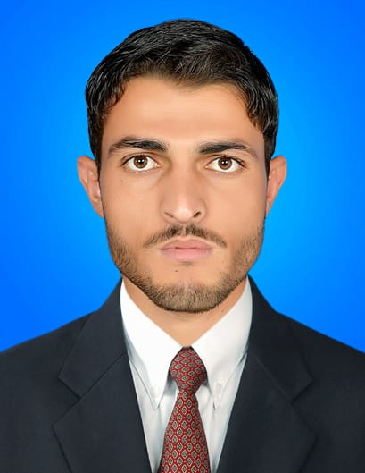**Dr. Shahab Ud Din**

[shahabkakar99@gmail.com](mailto:shahabkakar99@gmail.com)

Contact**:** 0310-8170493

**PERSONAL PROFILE:**

* Father Name : Nasurllah Khan
* Date of birth : 02-October-1994
* Nationality : Pakistani
* CNIC : 54203-9784304-7
* Postal Address : : C/O Mirwise, Heart & General Hospital Laboratory, Quetta

**CAREER OBJECTIVE:**

* Passionate and meticulous doctor. Patient focused, conscientious, reliable, and hardworking medical professional.
* Possesses a genuine passion for delivering high-quality, personalized care to patients and helping diverse groups and individuals within the healthcare industry. Immaculately organized and laser focused.
* A strong leader, adept at managing any number of responsibilities in a fast-paced and high stress work environment, committed to providing patients with the best care and treatment possible. Experienced in counseling patients on preventative care and positive lifestyle changes, and works well with other medical professionals.
* Aimed to achieve the absolute highest possible quality of patient care at all times.

**EDUCATION:**

1. **Bachelor of Medicine, Bachelor of Surgery (MBBS)**

Bolan Medical College, Quetta

Year: 2022

Bachelor of science

University of Balochistan

Year:2014

1. **Higher Secondary School Certificate (HSSC Pre-Medical)**

FBISE, Islamabad.

Year: 2012

1. **Secondary School Certificate (SSC Science)**

FBISE, Islamabad.

Year: 2010

**PROFESSIONAL EXPERIENCE**

* Worked as House Officer at Sandeman Provincial Hospital, Quetta.

◇ Worked with PRCS as District Supervisor for about 6 months.

◇Worked as Medical Officer with. Government of Balochistan.

**CERTIFICATIONS:**

**Communication Skills.**

**◇Having Strong Communication Skills Either in the Field and Office .**

**Introduction to Computer and Internet.**

* **Good at Computer and Internet .**

**First Aid Training**

**◇ Pakistan Red Crescent Society**

**SKILLS AND COMPETENCIES:**

* Compassionate Patient Care.
* Effective Inter Personal Communication Skills.
* Assurance of Patient confidentiality.
* Good Team work capabilities.
* Stress & Time Management capabilities.
* Flawless Management of Patient records and Documents.
* Leadership of Peers & Colleagues.
* Microsoft Office.

**LANGUAGES:**

* English (Excellent in Reading, Speaking & Writing)
* Urdu (Excellent in Reading, Speaking & Writing)
* Pashto (Excellent in Reading, Speaking & Writing)
* Arabic (Excellent in Reading, Speaking & Writing)

**REFERENCE:**

Will be provided on demand.