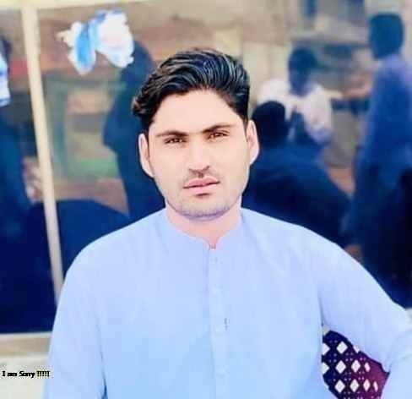

ABDUL RASHID

C:\Users\abdou\Desktop\Resumes for Customer\Customer Project\Resume 2\icon1.pngC:\Users\abdou\Desktop\Resumes for Customer\Customer Project\Resume 2\icon5.pngC:\Users\abdou\Desktop\Resumes for Customer\Customer Project\Resume 2\icon2.pngC:\Users\abdou\Desktop\Resumes for Customer\Customer Project\Resume 2\icon6.pngC:\Users\abdou\Desktop\Resumes for Customer\Customer Project\Resume 2\icon4.pngC:\Users\abdou\Desktop\Resumes for Customer\Customer Project\Resume 2\icon3.png

(I cansent to the processing of my personal data for the purpose of recruitment for the position to which I am applying.)

## Sales and distribution manager(S&D)

## Telenor Franchise

**I have 3 years’ experience in telenor franchise as sales and distribution manager(S&D)**

1. Ability to work in a fast –paced environment and under pressure.
2. Ensuring that all customer care and sale staff a professionally trained to answer any question.
3. Evaluating the customer care and sale team performance to enhance the overall performance.
4. Be accountable for maintaining control over fixed assets of the franchise materials

## Customer Relation Manager (CRM)

## Telenor Franchise

**I have 4 Years’ experience in Telenor Franchise as Customer Relation Manager (CRM)**

1. Assist customers by providing information and resolving any problems.

Lead by example – on floor selling and resolving customer issues

## RSO and DSO Team Leader

**Telenor**

**1 year experience in telenor as Retailer sale officer (RSO)**

**DSO Team Leader FCA Activity and IFCA and Mobile Account Activation.**

(1) Communicate with potential and existing retailers, demonstrates products benefit, and pro-activity participated in the whole sale process.

## Business Development Officer (BDO)

**I have 1 year Experience in Telenor as Business development officer**

(1) Provide virtual live demos negotiate and close sale contracts, and coordinate new account creation

HARD SKILLS

I have 7 Years Sales & Distribution experience in Telecom sectors with well-known multinationals & Telenor (paroa Franchise). Presentations, preparing facility reports, and maintaining the utmost confidentiality.& Diploma IT with several short courses, multiple training programs. Possess a B.A. in Economics and expertise in Microsoft Excel.

**DEGREE NAME**

University, AIOU

MSC Economics

(Continue)

Currently Studying (last semester)

**DEGREE NAME**

**B.Ain Economics**

Gomal University, 2017 – 2019

Adaptability

Collaboration

Strong Work Ethic

Problem Solving

Team work

Leadership

**Email:**

*rasheedkhanmkl@gmail.com*

**Phone:**

03420300001

**Address:**

Village, Naivela, P/O Naivela Tehsil. Paroa, Distt. DI Khan

**Permanent Address :**

Tehsil & distt. Musa Khel

Quetta Baluchistan

## *Sales and distribution manager(S&D)*

## *Telenor Franchise*

CAREER OBJECTIVE

EXPERIENCE

Microsoft Office

120 WPM Typist

Fluent Spanish

Quickbooks

CONTACT

SOFT SKILLS

EDUCATION