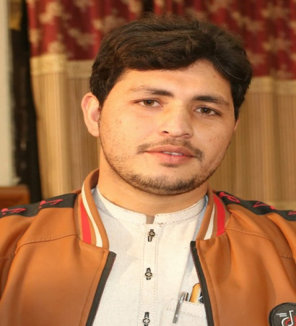 | - Curriculum Vitae  Personal information  - Name : Arif Ullah Khan  - CNIC : 11101-7592125-1  - Religion : Islam  - Marital Status : Married  - Postal Address : Peshawar Kohat Road
CONTACT  03319431797  03490009291  Communication  Can Understand, Speak and Read The Following Languages.  - Pushto  - Urdu | Education  Metric  - FA  Experience  3 Years Jolie Shoes  - 4 Years Bata Shoes Selmain  - 4 Years A2Z Mega Mart  One Year Experience as a Social Mobilzer in Comnet Polio Program  References  [Available upon request]

