CV
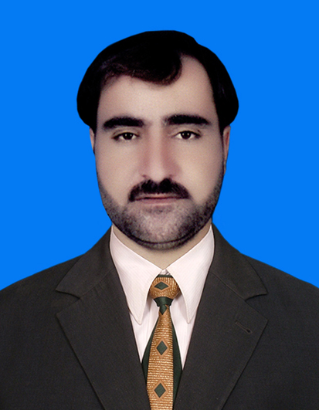

Imdad Ullah

Mailing Address:

Tehsil Ladha village Sultana Median

SWTD.

Mob: 03469496068
Email: Imdadtank@gmail.com
OBJECTIVE:

To become a part of a dynamic group where I could further explore the skills and capabilities
Which I gained in the whole academic career and to serve in a challenging a work environment and equally vast opportunities of career development based upon achievements results.

PERSONAL INFORMATION :

- Father s Name : Sher Nawaz
- Date of Birth : 15/02/1981
- C.N.I.C # : 21702-2340197-3
- Domicile : South Waziristan tribal district
- Nationality : Pakistani
- Religion : Islam
- Permenent Address : Village Sultana Maidan tehsil Ladha SWTD
ACADEMIC QUALIFICATION:

QUALIFICATION | Session | BOARD / UNIVERSITY
S.S.C | 1997 | B.I.S.E BANNU
FA | 2004 | B.I.S.E BANNU
BA | 2012 | Gomal University D I Khan
MA | 2014 | Gomal University D I Khan

SKILLS:

- Ms Office (World Excel Access Power pint Internet Explore Well Known in field of Electric)
EXPERIENCE:

- 8 Months Teaching Experience in a Private School.
- 4 Months Experience In FIDA as a Registration Officer in D.I.khan Point.
- 10 Months Experience In PEACE as a Social Organizer & Flood in Tank Point.
- 9 Months Experience In LHO as a Hard Social Mobilizer in Tank Point.
- 18 Months experience in PRDP as aTeam Leader in SWTD this project was held to facilitate education system in SWTD
- Taleem Foundation Gomal zam dam command Aria Irrigation project work in Tank
- 2 Years Experience as Polio Daily Wages Jobs With Health Department From Jan 2007 to 2008 during Non-CBV Set Up in South Waziristan Tehsil Ladha Maidan
- 3 months experience RIZ consulting as a field monitor in polio project and tehsil ladha
- LANGUAGE
- English
- Urdu
- Pashto

