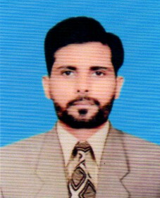
CURRICULUM VITAE
KAMRAN ANWER
Address:House#05 Street#06 Gulshan Ravi, Lahore.
Cell: 0322-4645065
Email: kamrananwer098@gmail.com
CAREER OBJECTIVE
To face the challenges with reward in competitive environment to achieve excellence by working in reputed and world class organization
PERSONAL DATA
Father’s Name : Muhammad Anwer
Date of Birth : 06-09-1990
Marital Status : Married
Nationality : Pakistani
Religion : Islam
CNIC : 35202-5902582-7
QUALIFICATION
- F.A 2013
(Lahore Board)
- Matric 2011
(Lahore Board)
EXPERIENCE
- 6 years Experience Electronics Items Barakers, Purchase & Sales Out
- 1 year Working Experience as a order Booker & Merchandiser Nutrilov food Uniliver Sigma
- 3 years working Experience in Malkani Traders as a Order Taker & Sales Supervisor.
EXTRA ORDINARY SKILLS
- 3 Months MS OFFICE from AIM College
- Internet
REFERENCE
Will be furnished on demand.

