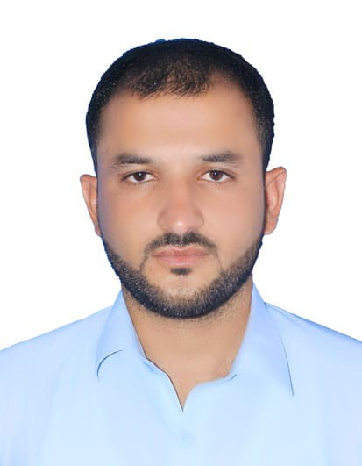
MUSAWER IQBAL KHATTAK
Cell No: +92 3370460766
+92 3489222570
E-mail: musawer670@gmail.com

Objective  Education  Skill and courses  Professional  Experience  (1)  (2)  Major projects worked on:  (3)  Major projects worked on:  (4)  Languages  PERSONAL COMPETENCIES:  AWARD AND ACHIEVMENTS  Extra-Curricular Activities  References | Looking for a challenging and rewarding future in a healthy and competitive organization and to prove my will power resolution is the ambition of my life. I offer my enthusiasm, honest effort, dynamism and commitment for achieving the goal with the following  - M.S. Office Short course including MS Word, MS Excel, and MS power point internet  - Research proposal writing skills  - Able to type 30+ words per minute  - Excellent presentation and communication skills  - Research Proposal skill  Designation: Field Officer  Organization: Borak Enterprises  Duration: 1 July 2023 _present.  Project: Gasco Engineering project Peshawar  Job Descriptions:  - Responsible for managing field operations and ensuring that all field employees are trained and compliant with company policies.  - Excellent communication skills  - Demonstrative experience as a field experience.  - Self directed.  - Attend weekly meeting with senior manager about quality and progress of works in project.  - Strong verbal, written, and statistical skills.  - Communication with all staff in daily basis.  - Exceptional supervision and relationship building abilities.  - Supervised all sites in district Peshawar.  Designation: Chief Supervisor  Organization: Wadan Construction Company  Duration: 7 January 2022 tsso 25 june 2023  Project: Constructed Bestway cement limited (BCL)  7200 TPD Greenfield Cement Plant paikhel district mianwali.  - Prepared work plan and jobs site allocation.  - Site supervision on daily basis.  - Prepared site activities reports and checklist of different activities.  - Monitoring employee productivity and providing constructive feedback.  - Organizing workflow and ensuring that employees understanding their duties or delegated tasks.  - Setting goals for performance and deadline in ways that comply with company’s plans and vision.  - Responsible for the all staff duty schedule.  - Ensure work quality and management of site activities as per specification and work schedule.  - Attend weekly meeting with senior manager about quality and progress of works in project.  - Attend safety meeting with safety department in daily basis.  - Communication with all staff in daily basis.  - Maintain monthly record.  - Prepared daily progress report.    Designation: Data Entry Assistant  Organization: Medical Emergency Resilience Foundation  Duration: 22 October 2021 to 31 December 2021.  Project: Covid Vaccination Project Peshawar.  Job Descriptions:  - Prepared daily field and vehicle work plan for vaccination team  - Data entry of daily vaccination client  - Conduct field monitoring visit of Covid vaccination team  - Responsible for liaison closely with the DHO, DC,AC Peshawar.  - Organize and clean both district data and update in NIMS system on daily base  - Remove Queries (CNIC error, Dosage day Gap error, invalid vaccination ID error ) from data on daily base for updating data in NIMS system  - Supervising of Two district data entry operator and vaccinator team on daily base.  - Prepared daily, weekly and project end reports  - Provide support to DHO office team on daily base distribution of PPEs Kit for vaccination team.  Designation: Data Entry Operator  Organization: International Rescue Committee  Duration: 1 Sep 2021 – 30 Sep 2021  Project: Covid Vaccination Project Peshawar.  Job Descriptions:  - Prepared daily field and vehicle work plan for vaccination team  - Data entry of daily vaccination client  - Conduct field monitoring visit of covid 19 vaccination team  - Responsible for liaison closely with the DHO, DC, AC Peshawar and Nowshere.  - Organize and clean both district data and update in NIMS system on daily base  - Remove Queries (CNIC error, Dosage day Gap error, invalid vaccination ID error ) from data on daily base for updating data in NIMS system  - Supervising of Two district data entry operator and vaccinator team on daily base.  - Prepared daily, weekly and project end reports  "    - Ability to work in a fast-paced environment to set deadlines.  - Excellent skills in managing people and events.  - Excellent time managing skills.  - Good at learning new skills and working in new situation.  - Ready to adapt change  - Merit based scholarship from Khushal khan Khattak university Karak 27200,and Khyber Pakhtunkhwa, Pakistan in BS-CMS from (2016-2020)  - Active member of Khushal khan Khattak university social welfare committee.  - Web Browising ,watching TV, Reading News paper, books and magazine, playing football, Gardening  Will be furnished on demand.
  Degree/Cert. | Year | Division/CGPA | Board/University
  SSC ( Science) | 2014 | 1st | BISE Kohat
  HSSC FSC | 2016 | 1st | BISE Kohat
  IT DIPLOMA | 2020 | GRADE A | TTB PESHAWAR
  BS (MASS COMMUNICATION) | 2020 | 3.12 | KKKUK karak
  Language | Read | Write | Speak
  English (Official) | Excellent | Excellent | Excellent
  Urdu (National) | Excellent | Excellent | Excellent
  Pashto (Native) | Excellent | Excellent | Excellent

