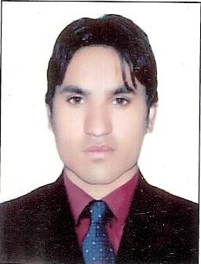

Curriculum vitae

Personalinformation

Name: - ShakirUllah

S/o: - Laghman Khan

Nationality: - Pakistani

Religion: - Islam

Domicile: - khyber

Marital status: - Married

Mobile: - 0307-8098097

Date of birth: - 01/06/1991

CNIC No: - 21202-5317164-7

Postal Address: - Lalacheena Jamrud Khyber Agency

Objectives

I have aimed to work in your Organization and take benefit from its excellence I think that I may use my abilities and experience in a good way to have success in my life and duty and also serve for our country.

Educationstatus

| **Degree/certificate** | **Year of Passing** | **Board/university** |
| --- | --- | --- |
| **SSC** | **2007** | BISE Peshawar |
| **FSc** | **2010** | BISE Peshawar |
| **BS(Hons)Computer Science** | **2014** | University of Peshawar |

Computer Skill

* Web designing
* CSS
* MS OFFICE
* Photoshop

Languages

* Pashto
* Urdu
* English

Experience

* worked as store keeper at LLIN Distribution program
* Sales incharge of Ebay and amazon at enyaa.co.uk
* 1 Year Experience as a Computer Operator in Telic Technologies.
* 1 Year Experience as data entry operator in project Titled “Mother Child Care” phase 2 Prime Foundation Peshawar.
* 6 Month Internship with KP IT Board.
* As EMU in Apex consultant of Pakistan.