Personal Data  D.O.B. :11th Dec 1984  Sex : Male  Nationality : Pakistani  Status : married  Contact  Mobile: +920 333 7971514  N I C No  51401-1140442-5  E-mail  Kohshan44@gmail.com  Skype ID  ubaid7  present address baghbana huzdar  Local: Khuzdar baghbana  Present Residency: baghbana  Postal Address: ayoub genral store mengal ababd baghbana  Languages Known  - English  - Balochi  - Brahvi  - Urdu  - Pashto  - sindhi | UBAID ULLAH SHAH  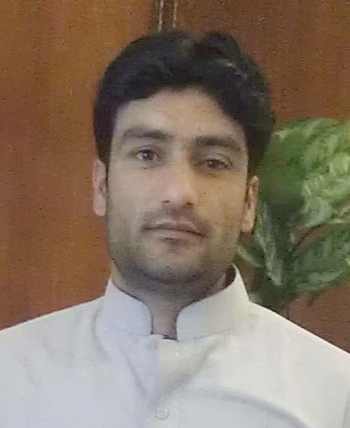  Pharmacist / social worker  Dedicated, multifaceted, professional with over 10 year  of experience with KOHSHAN,UNICEF,WHO,BOYS SCOUTS  BALOCHISTAN and SPO , 2 years affiliation and experience  with Society for exercising health and education in remote  areas of Balochistan (WHO and KOHSHAN) with diverse  business environments that demand strong organizational,  technical and interpersonal skills. Possess strong communication  skills, an ability to interact with cross-functional departments,  with the high degree of professionalism, discretion and problem  resolution capabilities. Quick learner, Self-motivated, Result oriented person, with proven record of growth and achievement.  Seeking a challenging position with a dynamic organization that welcomes initiative, dedication; demands excellence in consistently meeting business objectives, and exceeding standards.  Areas of Expertise  Skills Inventory  - Self motivated individual with admirable decision making skills.  - Swift apprentice, adapt well to change and pressures in the work place.  - Enthusiastic creative and willing to assume increased responsibility.  - Expressive communication skills with ability to quickly form relationships.  - Ability to work in team environment as an active member  Educational qualification  Doctor of pharmacy (Pham D) ,  Major Courses: pharmacology, pharmaceutics ,Medicine,  Master in International Relation  Major courses ; IR, IR organization IR law  Bachelor in Arts,  .  Major Courses: P.Science, Sociology and Brahvi.
  - Excellent Communication Skills
  - High Tolerance Level
  - Solution Driven Approach
  - Team Management Skills
  - Cross Cultural Communication Skills
  - Professional Druggist
  - Attractive Personality
  - Micro planer
  - Master trainer
  - Field monitoring
  - Mapping
  - Data collecting and Analyzing
  - Reporting
  - Drafting
OUTDOOR ACTIVITIES  - Comperer  - Athletics  - Organizer  - Stage performer  - Comidian  - Management  - Co ordinator  - Director  - Mind reader  - Monitor  - Trainer  - Researcher  - Drugest  PRACTICED SKILLS:  Can operate  - Suturing  - High king  - Auscultation  - Percussion  - Medicines  - Posture  - Diagnosis  - Scouting | Computer skills  Coursera course online certificate  Infographics  Power bi course  Familiar with:  - Microsoft family Office applications and operating system (MS Windows).  - Web browsing and e-mailing.  - MS Excel.  - Software.  - MS word very good command  - MS PowerPoint  Areas of Interest  - Volunteer works  - Scrabble game , and newspaper reading  Trainings and Internships  - INTERNSHIP as Pharmacist  1 year internship at BMC department of health Quetta Balochistan  2 year . internship at Civil hospital khuzdar Balochistan  PRE POSTING TRAININGS.  - 3 days Gender concept and network development program Quetta.  - 1 year development planning and management workshop Quetta.  - 4 days micro planning ,mapping field monitoring from WHO Quetta .  - 7 days Eye week activity from DHQ hospital khuzdar  - 2 days polio training from Health department  - 4 days HIV / AIDS Training from AMAL  - Publish the research on polio cases in Baluchistan  - Complete training on Polio .  - Nutrition plumy nut therapeutic food from MSF  BALOCHISTAN
Professional Experience

WORLD HEALTH ORGNIZIATION WHO QUETTA

Designation: UCPO quetta UCs

Project: EPI ( Monitoring )
Duration + six year

Responsibilities:
- Conduct consultative meetings in with area in charge about polio planning
- Pre campaign, campaign and post campaign monitoring
- Submit work plans & activity reports.
- Mapping and micro planning training,
- Mobilize community to help in beneficiary selection as per criteria.
- Participate related meetings/trainings/workshops.
- Keep every activity documented in soft and hard.
- To conduct surveys of the project.
- Submit work plans & activity reports.
- Ensure timely submission of weekly/monthly work plans.
- Develop & submit fortnightly work plans & daily activity report.
- Get every work plan & report signed by the line manager.
- To support in managing of human resource at site.
- Additional Visit of different UCs. From the office

PARITCIPATORY DEVELOPMENT INITIATIVES (PDI) KHUZDAR
Designation: Field MONNTER /Supervisor

Project: Sustainable Land Management Project Baghbana Khuzdar Balochistan

Responsibilities:
- To monitor the progress of the project.
- Coordinate ordering and delivery of equipment on time.
- Coordinate between the Project manager, the designer, client, and associated trades.
- Maintain project reports.
- Schedule in accordance with the project's plan.
- Meet all established milestones.
- Hand over complete documentation package including completion certificate.
- To resolve any issue arise from community.

UNICEF KHUZDAR
Designation: District Project Assistant

Project: primary education support project
Responsibilities:
Making Work plan and tour notes.
- To monitor the progress of the project.
- To conduct different teaching courses and best way of teaching to government and private teaching staff of different schools.
- To support the development of strategies and programmes regarding the upliftment of the civil society, ensuring good relations with government bodies and other policy influencing organizations.
- To conduct workshops and to create awareness among the communities for sustainable use of natural resources, respect for cultural diversity and human rights.
- Develop and implement the staff development program, training
- schedule for new volunteers, develop appropriate tools and methods to build organizational and strong teams.

- Documenting the best popular practices in the development of the community, preparing sets of necessary materials and submission of reports as per the situation, handling correspondence, drafting the reports and evaluations.
- Scheduling meetings with local NGOs, arranging conference calls, making travel arrangements, planning and organizing workshops to identify their needs for development and training.
Designation: Procurement officer
Sardar Bahadur Khan women University

Project: Sub Campus Khuzdar
Responsibilities
- All the procurement responsibility
- Tender procedure
- Pre and post procurement planning
- Procurement committee arrangement
- Local purchasing

CTC COMMnet Unicef Khuzdar
Designation , Polio communication office Khuzdar
Responsibilities monitoring ,planning evaluation
Training etc .
Duration 2 year

People / COMMnet Unicef Khuzdar
Designation Polio communication office baghban Khuzdar
Responsibilities monitoring ,planning evaluation
Training etc .
Duration till yet

KOHSHAN COMMUNITY ORGANIZATION BALOCHISTAN
Designation , program coordinator
Responsibility
- Project proposal writing
- To call the Cabinet meeting
- Reports writing
- To co induct the workshops
- Monitoring the all aspects of projects activities

BOYS SCOUT BALOCHISTAN
Designation Group leader balochistan
Responsibility
- To call the Cabinet meeting
- To prepare the plan for scouts training
- To implement the guideline of provincial office Quetta

Reference

Dr Mukhtar zehri
Provincial nutrition specialist Tariq shah HR manager
PPHI Baluchistan WHO Quetta
Pakistan

Dr Irfan Raisani
Dept director TB program
Balochistan

Muhammad Azam Marri
Coordinator UNICEF (PESP)
Jafer abad balochistan
Pakistan

