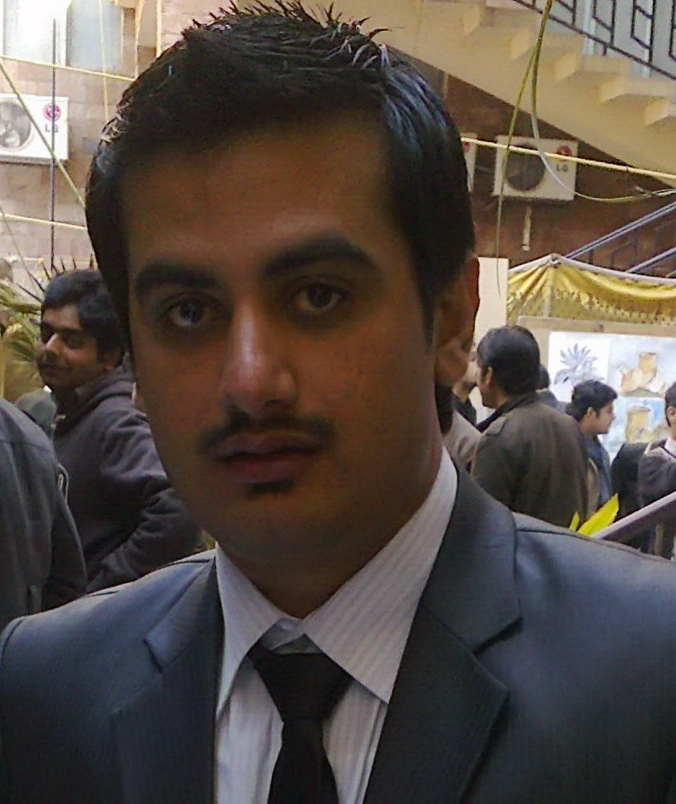
ZEESHAN FAISAL
Village Bahader Kot Kohat
Kpk Pakistan
S/O Hussain shah
Cell: +92-334-8289392
Email: zeeshanfaisal07@gmail.com

PROFESSIONAL OBJECTIVE

To pursue a challenging career and to be a part of a reputable organization that gives a scope to enhance my knowledge and skills providing challenging opportunities to contribute towards the development of organization with sheer dedication and hard work and to reach the pinnacle in this field.

Education&Certificates M.SC Electrical Communication Engineering (2nd Semester) UET Peshawar (2023 Till Now) B.SC Electrical Engineering CECOS University Peshawar (2012-2016) Engineering Project Obstacle Detection System For Blind People PROFESSIONAL EXPERIENCE

Currently working with NADRA as (TSO) at Nadra Zonal Office Kohat (January 2023 Till Now) Mentor at (CERP) Centre For Economic Research in Pakistan (03 Jan 2022 To 20 March 2022)
I represented the Centre For Economic Research in Pakistan, a Research Non Profit that was working with the Government of KpK Education Department to Implement the Targeted Instruction Program(TIP), in Government primary schools.
Sr Executive Officer At Customer Care Services Ufone Helpline (333) In UFONE Head Office Islamabad (SEP 2017 TO FEB 2020) Services Provided
Bill enquiry (credit limit, expiry date etc.)
Reporting of lost phone
Number blocking in case of lost or stolen SIMs
Connection status (active / inactive)
Products information
Ufone Sales & Service Center information
Nearest dealer information
Ufone coverage areas
Emergency number information
International roaming information
Value added services information
Missed call alerts
Call forwarding
Conference call
FNF Activation / Changes Tariff
KONNECT HOLDEN PRIVATE LIMITED, ISLAMABAD (JUNE 2013-AUGUST 2013):
Internee, Operations & TI Department:
Worked in the operations and TI department of the KHL, also was nominated to be part of the SE training of ZTE, and completed my 3 months of internship. Main responsibilities included:
Planning and implementation for rollout of TI sites under KHL domain. Coordination with field teams during TI activity.
Monitoring at FLM NOC, preparation of daily reports, coordination with field teams for TT resolution.

PRACTICAL TRAININGS & PROJECTS

ZTE PAKISTAN SE TRAINING: JUNE 2014:
Attended 3 weeks training conducted at UET Lahore under ZTE Pakistan for Telenor Vega project. Main courses of the training were Civil Works, Telecom Equipment Installation, HSE Standards, Project Management, Microwave Installation, Ipasolink Installation, SDR Installation & Configuration and Quality Management. Attained 90% marks in the examination and among top 10 students who were issued certificates and cards.

ENGINEERING PROJECT:
Obstacle detection system for blind people

IELTS Band Score = 6.0
PEC CARD NO=34871 D.O.B = 15/08/1988

