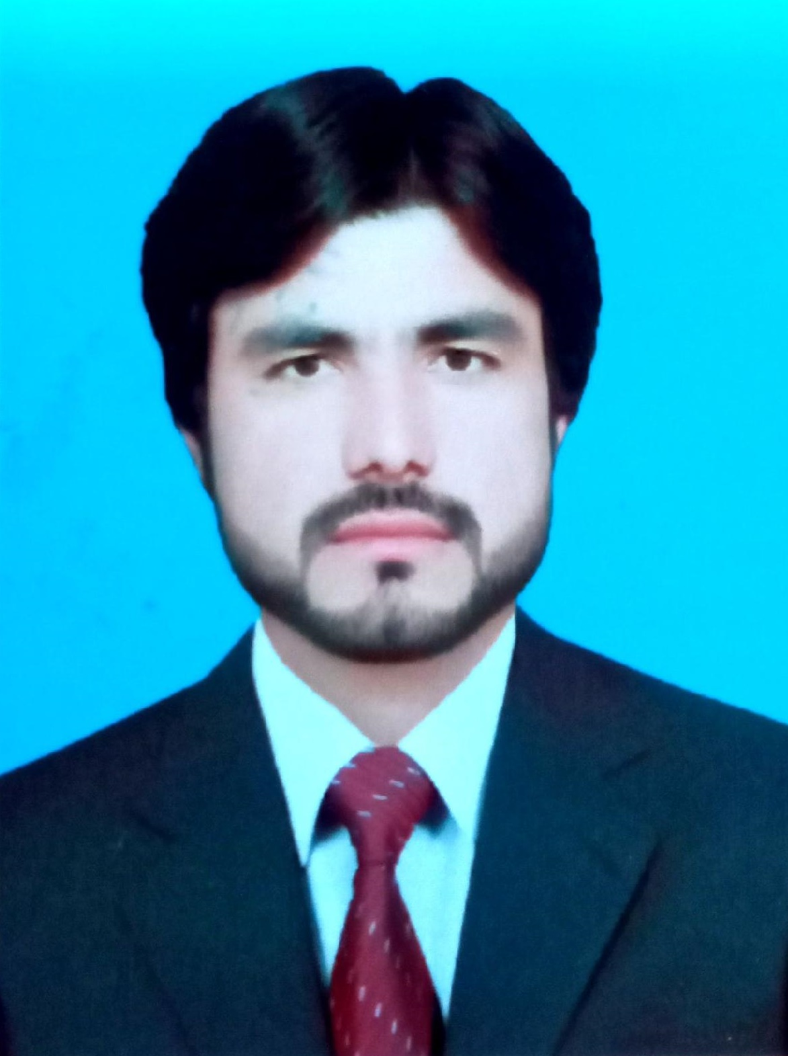

**Abdul Qadoos**

***Address: Sana battery agency new adha zobe road loralai***

***Contact: 03318002924***

***E-mail: abdulqadoos238@gmail.com***

**CAREER OBJECTIVE**

I am Abdul Qadoos, Completed MA in IR as well in Political science. I am doing working with WHO from last Five years to date,and Got BEST PERFORMENCE CERTIFICATE from WHO.Got Best” MONITERNING AND REPORTING ” Certificate from DC Office. To acquire a challenging position in an organization where I can better utilize my education as well as professional, technical and social skills, and to be a part of a friendly and progressive environment where there are constant opportunities of growth for both personal and professional abilities.

**Bio Data**

|  |  |
| --- | --- |
| **N.I.C #:** | **56302-1549936-9** |
| **Marital Status:**  Local | Single  Loralai |
| **Languages** | English Excelent  Urdu Excelent  Pashto Excelent |

**PROFESSIONAL DEVELOPMENT COURSE**

1. Four years above experience in Polio program with WHO
2. Volunteer as a Area incharge and team member. Team leader of Four UCs in Polio program in WHO
3. Refusal coverges in polio campaign and Awarded best Monitrong certificate by DC .

|  |
| --- |
|  |

**ACADEMIC BACKGROUND**

**Degree/Certification YEAR College/Inst./University**

Matric (Science) 2010 Govt high school loralai

FSC.. ( Pre Engineering) 2012 Govt degree collage loralai

DAE. ( Diploma of Associate Engineering) 2020 Polytechnic collage Quetta

BA( Economics ) 2014 University of Balochistan. MA ( International Relation ) 2017 University of Balochistan.

MA (Political Science ) 2019 University of Balochistan

**TECHNICAL SKILLS**

* Short hand &Type writing Certificate
* DIT /A-DIT

**PROFESSIONAL WORKING EXPERENCE**

**WHO/CTC (UCPO Union Council Polio Officer) at District Loralai UC MAKHTER from AUGUST, 2019 to till date.**

**Responsibilities.**

Pre-campaign

* Micro planning assist and preparation and updating SIA micro-plans. Validate the micro-plans in the field. Help and identifying and mapping high risk areas in the UC.
* Completed the micro senses of the UC circle lll.
* Training assist the PEO and district trainers in planning, coordinating and organizing training session for vaccination teams and supervisors.
* Promote partnership with all influencing factors at UC level in support SIA.

Campaign implementation

* Social mobilization activities is carry out by me in each campaign.
* Monitor the process pf implementation of the campaign as per guidelines and provide feedback to PEO.
* Collect the tally sheet data from the areas of responsibility on daily basis.
* Ensure proper implementation of SIA with special attention too hard to reach areas and underserved high risk population.
* Attend the daily evening review meeting at UC level for every SIAs and record the findings/observations for corrective action on the following day of the campaign.
* Covered all chronic refusals along with other UC staff.
* Participate in preparation of realistic catch-up plans for missed children and monitor their implementations.
* Facilitate the work of independent monitors.

AFP surveillance

* Collection and submission of weekly zero reports form all HCFs in their UC to DHO every Monday.
* Visiting all priority 3 AS sites and assigned informal healthcare providers to inquire about AFP cases.
* Visiting all health facility Focal persons in the UC to inquire about AFP cases recently admitted.
* Immediate reporting of any AFP case found to the PEO/DSC.
* Facilitating in AFP cases investigation and stool sample collection.

**WHO TTSP (Tehsil Technical Support person) 1 year**

**Responsibilities**

* Taking cluster of the teams in different UCs.
* Coordinating training session for teams.
* Facilitate to AIC during micro planning.
* Attend the daily evening review meeting at UC level for every campaign.
* Covered NA and refusals along with teams.

**DSO ( Data Support Officer )_Additional Task Doing Till Now**

* Additional Task of Data Support Officer Assigned by immunization officer
* Supporting district in data compilation in polio campaign
* Compilation of polio data target,achievement,and still NA

SCSPEB ( Society for Community Support for Primary Education in Baluchistan).

Master Trainer 1 Year

Responsibilities:

* Capacity Building in hard areas of the primary education Baluchistan school teachers
* Conducting the training lead teacher on cluster level

Formation of PTSMCs where they do not exist community

**ARC International (Master Trainer) at District Loralai Refugee RVs in GBV Program BPRM Funded from Apr, 2017, to Nov, 2018**

**Responsibilities**

* Responsible for mobilizing the community of Refugee villages of Loralai district through dialogue, awareness raising and using PRA/RRA tools to identify causes of local problems and their solutions.
* To mobilize and organize the community for GBV project and form community groups, record keeping, internal saving mechanism and training/ capacity building of the members
* To ensure active community support for the project activities and ownership.
* MT will maintain liaison with community elders and leaders in Refugee Village to facilitate the regular meetings of ADR and other project stakeholders like religious and social leaders in the community
* To coordinate and facilitate the WFS and youth club activities.
* To identify and proactively communicate any issues that might affect the project implementation and engage community support with guidance from the District Coordinators and Snr. Program Officer to address the issues.
* Collection and dissemination of information between communities, ARC project staff and stakeholders.
* Reporting the progress on regular basis

**APEX ( ZFO ) Zonal field officer 1….**

**( 1 Year)**

* **To conduct Post campaign( PCM )**
* **To monitor post campaign team of zhob division**
* **To check the quality of polio campaign**
* **Give result to our head office**

**SDF ( Salar Development Foundation ) Social Moblizer.**

**( 1 Year )**

* **To get houses data names,father names,and whole family**
* **Make Report of data and share with head office**
* **Arrange sessions and community meetings with different community**

**REFERENCES**

* References to be provided upon request.

1. Izzatullah khan ( PDA ) Program data assistant zhob divison

Email: [izzatullahkhan_81@yahoo.com](mailto:izzatullahkhan_81@yahoo.com)

Cell No: 03368148745

03218148744

1. Dr Muhammad Najeeb (Area Coardinator WHO )

Cell No: 03337917008

Email: najeebmarwat11@gmail.com

1. Dr Muhammad Ashraf ( Immunization offic WHO ……

Cell No: +923368300042

Email: khanmuhamm@who.int

1. Dr Abdullah jan ( Deases surveillance officer) WHO )

Cell No: 03347621915

Email: jana@who.int