**r**

**ABDUL SATTAR BALOCH**

Email: [balochsattar86@gmail.com](mailto:balochsattar86@gmail.com)

**CELL # +923327820196 +923418080889**

**CAPABILITIES:**

* Excellent Leadership Qualities
* Result oriented approach
* Excellent Communication and interpersonal Skills
* Great deal of confidence in handling forward activities
* Good motivation power.

**COMPUTER SKILLS**

* One Year Diploma Course of Computer.
* MS Office,
* MS Word
* Outlook,
* MS Excel,
* Internet.

**SKILLS AND COMPETENCIES**

* Strong interpersonal and communication skills and the ability to work effectively with a wide range of cultural background.
* Self-Confidence
* Team Leadership
* Results Orientation
* Enthusiastic and quick learner
* Influencing Others
* Fostering Teamwork
* Have good communication skills

**POSTAL ADDRESS**: Mehran Medical and General Store ,Behand Gatroon Co. Near Komal city Hub Chowki Balochistan,Pakistan.

**Email ID:** Hakimjan46@gmail.com

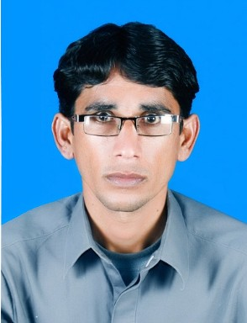

# RESUME

ZZ

**OBJECTIVES**

To be associated with a team of business professional as a responsible team member being futuristic about progressive career path, with an organization having a dynamic and objective driven work environment

**PERSONAL INFORNATION:**

**Father’s Name: Sakhi Dad**

**Marital Status: Married**

**Surname: Baloch**

**DOB: 13-04-1984**

**NIC: 51102-5105805-1**

**Nationality: Pakistani**

**Religion: Islam**

**Local /Domicile: Local District Awaran Balochistan, Pakistan**

**ACADEMIC QUALIFICATION:**

M.Phil. Balochi Literature

Master of Literature (Balochi)

* (Major in Literature)
* CGPA: 1st Division
* University of Balochistan, Quetta.

Bachelor of Art

* University of Balochistan
* Percentage: 2nd Division

F.S.C Pre Medical

* Government Degree College, Quetta.

S.S.C

* District Awaran Balochistan, Board.

**EXPERIENCE**

* One Year Experience as a District Supervisor in BEF District Awaran.
* Worked as a Supervisor in survey of Poverty Scoring Card project in NRSP funded by BISP January 2019 to August 2019 in district Awaran.
* Worked as Admin and Finance Officer in Institute of Rural Management District Lasbela from Sep 17th 2017 to December 30th 2018.
* Worked as Monitoring & Evaluation officer in BRAC international at Lasbela from April 2014 to August 2017.

**LANGUAGE**

* English
* Urdu
* Balochi

**REFERENCES**

Will be furnished as required.

**RESPONSIBILITES:**

* Supervise the survey activities in field level Monitoring and support the team.
* Monitoring & Evaluation.
* Monitoring the progress, analyzing data, evaluating outcomes.
* Report writing & target achievement .
* Compliance Monitoring.
* Context Monitoring .
* Beneficiary Monitoring.
* Organizational Monitoring.
* Result Monitoring.
* Collecting report ,Analyzing,& reporting data.
* Monitoring plans & data collection .
* Monitoring &Evaluation plans.
* Research ,sampling & statistical & analytical skills.
* Reporting & record keeping.