Contract Extension Help Document

# Step-1

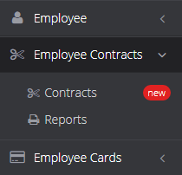

<http://hrms.ctcorg.com/index.php/admin/contract_management/employee_contracts>

# Step-2

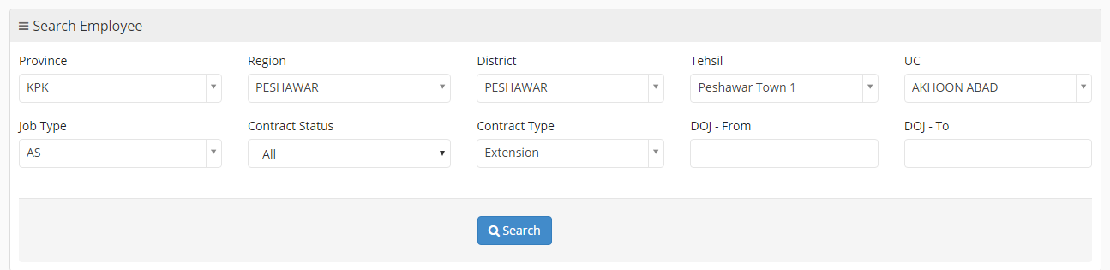

Search Employees – Filter out location, Title and Contract Type (Extension). It gives you list of employees.

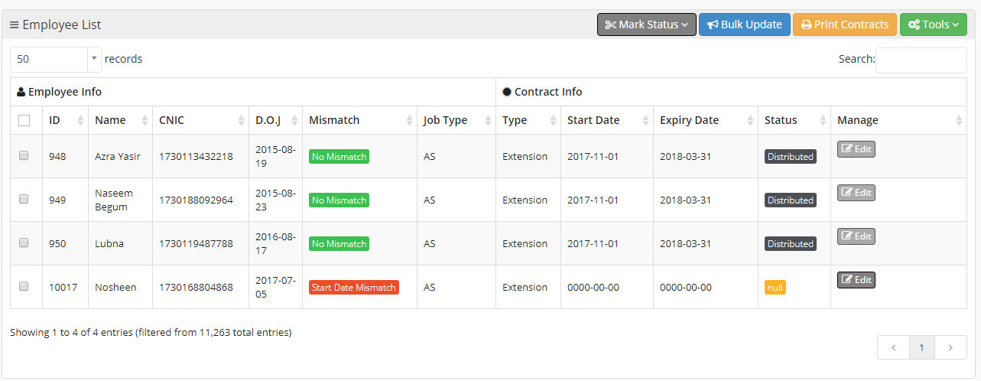

# Step-3

Make Sure Mismatch Column must be green before updating contract status.

All contract extension would be in pending status, if it’s not then ask your administrator

# Step-4

Enter contract expiry date one by one or bulk update,



It opens a box where you can enter contract expiry date, then save it

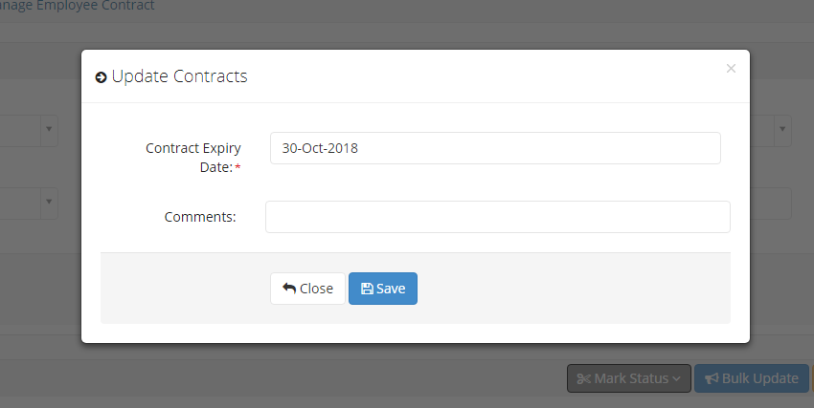

# Step-5

After that, you can update contract status pending to document generated. Those job position have their template the document will generate and other will remain in pending state.

Check the employee and click on Mark status button.



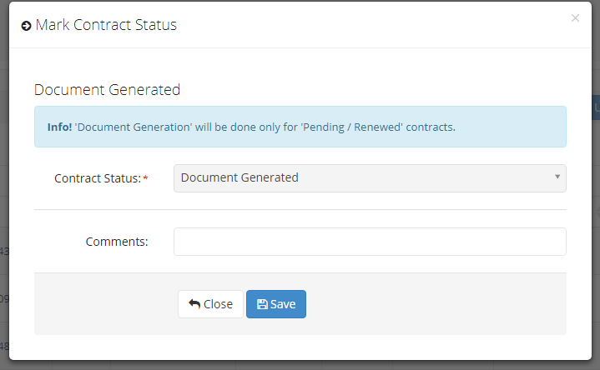

It open a box where you can update contract status. Click on save

You can see, contract status is change.

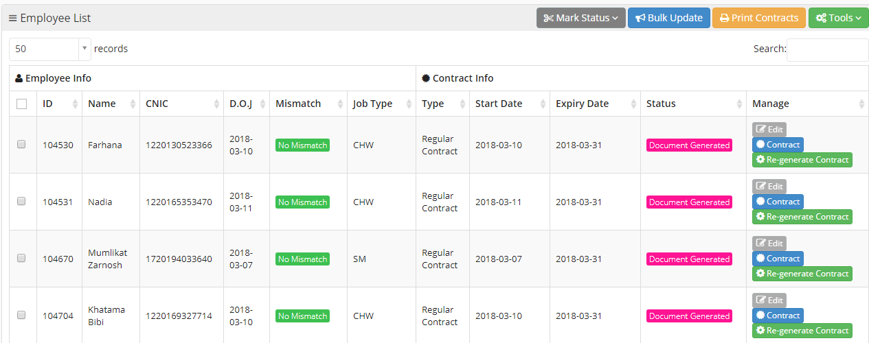

# Step-6

Now review its contract randomly, by clicking on blue button namely Contract



It will open a screen on a new tab, where you can review contract and if there is any change then change it and save it.

Also review employee name, cnic, title, signature, salary etc.

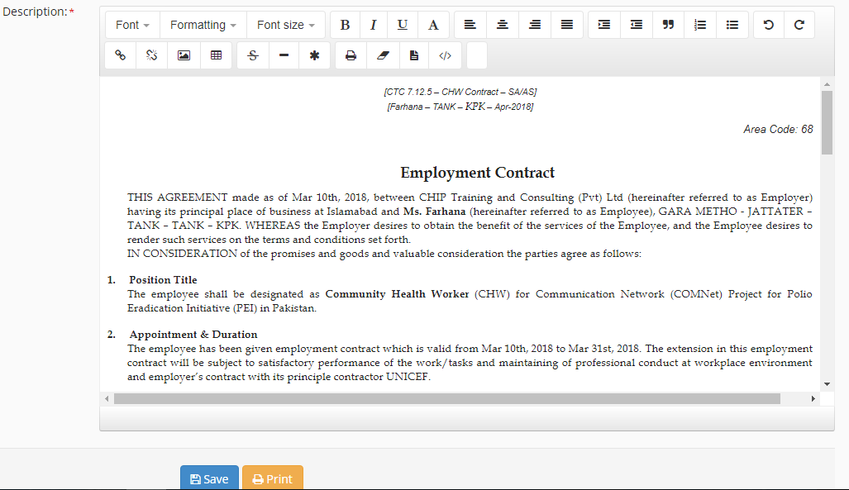

# Step-7

Printing. Click on Print Contract button to print all selected contract in one go



After click this document will open in new tab in printing form.

Scroll down your page and click on PRINT button. Remember please allow you windows pop-up blocked.

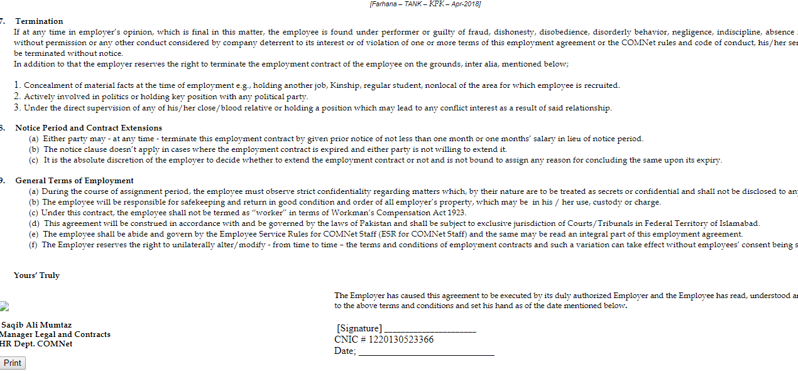

# Step-8

Printing settings. Please set margin with custom option.

Left and right margin = 0.92”

Top margin = 0.4”

Bottom margin = 0.94”

Please zoom below picture to make it clear.

Click on printing to print contracts

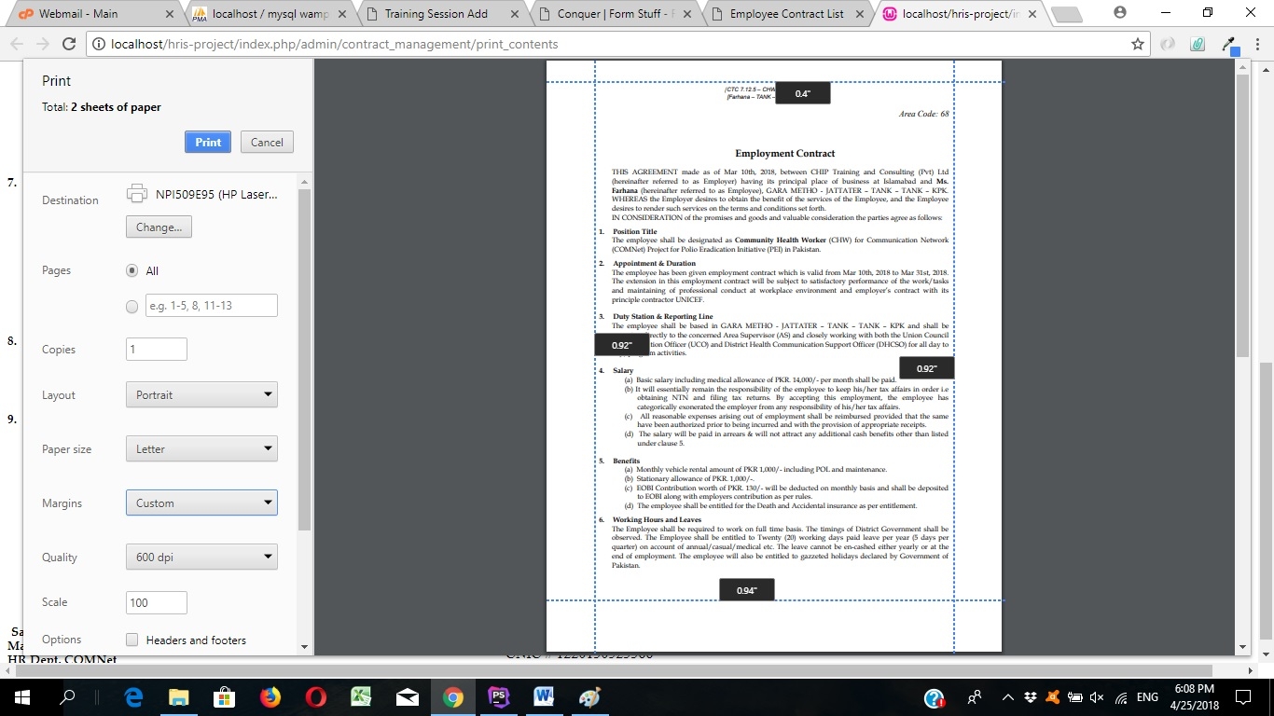

# Step-9

After printing mark status to next status and so on.

