**Employee Card Print Setting**

**Setting is**

**margin:none**

**scale 90%**

**letter 81/2x11n**

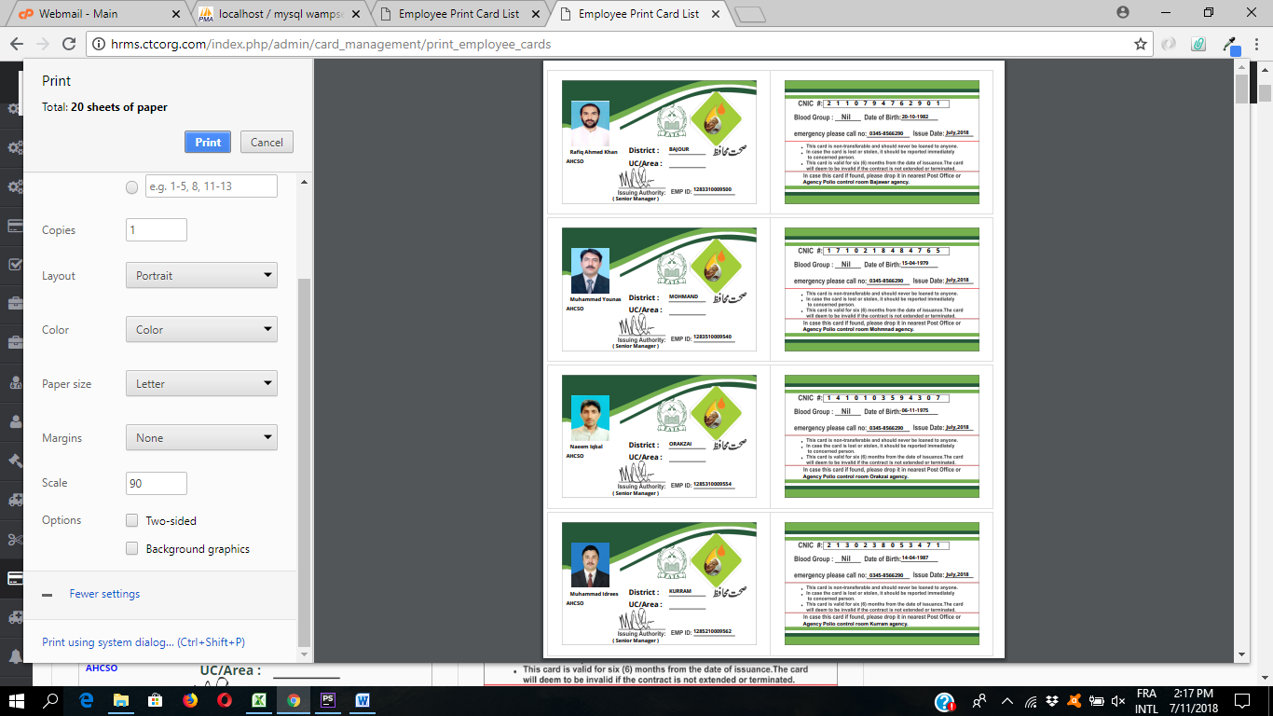

One page contains four cards

Note : sacle is 90 and margin none. This option is under “more settings”.

Then click on link or press Ctrl+Shift+P

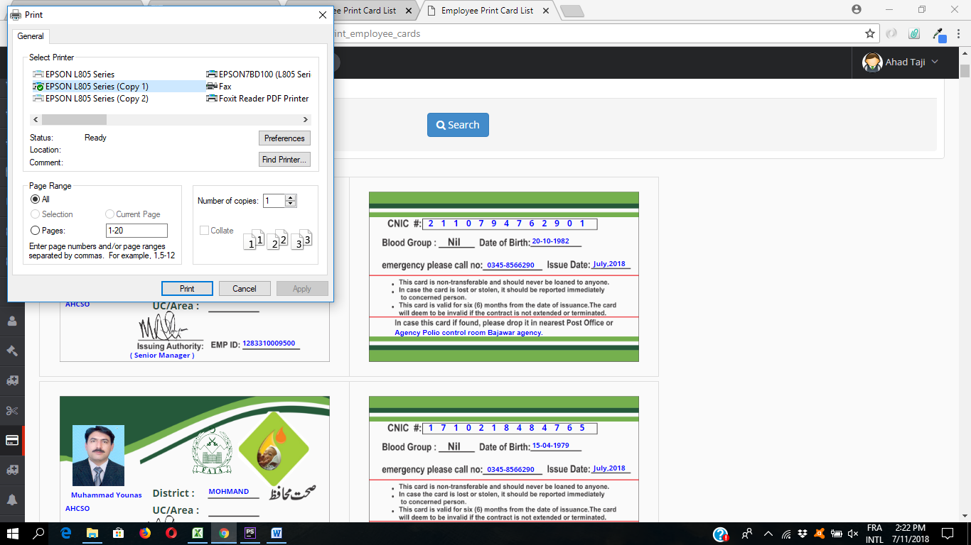

Click on preference after selection of your printer.

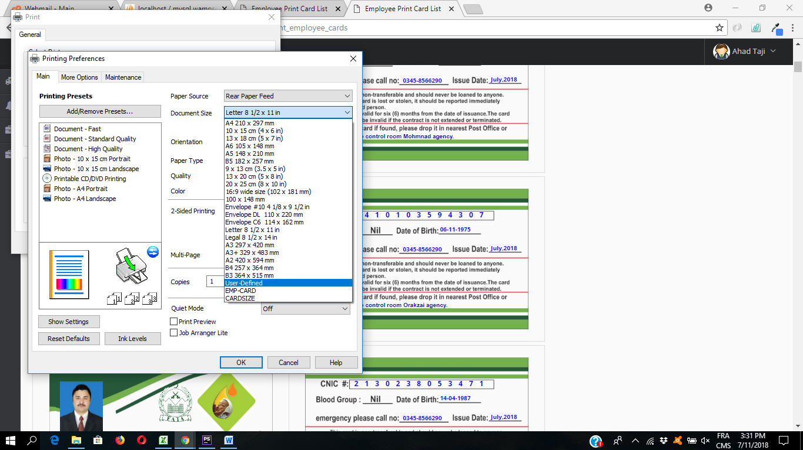

Then change the document size, create your user define size and give name as card-size.

Card print setting

7.85 x 11.80

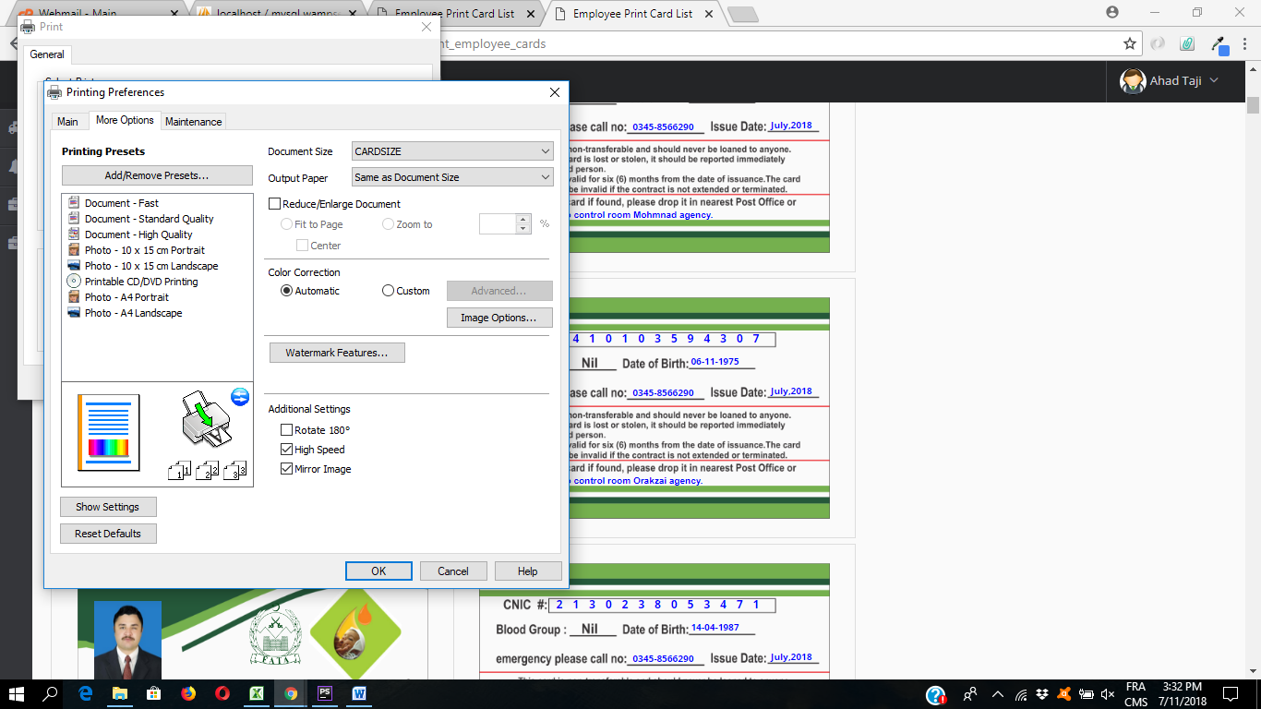

Then click on more option tab on the top left corner. And check the high speed and mirror printing option as show in above picture. Then click on OK and print it.

Note: put smooth surface side of paper backside of printer and rough side front of you.