[CTC–HR&OPS–Recruitment–F-7.2-038–c-IF/SF/SK][Joining Form–May_2024]

CHIP TRAINING & CONSUL TING

**JOINING REPORT BY A NEW EMPLOYEE**

|  |  |
| --- | --- |
| *Name of the Employee* | *Dilawar Ali* |
| *Position appointed to* | Safety & Customer Experience Officer |
| *Department and/or Location of appointment* | CHIP Training & consulting Or Ravi view shall station Lahore. |
| *CNIC#* | *35401-0829417-3* |
| *CNIC Expiry Date* | 14/02/2027 |
| *Date of Joining* | 23/09/2024 |
| *Date and Ref. No. of appointment letter* | 23/09/2024 |
| *Name of the Supervisor* | Mansoor Elahi |
| *Designation of Supervisor* | Safety and customer experience specialist, CHIP Training & consulting |
| *Supervisor’s Comments* | New hire candidate |
| *Supervisor’s Signature* |  |

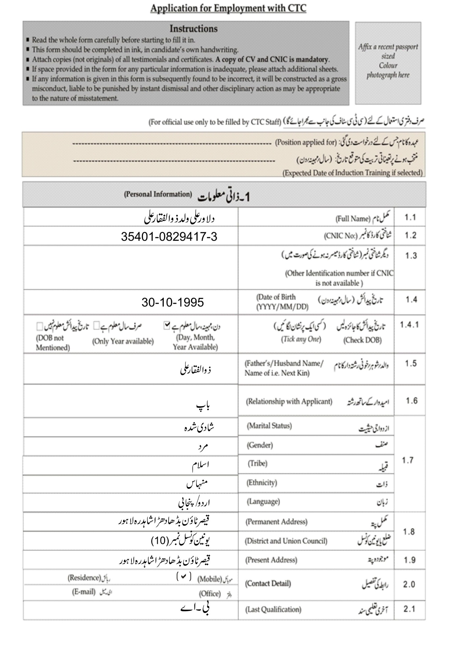

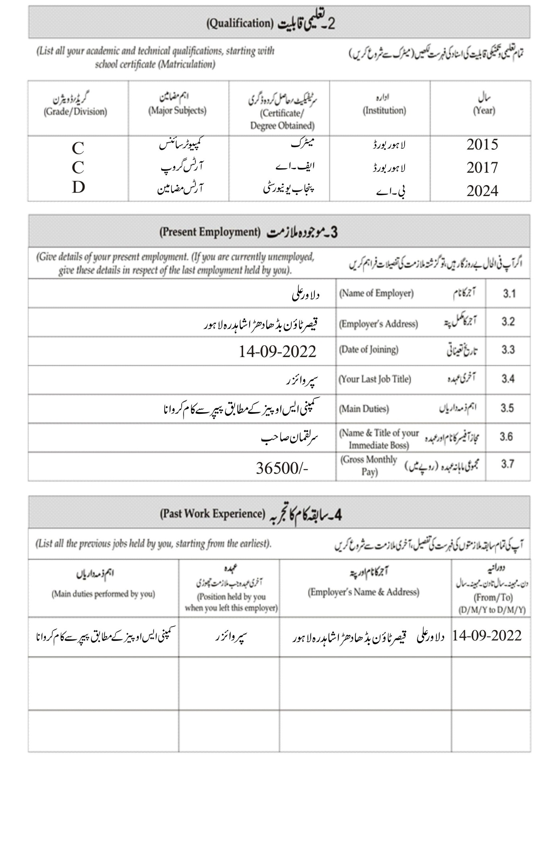

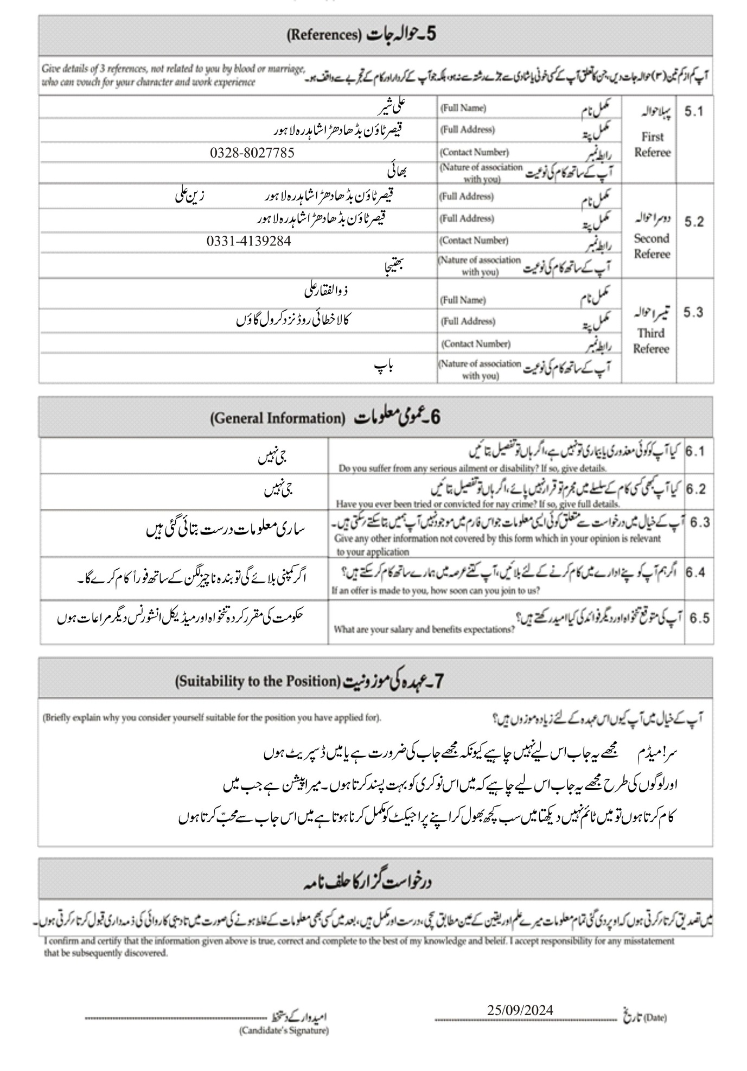

**CHIP Training & Consulting (Pvt). Ltd**

**Declaration Form of Candidate for Residential Address**

**(To be filled & signed by Candidate)**

|  |  |  |
| --- | --- | --- |
| Name of Candidate as per CNIC: | Dilawar Ali S/o Zulfiqar Ali | |
| S/D/W of; |  | |
| CNIC NO: | |  |  |  |  |  |  |  |  |  |  |  |  |  | | --- | --- | --- | --- | --- | --- | --- | --- | --- | --- | --- | --- | --- | | **3** | **5** | **4** | **0** | **1** | **0** | **8** | **2** | **9** | **4** | **1** | **7** | **3** | | |
| Position Applied: |  | |
| Permanent address as per CNIC: | |  |  | | --- | --- | | House No: | Main Bazar Qaiser Town | | Street #: | Main Bazar Qaiser Town | | Mohallah: | Qaiser Town | | Village: | Qaiser Town | | Sector/UC: | UC No : 10 | | Town /Tehsil: | Tehsil Lahore | | District | Lahore | | |
| Current Residential Address:  *(Kindly don’t fill this section if permanent and residential addresses are same)* | |  |  | | --- | --- | | House No: |  | | Street# |  | | Mohallah: |  | | Village: |  | | Sector/UC |  | | Town /Tehsil: |  | | District |  | | |
| Signature & Date: | **Date of Form Filling:** | **Signature of Applicant:** |
| **25-09-2024** |  |

**Disclosure of Relationship Form**

**(To be filled by Candidate)**

I DILAWAR ALI S/ O ZULFIQAR ALI Holding CNIC 35401-0829417-3 Resident of Qaiser Town Budha Dhara Shahdra Lahore UC NO 10 Tehsil LAHORE District LAHORE Candidate for the position of SAFETY & CUSTOMER EXPERIENCE OFFICER with CHIP Training & Consulting (Pvt.) Ltd. under its third party contract for PTPP project, do hereby declare as under:

1. That none of my blood/close relations which may include inter alia parents, brother, sister, husband, wife, spouse, children, maternal and paternal uncle, aunt, niece, nephew, brother/father/mother/sister-law or any other relationship which could come into the standard definition of “blood/close relation” is employed under PTPP project in the same district or PTPP or CTC offices in the same province where I am candidate for this position.
2. That, if selected for this position, I shall be bound to declare - during the course of my employment - any of my above said relationship if the same joins PTPP, CTC or/and WHO to CTC at the earliest.
3. The following blood/close relations (as mentioned in article 01 above) are employed within PTPP CTC or WHO as of the date mentioned below:

|  |  |  |  |  |  |
| --- | --- | --- | --- | --- | --- |
| Name | Designation | Organization | Province/District | UC | Relationship |
|  |  |  |  |  |  |
|  |  |  |  |  |  |
|  |  |  |  |  |  |

**Declaration**; I do hereby solemnly affirm and declare that the information provided above is true and correct and nothing has been concealed therein.

**Signature**:

______________

Date:25-09-2024

**DECLARATION FORM**

**(TO BE FILLED BY THE EMPLOYEE)**

1. I DILAWAR ALI S/ O ZULFIQAR ALI Holding CNIC 35401-0829417-3 Resident of Qaiser Town Budha Dhara Shahdra Lahore UC NO 10 Tehsil LAHORE District LAHORE Candidate for the position of SAFETY & CUSTOMER EXPERIENCE OFFICER with CHIP Training & Consulting (Pvt.) Ltd. under its third party contract for PTPP project, do hereby declare as under:
2. That, I have not enrolled myself in any program in any college/university which comes under the category of regular studies and that currently I am not taking any regular classes.
3. That, I am not employed by any government department or private organizations neither have I any private business registered in my name nor am active partner in family business.
4. I shall be bound to declare - during the course of my employment – any of the above mentioned scenarios.
5. If found making a false or misleading statement when applying for this position with the company, I will be liable to instant dismissal, without benefits, on discovery of such falsehood or misrepresentation.

The following are the details of my regular studies or dual job, if any:

|  |  |  |  |  |  |  |
| --- | --- | --- | --- | --- | --- | --- |
| Name | Regular Student  Of | Department/  Institute  Name | Working as  employee with  (Govt/Private) | Department/  Organization  name | Private business,  if any | Any other part  time job |
|  |  |  |  |  |  |  |
|  |  |  |  |  |  |  |
|  |  |  |  |  |  |  |

**Declaration:** I do hereby solemnly affirm and declare that the information provided above is true and correct and nothing has been concealed therein.

Signature

__________________

Date:25-09-2024