July 18th, 2024.

**TO WHOM IT MAY CONCERN**

This is to certify that Ms. Zeeba Tahir Hashmi bearing CNIC# 37405-0451524-2 has been working with CHIP Training and Consulting (Pvt) Ltd, since May 02nd, 2023. Currently, she holds a position of Monitoring and Evaluation Coordinator.

Please contact undersigned for any further information/clarification in this regard.

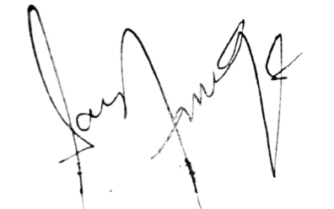

­­________________________

Sarah Farooqui

CEO