SECTION 1: APPLICANT’S DETAILS
Employee Name | Muhammad Tariq
Designation | TCSP
CNIC No. | 21106-2982298-1
District/UC | Bajaur
Leave application date | 25 th July- 2020

SECTION 2: DETAILS OF LEAVE
 | Reason of Leave Applied for (Tick in appropriate box)
 |  |  | Hajj |  |  |  |  | Umrah/Ziarat
 |  |  | Chillah, Tableegh, Ehtikaf |  |  |  |  | Christmas, Diwali
 |  |  | Study/Exams |  |  |  |  | Maternity
 |  |  | Family Wedding |  |  |  |  | Self-Wedding
 |  |  | Immediate Family Death |  |  |  |  | Self-Sick Leave
 | √ |  | Immediate Family-Sick Leave |  |  |  |  | Accident/Sickness-while at work
 |  |  | Accident/Sickness-while not at work |  |  |  |  | Emergency Leave
 |  |  | Vacations |  |  |  |  | Others
Number of Days Leave Applied for two day
Leave start date 27th July- 20120 |  |  |  |  | Leave end date -28th July 2020
OIC Name and designation:

Employee signature:_______ 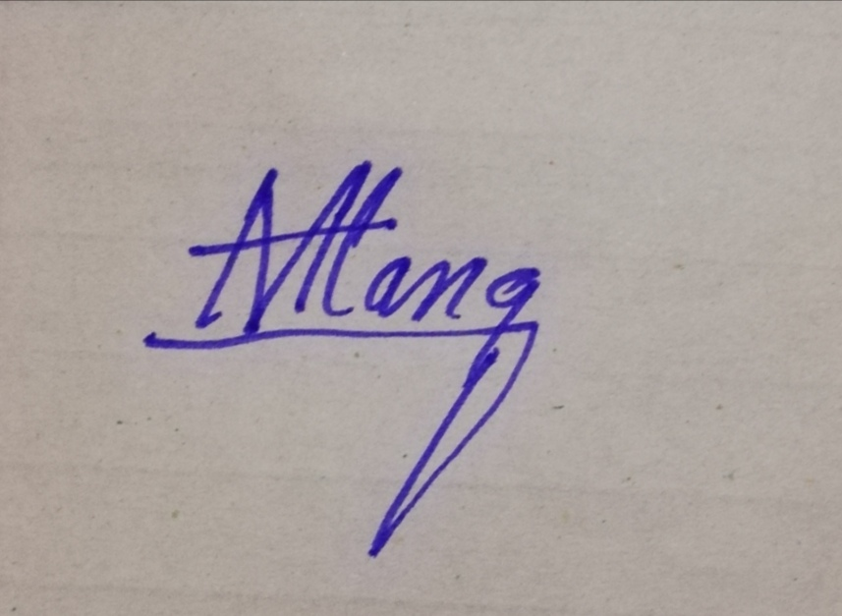_________________________ |  |  |  |  |  |  |  | Date:____25 March-2020_____________
PEO endorsement:___________________________________ |  |  |  |  |  |  |  | Date:____________________
PTL endorsement:__________________________________  For more than Two weeks |  |  |  |  |  |  |  | Date:____________________
CTC final approval:_________________________________ |  |  |  |  |  |  |  | Date:____________________

CTC Remarks, if any _________________________________________________________

NOTE: Leaves during campaign days are NOT allowed

