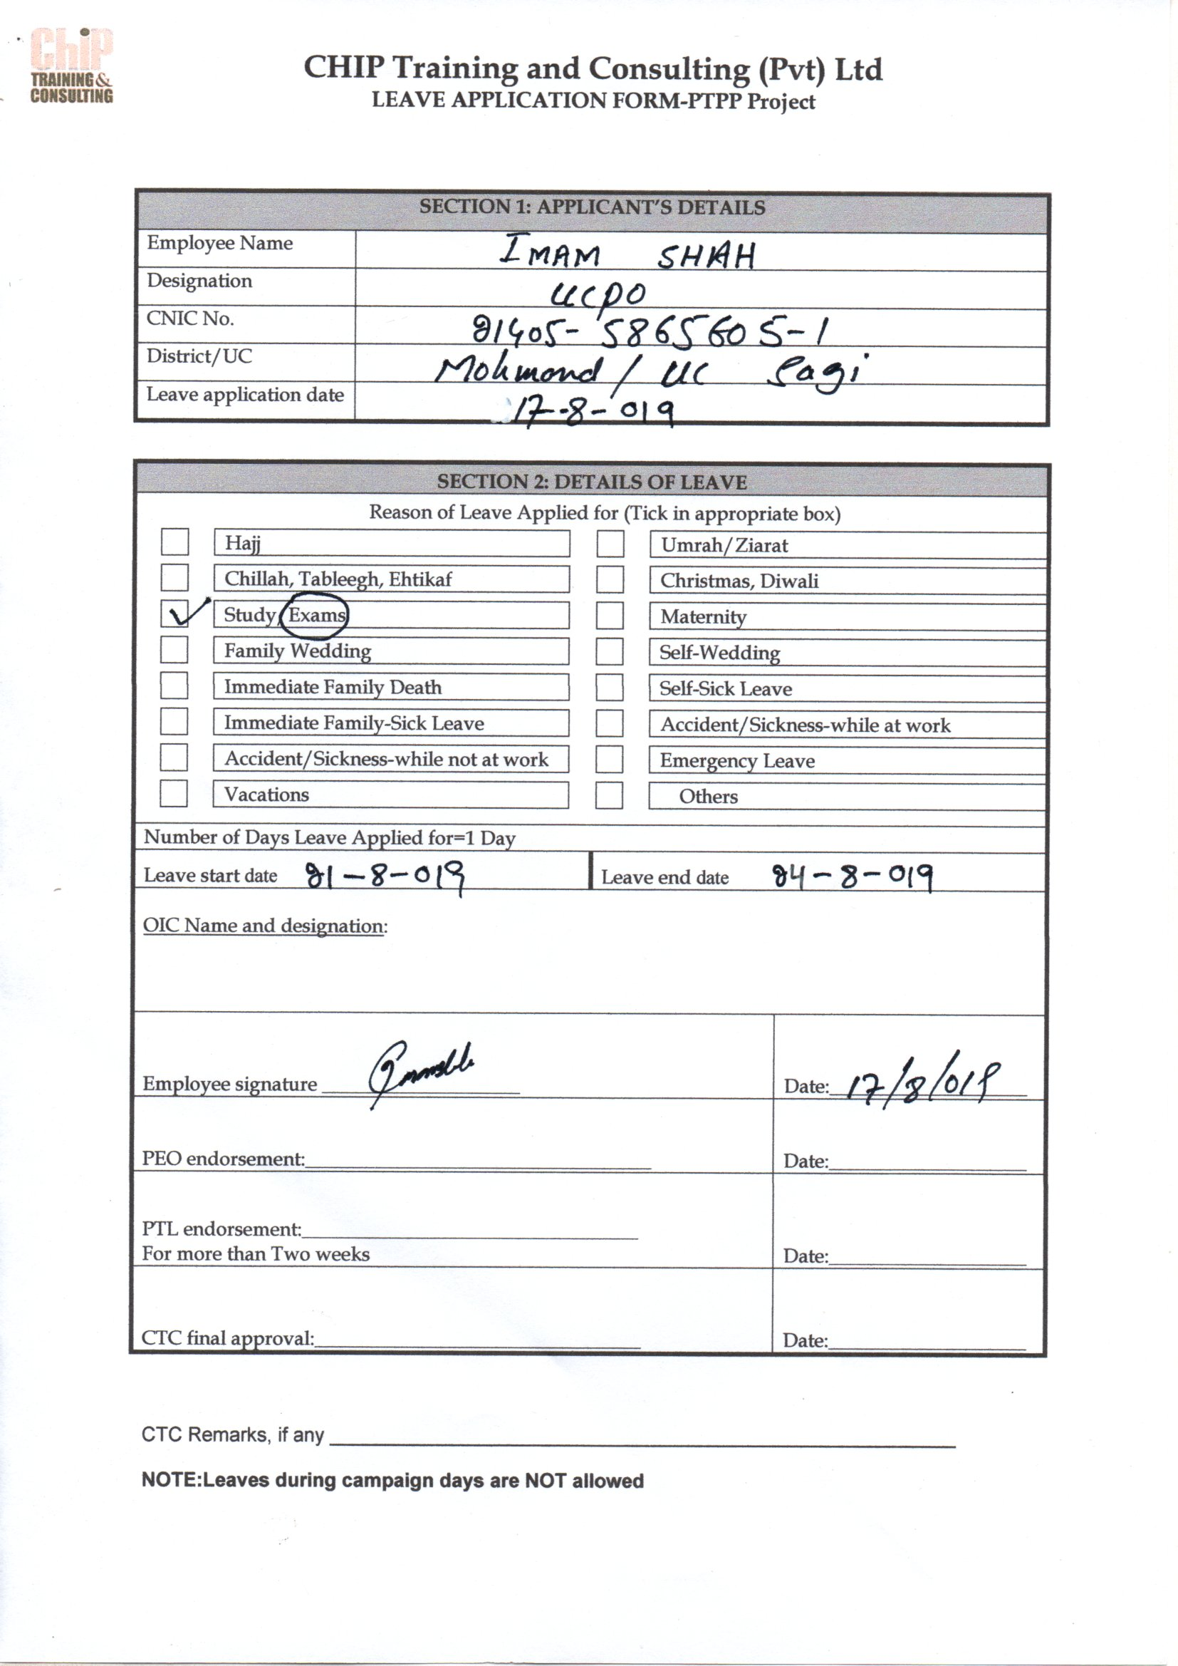

KHYBER PAKHTUNKHWA, BOARD OF TECHNICAL EDUCATION, PLOT NO. 22, PHASE-5, HAYATABAD, PESHAWAR.

**DATE SHEET For One-Year Diploma Level Course in D.I.T (Diploma in Information Technology) Term Examination 2019.**

**(Theory)**

**(Practical)**

|  |  |  |
| --- | --- | --- |
| ***DATE & DAY*** | ***TIME*** | ***D.I.T ( PART – I ) Theory Exam*** |
| **21.08.2019** **(Wednesday)** | **02:00 PM to**  **05:00 PM** | **Information & Communication Technology (ICT)** |
| **22.08.2019** **(Thursday)** | **-do-** | **Office Automation**  **(Word, Excel, Power Point)** |
| **23.08.2019** **(Friday)** | **-do-** | **Computer Programming C/C++** |
| **24.08.2019** **(Saturday)** | **-do-** | **Operating System** |
| **26.08.2019** **(Monday)** | **-do-** | **Computer Network** |
| ***DATE & DAY*** | ***TIME*** | ***D.I.T ( PART – II ) Theory Exam*** |
| **27.08.2019****(Tuesday)** | **02:00 PM to**  **05:00 PM** | **MS – Access** |
| **28.08.2019****(Wednesday)** | **-do-** | **Introduction to Database** |
| **29.08.2019****(Thursday)** | **- do-** | **Introduction to E-Commerce & Web Technology** |
| **30.08.2019****(Friday)** | **-do-** | **Graphic Designing** |

**(Practical)**

|  |  |  |
| --- | --- | --- |
| ***DATE & DAY*** | ***TIME*** | ***D.I.T ( PART – I ) Practical Exam*** |
| **02.09.2019****(Monday)** | **09:00 A.M to**  **04:00 P.M** | **Office Automation (Word, Excel, Power Point)**  **(100 % External)** |
| **03.09.2019****(Tuesday)** | **- do-** | **Computer Programming C/C++**  **(100 % External)** |
| **04.09.2019****(Wednesday)** | **- do-** | **Operating System**  **(100 % External)** |
| **05.09.2019****(Thursday)** | **- do-** | **Information & Communication Technology (ICT)**  **(100 % External)** |
| **06.09.2019****(Friday)** | **09:00 to 12:00**  **&**  **02:00 to 04:00** | **Computer Network**  **(100 % External)** |
| ***DATE & DAY*** | ***TIME*** | ***D.I.T ( PART – II ) Practical Exam*** |
| **07.09.2019****(Saturday)** | **09:00 A.M to**  **04:00 P.M** | **Project**  **(100 % External)** |
| **12.09.2019****(Thursday)** | **- do-** | **MS – Access**  **(100 % Internal)** |
| **13.09.2019****(Friday)** | **09:00 to 12:00**  **&**  **02:00 to 04:00** | **Introduction to Database**  **(100 % Internal)** |
| **14.09.2019****(Saturday)** | **09:00 A.M to**  **04:00 P.M** | **Introduction to E-Commerce & Web Technology**  **(100 % Internal)** |
| **16.09.2019****(Monday)** | **- do-** | **Graphic Designing**  **(100 % Internal)** |

**(MALIK FARIDULLAH KHAN)**  **ASSISTANT CONTROLLER OF EXAMINATIONS**

**C.C.** 1. The Chairman, KP BTE Peshawar.

2. The Controller of Exams, KP BTE Peshawar.

3. All affiliated Institutes / Centre Superintendents.

