The top food science, nutrition and food safety conferences to attend

**January**

**Monell Symposium**

**Wageningen, Netherlands**

Monell Symposium

On January 18th, 2022, The Monell Symposium is a valuable conference about sensory organs and their workings. The conference’s theme is “Exploring the Potential of Sensory to Enhance Quality of Life.”

It’s all about knowing how someone can utilize their senses of taste and smell to live a life at its fullest. The Monell Centre conducts the experiments over smell and taste so that the speaker will be their highly trained scientists.

**Website:** [Monell Centre](https://monell.org/events" \t "_blank)

**International Production & Processing Expo (IPPE)**

**Georgia, USA**

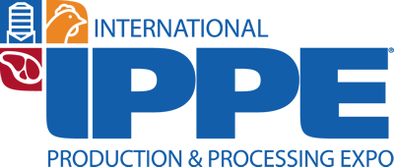

The IPPE will be held from 25th to 27th of January. It is the world’s largest poultry, meat, and feed event. This time it will be taking in Georgia World Congress Center, Atlanta. The event could be an amazing site for protein lovers. However, visitors are advised to take precautionary measures due to the outbreak of African swine fever and coronavirus.

**Website:** [Ippexpo](https://www.ippexpo.org/" \t "_blank)

**February**

**(TERA) Beyond Science and Decisions Workshop**

**Washington DC, USA**

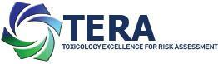

This workshop with free registration will be held in The Institute for the [Advancement of Food and Nutrition Sciences](https://www.cremeglobal.com/food-safety-and-nutrition/). The three days workshop will be set up from 15th to 17th February. The title is “Beyond Science & Decisions: From Problem Formulation to Comprehensive Risk Assessment.” The participants will present 50 case studies to help in “fit for purpose” risk assessments.

**Website:** [Tera](https://www.tera.org/Alliance%20for%20Risk/WS13Reg.html" \t "_blank)

**March**

**SOCMA / Specialty & Custom Chemicals America**

**Texas, USA**

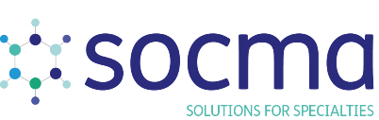

Omni Fort Worth Hotel will host the Specialty & Custom Chemicals Show from the 28th of February to the 3rd March. Many experts and industry leaders all across the globe will participate in the chemical’s commercial growth.

The event will require the physical appearance of the representatives of the food, fuel, cosmetics, and other 33 industries. The conference will be an amazing platform to explore products and technologies from these markets.

**Website:** [SOCMA](https://texas.chemicalsamerica.com/event-details/event-format-dates-times-tx)

**Future Food-Tech Summit**

**California, USA**

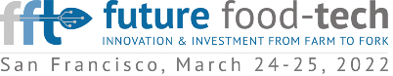

After three years of wait, Future Food-Tech is going to organize their hybrid meeting in San Francisco Marriott Marquis this year. The conference will take place on the 24th & 25th of March. 120 speakers from 40 countries are participating in this summit.

The event is tremendously valuable for those who crave a high-standard conference. Their partners include Accenture, Kellogg’s, Dole, Ingredion, Sidley, V2 Food, and other reputed brands.

**Website:** [Future Food-Tech](https://futurefoodtechsf.com/)

**SOT (Exposure science)**

**California, USA**

SOT (Exposure science)

With 6000+ attendees, San Diego will host the 61st Annual Meeting and ToxExpo. The SOT annual conference will hold 70 scientific sessions in 5 days, from 27th to 31st March.

Moreover, the conference will have 250 exhibitors participating in more than 60 social activities. Hence, it will be amazing to learn from the scientific sessions of toxicology.

**Website:** [Society of Toxicology](https://www.toxicology.org/events/am/AM2022/index.asp)

**GFSI Annual Conference**

**Barcelona, Spain**



Under the theme “Delivering Impact for Safe and Sustainable Food”, the GFSI Conference will be held from 29th to 31st of March. In addition, it will take place in International Barcelona Convention Centre and requires physical participation.

The participants will share ideas on providing safe and sustainable food to the public and private sectors. Also, they will put a light on 2022 World Food Safety Day and other important topics.

**Website:** [GFSI Conference](https://mygfsi.com/events/gfsi-conference)

**April**

**FoodSIM’2022 (Agri)**

**Ghent, Belgium**

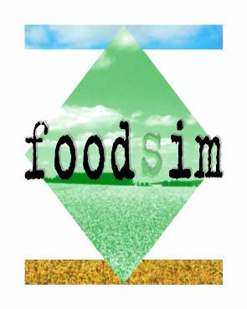

The three days 12th biennial FoodSIM 2022 will be held from 3-6 April. The venue for the conference is the University of Leuven, in Ghent. “Sustainable Food Systems in a Time of Climate Change” is the conference’s theme.

Furthermore, the event will connect the food researchers, experts, and industrial consumers to share their ideas as well as experiences on particular topics.

**Website:** [FOODSIM](https://www.eurosis.org/conf/foodsim/2022)

**Food Allergy Forum**

**Amsterdam, Netherlands**

The Food Allergy forum will be from April 4th to the 6th in person. The venue will be in Hotel Casa of Amsterdam, the Netherlands. It will be the third international conference of the Food Allergy Forum, which will focus on three topics.

The topics will be food allergen risk assessment & management and preventing allergies to new products. Also, it will focus on the maintenance of human immunity to prevent allergies.

**Website:** [Food Allergy Forum](https://foodallergyforum.org/fee.php)

**Extractables & Leachables USA 2022 (Exposure)**

**Virginia, USA**

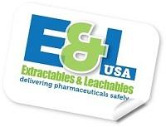

The event will be live from 5-7th April in the Westin Arlington Gateway. It is a hybrid conference, so you can also participate online. The event is categorized into six sessions in which 20 speakers will address the attendees.

The topics will include regulations, standards, testing, assessments, the future of E&L, and more. Their past attendees include Abbott, Exxon Mobil, Johnson & Johnson, Pfizer, Toxicon, and others.

**Website:** [E&L USA 2022](https://www.eandl-conference.com/extractables-and-leachables-usa)

**May**

**ILSI: 7th International Symposium on Food Packaging**

**Barcelona, Spain**



The conference will be live from 3-6 May online only. The event will cover the technology for food packaging. This conference is held every four years.

So, it will be an ideal opportunity for those who want to explore packaging safeties and how we can integrate them will the latest technology means.

Additionally, the conference has four main topics: analytical techniques advancements, progress in risk assessments and toxicological prediction, and contact materials.

**Website:** [International Life Science Institute](https://ilsi.eu/event/7th-international-symposium-on-food-packaging-scientific-developments-supporting-safety-and-innovation/)

**IAFP EU**

**Munich, Germany**

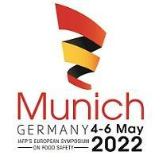

The event will organize from 4th to 6th May, and it’s going to be the 17th IAFP European Symposium. The conference will be held in Munich, Germany.

Unfortunately, it will not be online. Otherwise, the forum will be great for those who want to discover new ideas. The participants will share the latest developments in food science and safety.

**Website:**| [IAFP EU](https://www.foodprotection.org/europeansymposium)

**Food Safety Summit (Agri)**

**Illinois, USA**

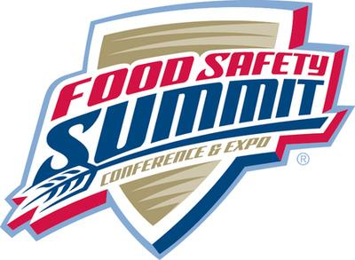

The Food Safety Summit Conference and Expo will be organized from May 9th-12th. Rosemont will host the in-person event in Donald E. Stephens Convention Center. The event is vital for all those small businesses seeking food safety solutions.

In the program, the topics will include cybersecurity in food safety, food donation, culture, and the development of FSMS. There will be even more technical and aspiring sessions in those four days.

**Website:** [Food Safety Summit](https://na.eventscloud.com/ereg/newreg.php?eventid=624291&)

**SETAC 32nd Annual Meeting (Exposure)**

**Copenhagen, Denmark**

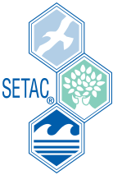

The SETAC 32nd Annual Meeting will be held from 15th to 19th May of this year. It will take place in Bella Centre Copenhagen. This five-day conference is both online and physical.

Furthermore, there will be 94 scientific sessions divided into 7 tracks. The event is beneficial for those seeking scientific advancements in Europe and thriving for innovation.

**Website:** [SETAC](https://europe2022.setac.org/)

**Institute for Food Safety and Health (IFSH) Event**

**Online**



This year the Institute for Food Safety and Health will organize the 5th IFSH High-Throughput Sequencing Virtual Symposium. It will be held on the 18th and 19th of May. As the name suggests, the meeting will be virtual via zoom, so there will be no physical presence at the venue.

The program will revolve around the High Throughput Screening (HTS) services. The topics will be how HTS has improved the diagnosis, analysis, and food safety research. Also, the speakers will talk about new researches and innovations the HTS provides.

**Website:** [IFSH 5th Symposium](https://www.ifsh.iit.edu/events/5th-ifsh-high-throughput-sequencing-hts-virtual-symposium)

**NonTarget Analysis for Environmental Risk Assessment Meeting (Exposure, SETAC)**

**North Carolina, USA**



Another SETAC meeting will be held from 22-26 May, on the environmental topic. Durham Convention Center will host the 2022 NonTarget Analysis for Environmental Risk Assessment. The meeting will be in-person.

The conference’s main objective is to connect chemical analysis experts and environmental chemists. So, it will be amazing for those concerned about the ever-degrading Earth’s atmosphere.

**Website:** [NonTarget 2022](https://nta.setac.org/register" \t "_blank)

**June**

**North American Summit on Food Safety 2022**

**Toronto, Canada**



The symposium will be held on 7 & 8th of June, 2022. Toronto will host the summit where delegates from various fields of food safety will gather. The participants will be food processors, manufacturers, retailers, brokers, suppliers, federal and provincial regulators, and industry consultants.

The summit will cover many topics, including training strategies, allergens and labels, sanitation solutions, and delivering quality products. Moreover, there will be a discussion on international government regulations on food safety.

**Website:** [North American Summit](https://www.foodsafetycanada.com/)

**Bio Annual Meeting (Exposure)**

**California, USA**

BIO International Convention

The BIO International Convention will occur in the San Diego Convention Center from June 13th to 16th. The convention’s theme is “Limitless,” which will surely attract many researchers and leaders from the biotechnological industry.

Moreover, there will be more than 15000 biotechnology researchers and pharma leaders making new opportunities and sharing ideas. They will cover topics like drugs, biomanufacturing, biofuels, nanotechnology, and cell therapy.

**Website:** [BIO Annual Meeting](https://www.bio.org/events/bio-international-convention/registration)

**Agrostat 2022 (Agri)**

**Bragança, Portugal**



The Agrostat 2022 Conference will be held in Polytechnic Institute of Bragança from 14-17 June. The event will revolve around 8 themes of technology, agriculture, and analysis. They will be sensometrics, chemometrics, experimental designs, press control, and big data. Other themes include software tools, predictive microbiology, and meta-analysis.

**Website:** [Agrostat 2022](http://agrostat2022.esa.ipb.pt/pre-register-now" \t "_blank)

**Institute for the Advancement of Food and Nutritional Science IAFNS 2022 Annual Meeting**

**Washington, USA**

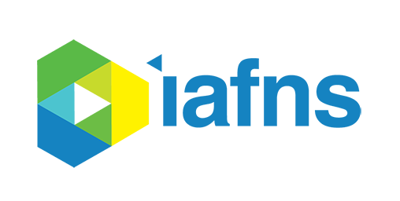

From June 20th to 23rd, the Institute for the Advancement of Food and Nutritional Science will organize its annual meeting in Washington, DC. Their last annual meeting of 2021 was all virtual, but this time it could be hybrid. However, not many details are available on the IAFNS website.

**Website:** [IAFNS Annual Meeting 2022](https://iafns.org/event/iafns-2022-annual-meeting)

**Food Safety Europe 2022 EFSA European Food Safety Authority**

**Brussels, Belgium**

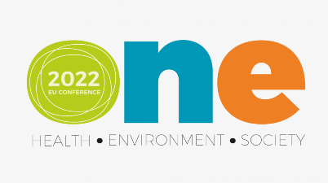

The European Food Safety Authority will organize their One—Health, Environment, Society—Conference 2022 in Square: Brussels Convention Centre. But the event is hybrid (it will also be conducted online) from 21-24 June 2022.

The event partners include ECDC, ECHA, EEA, EMA, and European Commission’s Joint Research Centre. The program will focus on broader food sustainability, risk assessment science, and future strategic goals, including new policy targets.

**Website:** [Food Safety Europe](https://www.efsa.europa.eu/en/news/one-health-environment-society-conference-2022)

**July**

**20th ICC Conference (Agri) International Association for Cereal Science and Technology**

**Vienna, Austria**

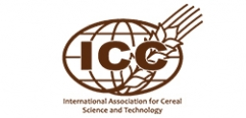

With the help of BOKU (University of Natural Resources and Life Sciences), the 20th ICC Conference 2022 will be held there. It will be a hybrid meeting from 5th to 7th July, on the cereals and their nutrition.

The food experts from worldwide will gather to discuss the cereals processing, quality, analytics, demand, and safety of the business. Other topics will be on crop production and the influence of climate change on the world’s nutrition.

**Website:** [20th ICC Conference](https://icc2022.meetinghand.com/en/)

**IFT First 2022 – Institute of Food Technologists**

**Illinois, USA**

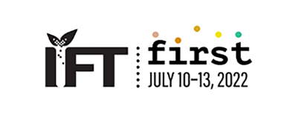

The IFT Food Expo and Virtual Experience Conference will occur from 10th to 13th July 2022. The McCormick Place will host this largest B2B food expo and other future events.

It will also be a great place for those searching for the latest global trends. The explorers will learn the cutting-edge solutions and the newest innovations. Moreover, it will provide a great platform for businesses to generate new leads.

**Website:** [IFT 2022](https://www.iftevent.org/schedule/future-dates)

**August**

**IAFP International Association for Food Protection 2022 (Agri)**

**Pennsylvania, USA**

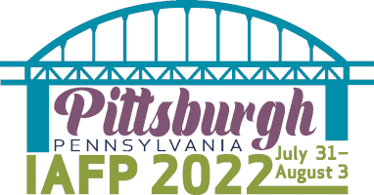

The International Association for Food Protection 2022 Annual Meeting will take place in David L. Lawrence Convention Center. The event will last for up to four days, from the 31st of July to the 3rd of August. More than 3,800 attendees will physically appear from the six continents.

The conference is valuable for agricultural advancement seekers. It will cover topics like acidified food, agricultural water quality, computer modelling for dairy, foodborne diseases, and many more.

**Website:** [IAFP 2022](https://www.foodprotection.org/annualmeeting)

**ACS Fall 2022 National Meeting & Exposition (Exposure)**

**Illinois, USA**

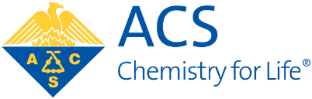

The American Chemical Society (ACS) conference will be held from August 21st-25th, 2022. The main theme of the meeting is “Sustainability in a Changing World,” where many chemists will participate. The meeting is hybrid (online as well as in-person).

The conference will open an opportunity for professionals to share their findings and advanced research. Also, it will be a great platform for new chemists to learn and explore different advanced techniques.

**Website:** [ACS Fall 2022](https://www.acs.org/content/acs/en/meetings/acs-meetings/abstract-submission/call-for-abstracts.html)

**FoodMicro 2022**

**Athens, Greece**

Food Micro International Committee on Food Microbiology
and Hygiene

The Megaron Athens International Conference Centre will host the 27th International ICFMH Conference. It will be held on August 28th-31st, 2022. However, the conference already suffered delays in the dates twice due to COVID Pandemic.

The speakers, Kostas Kosntantinidis, Tjakko Abee, Christopher Brewster, and 4 others, will describe the heritage of historic cities. Moreover, the conference will be hybrid and offer a high-standard scientific program.

**Website:** [FoodMicro 2022](http://foodmicro2022.com/" \t "_blank)

**September**

**IUTOX XVIth International Congress of Toxicology (ICT) 2022 (Exposure)**

**Maastricht, Netherlands**



The XVIth ICT 2022 will take place from 18th-21st September. The International Union of Toxicology (IUTOX) and the European Union of Toxicology (EUROTOX) are collectively arranging this congress in Maastricht Exhibition & Conference Centre (MECC).

The theme of the congress is “Uniting in Toxicology.” So, it would be an excellent event to meet the best toxicological researchers and scientists. Additionally, the program will be categorized into 32 sessions.

**Website:** [XVIth ICT 2022](https://www.ict2022.com/" \t "_blank)

**ISES 2022 (Exposure)**

**Lisbon, Portugal**

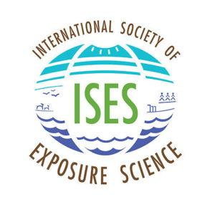

The International Society of Exposure Science will hold its 2022 Annual Meeting from September 25-29th. It will discuss various multidisciplinary issues and policies.

The discussion panel will share their point of view to understand the environmental health complexities. Also, it will be a fabulous source of information about the environmental exposure sciences and related fields.

**Website:** [ISES 2022](https://intlexposurescience.org/event/2022-meeting)

**CropLife America (CLA) 2022 (Agri)**

**Texas, USA**

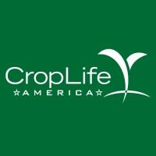

From September 26th to 28th will be the CropLife America (CLA) annual meeting of 2022. The three days conference will be held in San Antonio. However, there are not many details about the conference yet.

**Website:** [CLA Annual Meeting](https://www.croplifeamerica.org/events/event-five-8efjt)

**North America Food Safety (NAFS) 22**

**Illinois, USA**

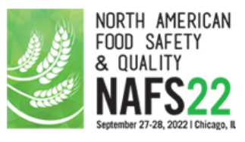

The North American Food Safety and Quality 22 Conference will be held on the 27th & 28th September 2022. The Westin Chicago North Shore will be the venue for experts, researchers, and other attendees.

In addition, 10 speakers will cover the program with different topics. The topics include food safety systems, supply chain and risk management, leadership tools and skillsets, and FSMA reviews.

**Website:** [NAFS 22](https://foodsafetyna.com/)

**October**

**Nutrevent Conference – ILSI Europe**

**Nantes, France**



The 8th Nutrevent Conference will be held on 4th & 5th October. More than 25 countries will represent their products and technologies in Nantes Congress Centre. The conferences will have four tracks, including food, feed, nutrition, and health.

Furthermore, the conference will be a great opportunity for those who want to learn about innovations in the above departments. Also, they will know the different advancement strategies of the experts.

**Website**: [Nutrivent](https://www.nutrevent.com/registration/registration-fees" \t "_blank)

**2nd International Conference on Food Technology & Nutrition**

**Paris, France**



It is a three-day conference from October 24th to 26th, 2022. The event will take place in Hampton by Hilton Paris Clichy. The conference’s main theme is how we are blessed with food on our plates every day.

The event will cover various topics like global strategy on nutrition and its advancement. You will know food technology and microbiology, food waste management and preservation techniques, and many other things.

**Website:** [Food Technology & Nutrition](https://foodtechnology.prideconferences.com/registration)

November

**SETAC North America 43rd Annual Meeting (Exposure)**

**Pennsylvania, USA**



From 13th to 17th November, there will be the 43rd Annual Meeting of SETAC North America. This five-day meeting will be held in Pittsburgh’s David L. Lawrence Convention Center. No further details are available on the website regarding the conference. Otherwise, it will be a must-attend event for the environment and nature lovers.

**Website:** [43rd SETAC Annual Meeting](https://www.setac.org/m/event_details.asp?id=1514444)

**December**

**SRA Annual Meeting 2022 (Exposure)**

**Florida, USA**

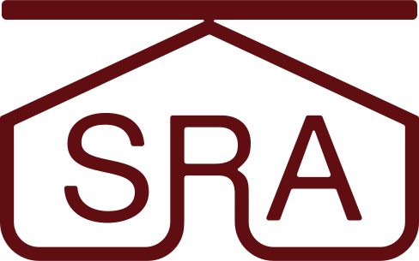

The SRA Society for Risk Analysis Annual Meeting of 2022 will be held in Tampa. The five-day event is scheduled to be held from 4th to 8th December. The venue for the meeting is Tampa Marriott Waterside Hotel. But yet, there are not many details on the programs.

**Website:** [SRA Annual Meeting](https://www.sra.org/event/2022-sra-annual-meeting)

**22nd IUNS – International Congress of Nutrition**

**Tokyo, Japan**



The International Congress of Nutrition (ICN) conference also suffered delays due to the pandemic, and now will take place on 6th to 11th December. The 22nd ICN will occur in the Tokyo International Forum.

The main theme for the conference is “The Power of Nutrition: For the Smiles of 10 Billion People.” It will be great for those who want to discover global health issues and nutritional concerns.

**Website:** [22nd IUNS](https://icn22.org/registration.html)

**Postponed**

**12th International Conference on Predictive Modelling in Food**

**Sapporo, Japan**

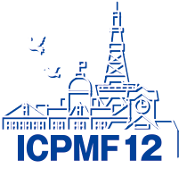

The 12th International Conference on Predictive Modelling in Food has been set from 13th to 16th of September 2022. But now, it is postponed to 13-16th June 2023.

The event is also moved to the next year because the domestic committee doesn’t want to overlap it with the FoodMicro event. However, next year, this conference will be an opportunity for food experts to discover new ideas and share theirs’ too.

**Website:** [12th ICPMF](https://www.ec-pro.co.jp/ICPMF12/welcome.html)