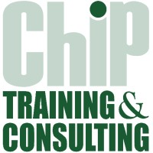

CAREER OPPORTUNITIES

**CHIP Training & Consulting is seeking to hire experienced and competent professionals for the following position in Karachi, Sargodha and Peshawar:**

**Master Trainer SHELL Project – Karachi, Sargodha & Peshawar**

* Bachelors/Master’s degree in Business Administration or relevant field with 3 to 4 years’ experience preferably in independent safety audit or customer service retail experience.

Note: Please apply and share your CV at jobs@chipconsulting.org by September 3rd, 2023. Only shortlisted candidates will be called for the test and interview.

**WE ARE AN EQUAL OPPORTUNITY EMPLOYER**