Dear Saqib,

Please go ahead with many thanks.

Regards,

**From:** Saqib Atta <saqib@ctc.org.pk>   
**Sent:** Tuesday, July 21, 2020 12:47 PM  
**To:** HAMMADI, Rusul <aminr@who.int>  
**Cc:** naila@ctc.org.pk; FAROOQ, Zainab <farooqz@who.int>  
**Subject:** RE: [EXT] Re: Absent from mOPV2 Training

Respected Rusul Amin,

With reference to UCPO Noman Show cause letter and his response. AC Dr Abid also comments on his response which seems unsatisfactory in below.  For further processing your approval is required to issue him warning letter and particularly unpaid leave deduction from salary. He was absent from 16 June and joined back on 4th July but again absent on 6-7 July in training. He did not share any leave application and medical proof . On demand he shared his Covid Report which tested on 16th July (which is negative now). Please guide

Regards,

Saqib Atta

**From:** HAMMADI, Rusul [<mailto:aminr@who.int>]   
**Sent:** Saturday, 18 July 2020 10:43 am  
**To:** [noman_akhtar@ymail.com](mailto:noman_akhtar@ymail.com); [drabidwho@yahoo.com](mailto:drabidwho@yahoo.com); [drrghazali@gmail.com](mailto:drrghazali@gmail.com)  
**Cc:** [saba.irshad@ymail.com](mailto:saba.irshad@ymail.com); [saqib@ctc.org.pk](mailto:saqib@ctc.org.pk)  
**Subject:** RE: [EXT] Re: Absent from mOPV2 Training

Dear Mr Nauman,

You had to inform your both line supervisors from the beginning regarding symptoms you has since that time as it’s not just being absent from duty without any official leave or even informing the concerned.

This is not acceptable.

Thank you and regards,

**From:** Noman Akhtar <[noman_akhtar@ymail.com](mailto:noman_akhtar@ymail.com)>   
**Sent:** Saturday, July 18, 2020 9:59 AM  
**To:** [drabidwho@yahoo.com](mailto:drabidwho@yahoo.com); [drrghazali@gmail.com](mailto:drrghazali@gmail.com)  
**Cc:** [saba.irshad@ymail.com](mailto:saba.irshad@ymail.com); [saqib@ctc.org.pk](mailto:saqib@ctc.org.pk); HAMMADI, Rusul <[aminr@who.int](mailto:aminr@who.int)>  
**Subject:** [EXT] Re: Absent from mOPV2 Traning

Respected  Sir ,

Sir my final report is attached .

I isolated myself as soon as I got the symptoms According to the instruction of the doctor and I did not get the test done at that time .I had discussed  this matter with  Madam and Doctor Ghazali sahb too.

I have spent a lot of hard time and have taken a lot of precaution ۔

Sir, I did not attend training because I was afraid that No one else effected like i was .

Sir i have always worked hard With honesty And will always be sincere  with my work.

Best regards

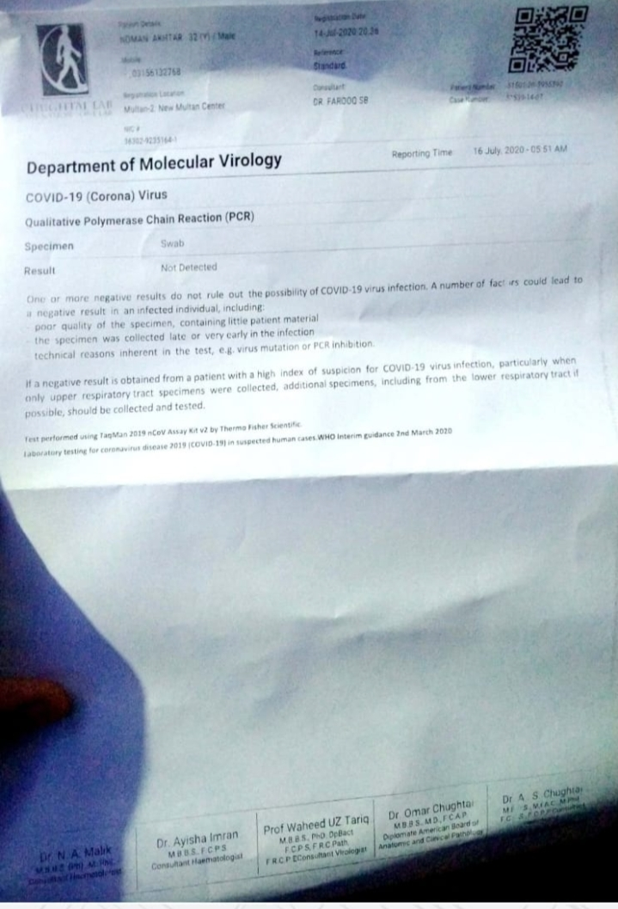

[Sent from Yahoo Mail on Android](https://go.onelink.me/107872968?pid=InProduct&c=Global_Internal_YGrowth_AndroidEmailSig__AndroidUsers&af_wl=ym&af_sub1=Internal&af_sub2=Global_YGrowth&af_sub3=EmailSignature)

On Wed, Jul 15, 2020 at 10:19 AM, drabidwho

<[drabidwho@yahoo.com](mailto:drabidwho@yahoo.com)> wrote:

Dear Nauman,

             Please share your COVID 19 lab result.When did you become positive.How many days have you been isolated.You have not shared any thing with us till time.How would you work in campaign without training which was conducted from 6-7 July

You did not resume duty from 16June to 3 July

In case of failure to provide lab result, you were considered absent from duty

Thanks

Regards

Dr Abid

Sent from my Samsung Galaxy smartphone.

-------- Original message --------

From: Noman Akhtar <[noman_akhtar@ymail.com](mailto:noman_akhtar@ymail.com)>

Date: 15/07/2020 09:32 (GMT+05:00)

To: [drrghazali@gmail.com](mailto:drrghazali@gmail.com)

Cc: drabid who <[drabidwho@yahoo.com](mailto:drabidwho@yahoo.com)>

Subject: Re: Absent from mOPV2 Traning

Respected Sir,

Hope all is good at your end .

This institution (WHO) Staff  and my work Is very important to me .

I will never ever mislead my office Authorities .

Sir, I joined the field from 4th of July And I also messaged you and Madam ۔I did not come to mark attendance  and I did not attend training because I didn't want anyone else to get infected as i was infected .This is why I avoided going to the office and meeting.

I was also in the field on 7 July and 8 July was not on leave ۔I  shared some pictures on July 7 in the WHO group .

Sir i work very honestly and full  devotion. Whenever a doctor came for monitoring , I was never found out of the field .I am commented with my work and organization And always will be .

Best regards

[Sent from Yahoo Mail on Android](https://go.onelink.me/107872968?pid=InProduct&c=Global_Internal_YGrowth_AndroidEmailSig__AndroidUsers&af_wl=ym&af_sub1=Internal&af_sub2=Global_YGrowth&af_sub3=EmailSignature)

On Wed, Jul 15, 2020 at 8:48 AM, Dr.

Dear Noman.

                       Kindly reply till evening, have you attended mOPV2 training on 6th & 7th July 2020,if not have you sent any leave for approval.

Thanks & Regards

Dr.Riaz Ghazali

PEO /WHO