Employee Name | Muhammad Idris | CNIC No. | 11201-9658597-9
Designation | UCPO | District/Tehsil | Lakki Merwat
UC | Titter Khel | Last Working Date:01-September-2020
Contact Number | 03458637310

TO: HR Department-CTC

Subject: One Month Pre notice of Resignation
Dear Sir/Madam,
Reference to the subject cited above, I am writing to inform you that due to some domestic problems, I will not be able to continue my services as Ucpo after 1 September 2020.
Sir I have greatly enjoyed working for WHO and CTC for Tie past more then 5 Years. I feel that I have learned a lot and grown professionally during time in WHO and CTC. I appreciate the opportunity to have worked with such a great group of people for a great cause.
Sincerely Yours
Muhammad Idris
Ucpo UC TITTER Khel
Mobile No. 03458637310
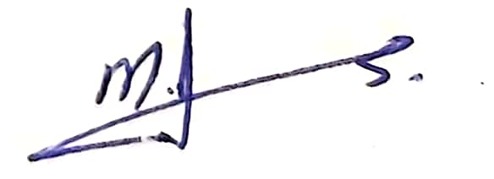
Email. idrisdrs86@gmail.com

Signature:____________

Date:____05-August-2020______

