**UCPO Maryam UC 4 Site Town ,District Keamari**

During the field monitoring Visit on 12-01-2021 to UC 4 Metroville Site Town during NID JAN 2021 it was found that one of the AS (Faiza) was carrying tally sheet analysis and 2A analysis formats with her in the field. Upon inquiring she told that they were all asked to do tally sheet and 2A analysis by the UCMO and UCPO UC 4 Maryam and to submit it on the 6th day of campaign.

* Tally Sheet which was found with the AIC. She already had done day 1 analysis of her 3 teams.
* This issue was discussed. In evening review meeting, town focal person of Site Town was part of it. Despite the message being communicated, the analysis practice was continued with this text from Maryam to the AIC’s.

Maryam Contact No :0345 -2790733

AIC Faiza UC 4 was called to DEOC on 19-01-2021 where she admitted that this practice is going on and in her statement (Which is attached below )she stated that they were pressurized by the UCMO Tariq and UCPO Maryam to do the tally sheet ,2A and UC analysis .Even after DDOSO Dr Nadia pointed out and ask to discontinue this practice , UCPO Maryam asked the AIC to not take these analysis format to the field in order to hide it from any Monitor .AIC Faiza refused for analysis but still UCMO Tariq insisted to do it .UCPO Maryam asked AICs to cooperate with her and then they done the analysis and submitted it to her on catchup day 2 .

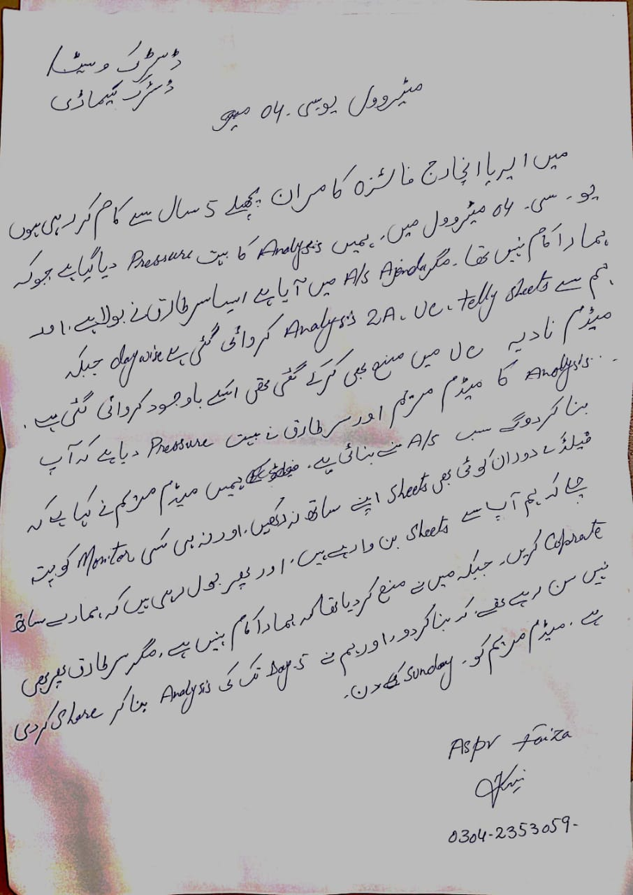

AIC Faiza Kamran UC 4 statement

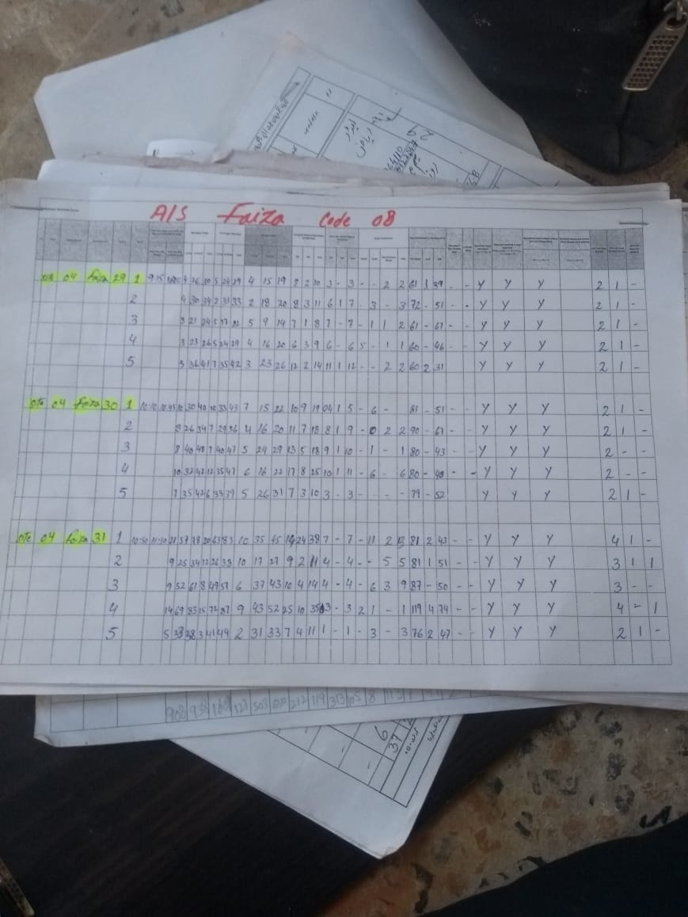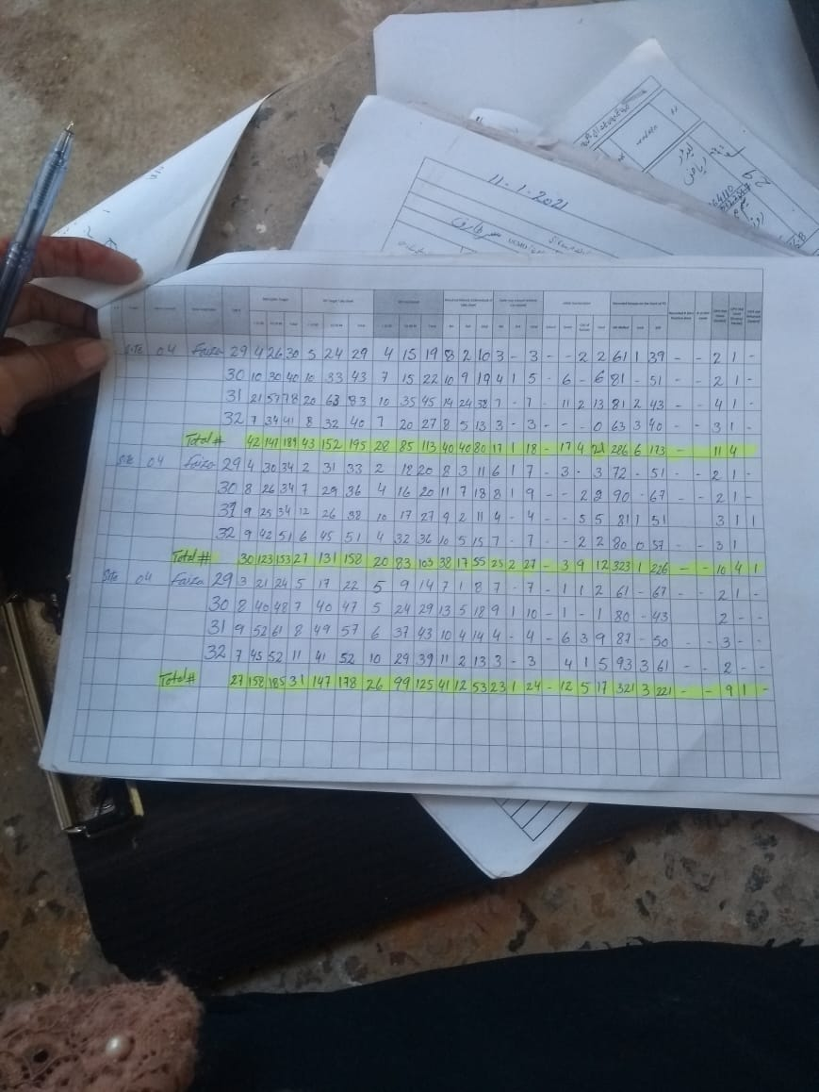

* 5 Day Analysis done by AIC Faiza and has been submitted to Maryam through AIC Namreen as Maryam was at home in isolation after being tested positive for COVID -19 .

CMO Tariq was also asked to Come to DEOC on 19-01-2021 to Clarify and he gave his statement.

* In his statement he stated that he was told by UCPO Maryam that the analysis by AIC is part of the agenda training .On day 2 of the campaign UCMO Tariq asked AS Ghazala if she was also doing analysis ,She said she had done analysis until last night .After this UCMO Tariq and DR Sami strictly prohibited analysis and after these directives no AS was found doing analysis.

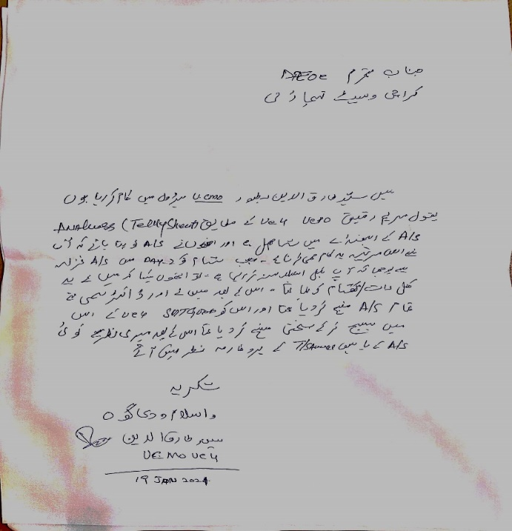

* UCMO Tariq Statement

UCPO Maryam was asked to come to DEOC on 21st Jan 2021.Where she confessed that she had asked the AICs to do the Tally sheet and 2A analysis which has to be done officially by her. Maryam UC 4 statement is attached below

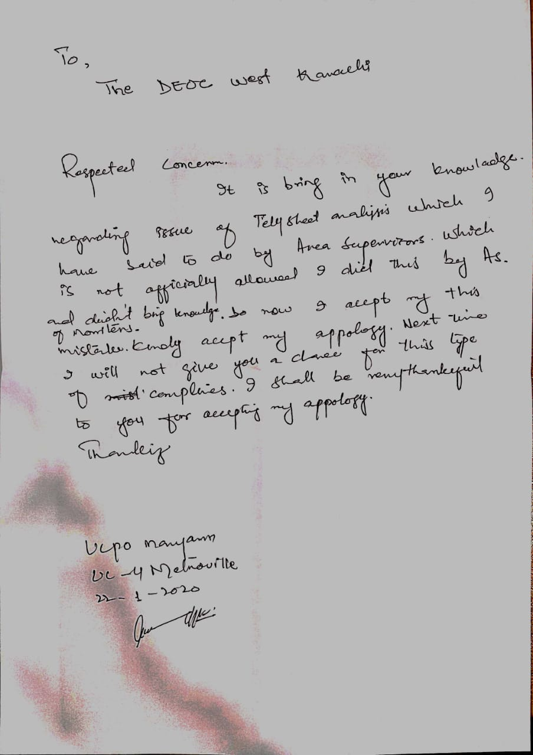She stated in her statement that she asked the AIC’s to do the Tally sheet and 2A analysis which is not officially allowed and asked them not to bring this in any monitors Knowledge. She accepts her mistake and asked us to accept her apology and she will not repeat this misconduct in the future .