Dear Awais

UCPO informed that UCDO took a fake cluster which was verified by concerned TDO. The cluster was not fake as per email attached. Similarly, we have shared an email with Miss Naila regarding allegations of Harassment by UCDO. I will request your team to investigate both issues as soon as possible.

Regards

Naveed Khurshid

Get [Outlook for Android](https://aka.ms/AAb9ysg)

**From:** [awais@ctc.org.pk](mailto:awais@ctc.org.pk) <[awais@ctc.org.pk](mailto:awais@ctc.org.pk)>  
**Sent:** Friday, August 13, 2021 10:31:07 AM  
**To:** IQBAL, Ahsan <[iqbalah@who.int](mailto:iqbalah@who.int)>  
**Cc:** KHURSHID, Muhammad Naveed <[khurshidm@who.int](mailto:khurshidm@who.int)>; IQBAL, Ahsan <[iqbalah@who.int](mailto:iqbalah@who.int)>; ABBAS, Waseem <[wabbas@who.int](mailto:wabbas@who.int)>; 'Naila Nizam' <[naila@ctc.org.pk](mailto:naila@ctc.org.pk)>  
**Subject:** FW: [EXT] UC Shahi Bagh Fake clusters inquiry

Dear Sir,

As per our telephonically discussion, Please share details of the case so we can proceed as per SOPs.

Regards,

Awais Khan

HR Officer

CHIP Training & Consulting (Pvt) Ltd.

Plot 1, Street 9,  G-8/2, Islamabad, Pakistan.

Tel: [+92-51-111-111-920](tel:+92%2051%20111%20111%20920), Cell: Cell:0340-8442573

**From:** KHURSHID, Muhammad Naveed [<mailto:khurshidm@who.int>]   
**Sent:** Friday, 13 August 2021 1:25 am  
**To:** 'Naila Nizam' <[naila@ctc.org.pk](mailto:naila@ctc.org.pk)>  
**Cc:** ABBAS, Waseem <[wabbas@who.int](mailto:wabbas@who.int)>; IQBAL, Ahsan <[iqbalah@who.int](mailto:iqbalah@who.int)>  
**Subject:** Fwd: [EXT] UC Shahi Bagh Fake clusters inquiry

Dear Miss Naila

Repeated complaints on the UCPO misuse of authority. An email shared yesterday as well.

Please follow it as per SOPs

Regards

Dr Naveed Khurshid

Get [Outlook for Android](https://aka.ms/AAb9ysg)

**From:** Bibi Zenib <[zenib.ctc@gmail.com](mailto:zenib.ctc@gmail.com)>  
**Sent:** Thursday, August 12, 2021 11:36:13 PM  
**To:** Ahsan Iqbal <[ahsaniqbalkmc@gmail.com](mailto:ahsaniqbalkmc@gmail.com)>  
**Cc:** KHURSHID, Muhammad Naveed <[khurshidm@who.int](mailto:khurshidm@who.int)>  
**Subject:** [EXT] UC Shahi Bagh Fake clusters inquiry

Respected Sir,

Reference to our telephonic discussion regarding the issue of fake clusters in UC Shahi Bagh, As per your instructions I personally visited the same highlighted area and houses, clusters of which according to the concerned UCPO were fake taken by the UCDO Shahi Bagh.

During my visit of the area, I assured to visit the same houses of ICM check lists of campaign days (31 July and 02 August) handed over by UCPO Shahi Bagh.

During investigation, I found the children at houses who were being mentioned in the cluster. Similarly, I enquired the households whether UCDO visited those houses or not, upon which The households affirmed her visit.

Recommendations: The personal issues of the UCPO and UCDO, results in deterioration of the UC working environment and also waste of time of district management. Kindly see in to the matter and

Enclosed hereby please find the check lists provided by UCPO, for your reference.

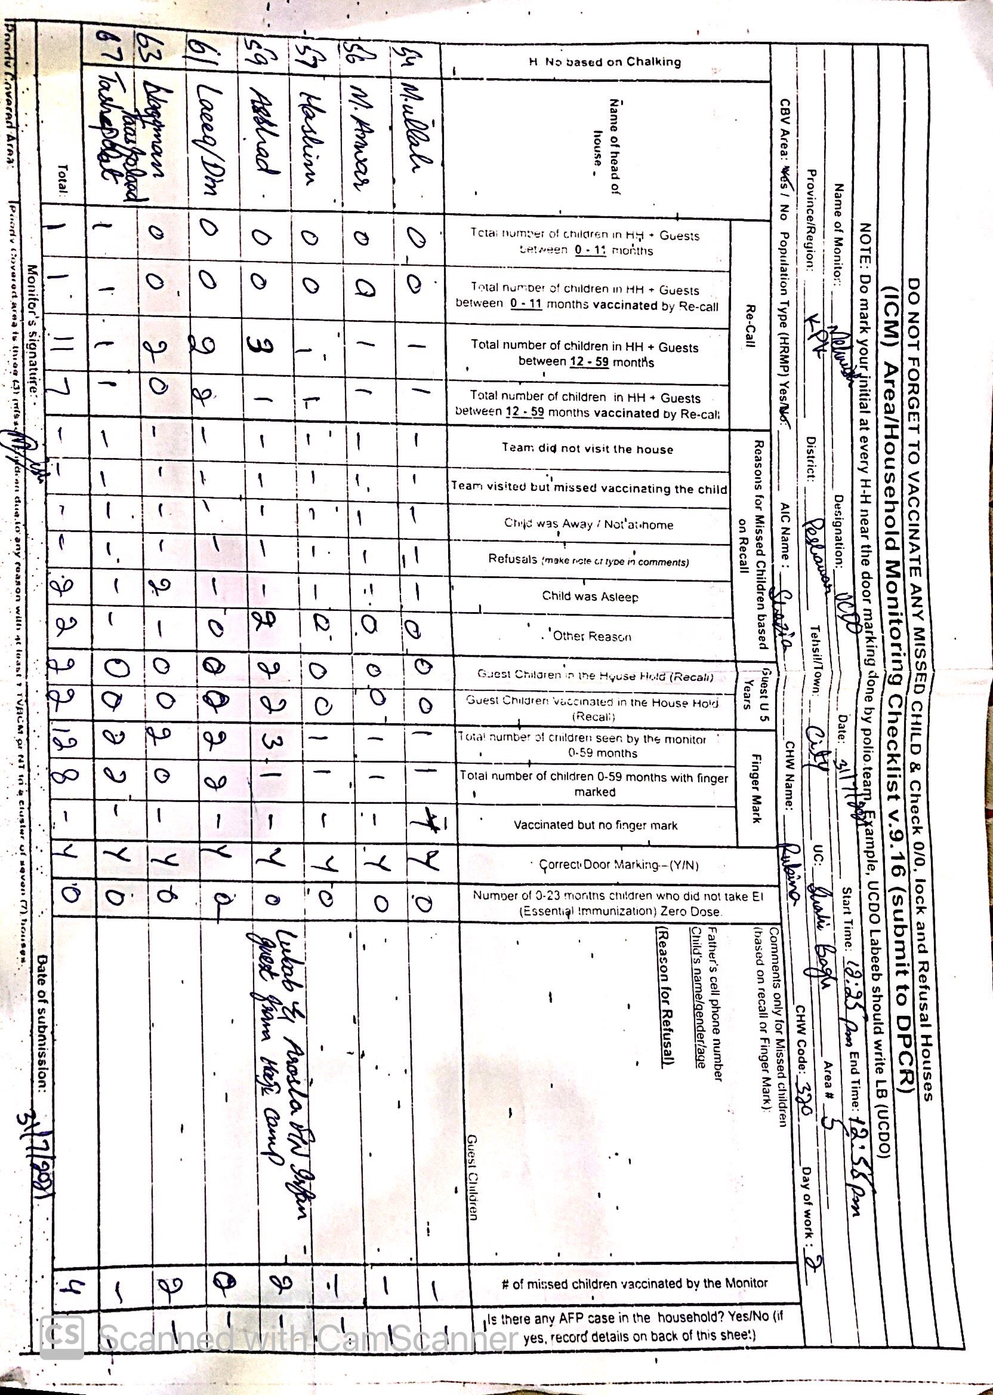

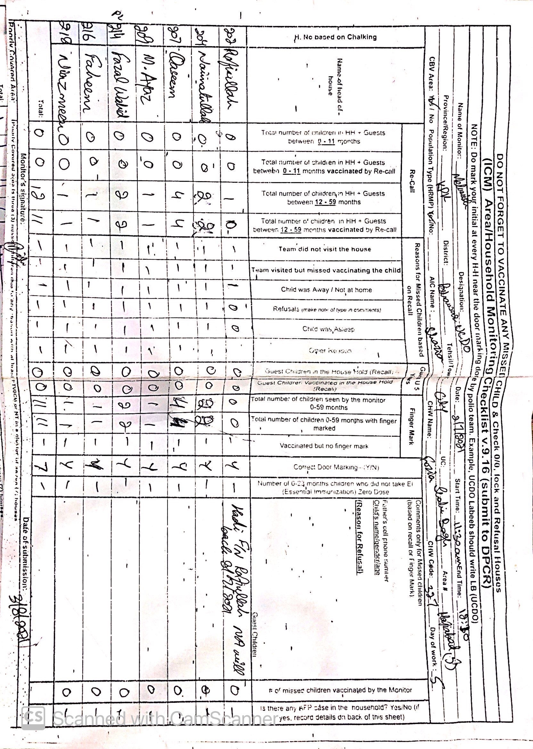

--

Bibi Zenib (TDOSO)  
City- Peshawar  
0300-0502523

--

Bibi Zenib (TDOSO)  
City- Peshawar  
0300-0502523