Dear Waseem,

With reference to below email, UCPO Mr. Zahoor Ahmed has not shared PTP coverage data in due time and it is affecting the whole district performance. This act shows his non serious attitude towards his job responsibilities. Moreover he has already received 3 warning letters within his service tenure with CTC.

Therefore it is recommended to issue him show cause notice to record his stance.

WHO PO approval is requested for aforementioned action.

|  |  |  |  |  |  |  |  |  |
| --- | --- | --- | --- | --- | --- | --- | --- | --- |
| S.No | Name | CNIC | Province | District | Tehsil | UC | Previous Disciplinery Action | Remarks |
| 1 | Zahoor Ahmed | 1210153834963 | KP | Wazir-S | Sararogha | Bangi wala | 01) 1st Warning on account of unapproved Absentees w.e.f 04 Sep-2019. 02)2nd Warning on account of unapproved Absentees w.e.f 10 Au-2021. 03) Final warning on account of unapproved Absentees w.e.f 23 Aug-2021. | Recommended for Showcase |

Regards:

**From:** ALAM, Sardar <[salam@who.int](mailto:salam@who.int)>   
**Sent:** Wednesday, October 6, 2021 12:34 AM  
**To:** SHAKEEL, Samiullah <[shakeels@who.int](mailto:shakeels@who.int)>; [awais@ctc.org.pk](mailto:awais@ctc.org.pk); RASHID, Mamoon <[mrashid@who.int](mailto:mrashid@who.int)>  
**Cc:** UR RASHEED, Haroon <[urh@who.int](mailto:urh@who.int)>; Inamu Gul <[gul.inamu@yahoo.com](mailto:gul.inamu@yahoo.com)>  
**Subject:** RE: SWTD: PTP Ahmad Wam data Pending Sep 2021

Dear Dr. Mamoon,

This shall be very clear to all Staff that sharing of PTP coverage data, on as required and when required basis, shall be strictly followed by the concerned PTP Supervisor and UCPO in whom UC its falling or to whom its been assigned by the supervisor.

Non sharing or non-compliance of concerned staff is affecting the district performance which is totally unacceptable.

Kind Regards,

*Dr. Sardar Alam*

*Area Coordinator, WHO*

*Office of The Commissioner DI Khan Division*

*Contact# +92-334-914-2143*

**From:** SHAKEEL, Samiullah <[shakeels@who.int](mailto:shakeels@who.int)>   
**Sent:** Tuesday, 5 October 2021 9:09 PM  
**To:** [awais@ctc.org.pk](mailto:awais@ctc.org.pk); RASHID, Mamoon <[mrashid@who.int](mailto:mrashid@who.int)>  
**Cc:** UR RASHEED, Haroon <[urh@who.int](mailto:urh@who.int)>; ALAM, Sardar <[salam@who.int](mailto:salam@who.int)>; Inamu Gul <[gul.inamu@yahoo.com](mailto:gul.inamu@yahoo.com)>  
**Subject:** Re: SWTD: PTP Ahmad Wam data Pending Sep 2021

Kind Reminder Please for action on subject matter please.  
  
Regards

**Mr Samiullah Shakeel**

**Program Data Assistant  PEI W.H.O**

**DPCR SWTD**



*( Acknowledge the email Kindly )*

**From:** SHAKEEL, Samiullah <[shakeels@who.int](mailto:shakeels@who.int)>  
**Sent:** Monday, October 4, 2021 4:09 PM  
**To:** [awais@ctc.org.pk](mailto:awais@ctc.org.pk) <[awais@ctc.org.pk](mailto:awais@ctc.org.pk)>; RASHID, Mamoon <[mrashid@who.int](mailto:mrashid@who.int)>  
**Cc:** UR RASHEED, Haroon <[urh@who.int](mailto:urh@who.int)>; ALAM, Sardar <[salam@who.int](mailto:salam@who.int)>; Inamu Gul <[gul.inamu@yahoo.com](mailto:gul.inamu@yahoo.com)>  
**Subject:** Re: SWTD: PTP Ahmad Wam data Pending Sep 2021

No response is Shared, Dear Seniors it is Recommended for standard operation procedure in such situation is requested.  
  
Regards

**Mr Samiullah Shakeel**

**Program Data Assistant  PEI W.H.O**

**DPCR SWTD**



*( Acknowledge the email Kindly )*

**From:** SHAKEEL, Samiullah <[shakeels@who.int](mailto:shakeels@who.int)>  
**Sent:** Friday, October 1, 2021 5:23 PM  
**To:** Zahoor Ahmad (via Google Sheets) <[zahooorahmad22@gmail.com](mailto:zahooorahmad22@gmail.com)>  
**Cc:** [awais@ctc.org.pk](mailto:awais@ctc.org.pk) <[awais@ctc.org.pk](mailto:awais@ctc.org.pk)>; UR RASHEED, Haroon <[urh@who.int](mailto:urh@who.int)>; RASHID, Mamoon <[mrashid@who.int](mailto:mrashid@who.int)>; ALAM, Sardar <[salam@who.int](mailto:salam@who.int)>; Inamu Gul <[gul.inamu@yahoo.com](mailto:gul.inamu@yahoo.com)>  
**Subject:** Fw: SWTD: PTP Ahmad Wam data Pending Sep 2021

Dear Zahoor,  
  
You Are requested to explain your position with in 2 days by replying to all .  
  
Regards

**Mr Samiullah Shakeel**

**Program Data Assistant  PEI W.H.O**

**DPCR SWTD**



*( Acknowledge the email Kindly )*

**From:** RASHID, Mamoon <[mrashid@who.int](mailto:mrashid@who.int)>  
**Sent:** Friday, October 1, 2021 5:07 PM  
**To:** SHAKEEL, Samiullah <[shakeels@who.int](mailto:shakeels@who.int)>  
**Cc:** ALAM, Sardar <[salam@who.int](mailto:salam@who.int)>  
**Subject:** Re: SWTD: PTP Ahmad Wam data Pending Sep 2021

Dear Sami,

Thanks for the information.

Please ask for an explaination from Mr Zahoor UCPO to clear his position within 2 days.

Regards,

I.O SWTD

Get [Outlook for Android](https://aka.ms/AAb9ysg)

**From:** SHAKEEL, Samiullah <[shakeels@who.int](mailto:shakeels@who.int)>  
**Sent:** Friday, October 1, 2021 2:22:40 PM  
**To:** RASHID, Mamoon <[mrashid@who.int](mailto:mrashid@who.int)>  
**Cc:** ALAM, Sardar <[salam@who.int](mailto:salam@who.int)>  
**Subject:** SWTD: PTP Ahmad Wam data Pending Sep 2021

Dear Sir   
  
Mr Zahoor UCPO not Understanding the importance of matter beside several Attempts to motivate to share data on time. for your kind action please.  
  
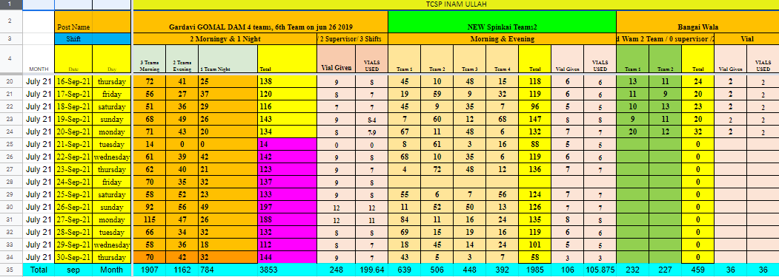  
Regards

**Mr Samiullah Shakeel**

**Program Data Assistant  PEI W.H.O**

**DPCR SWTD**



*( Acknowledge the email Kindly )*