Dear Zainab,

Below is the matter of UCPO Umair (Bhakkar). On the complaint of his AC Mr. Atiq CTC issued him explanation letter and in response UCPO explain his position. In the beginning Dr Atiq directly email to UCPO and call him for inquiry and explain his position. At that time I have emailed to Dr Atiq and explained about the CTC role/support in administrative and HR matter and CTC issued explanation letter to UCPO.

On UCPO Umair Response I have requested Dr Atiq for his comments. But he included UCPO in Email and again mentioned his decision in below email. Now further what we can do because as 3rd party we have to analyze the both parties and act accordingly.

It’s not complaint of anyone and understandable because they are attached each other for last 3-4 years. it’s just for your information because for smooth working we must have very good working relationship with each other and clear about the policy on which we all are agreed . I hope you will raise this at any suitable forum to avoid any further situation.

Regards,

Saqib Atta

Regional Co-ordinator Punjab

CHIP Training & Consulting (Pvt) Ltd.

Plot 1715, Street 5,  Jinnah Block New Shalimar Colony Multan

Cell: 0345-5009369

[www.ctc.org.pk](http://www.ctc.org.pk/)

**From:** atiq arshad [mailto:atiq922000@yahoo.com]   
**Sent:** Tuesday, April 23, 2019 7:12 PM  
**To:** karori1bk@gmail.com  
**Cc:** saqib@ctc.org.pk; asifnawaz01051981@gmail.com; Naveed Hussain Khan  
**Subject:** Fw: Reply of Explanation...

Dear Mr.Umair,

I am not satisfy with your statement regarding refuse to field work with Dr.Humayun Kazim. That’s zero tolerance.

On that day Dr.Asif Nawaz (PEO-Bhakkar), was on Sick Leave, you should supposed to be in office and You should facilitate the external surveyor.

This is warning to you next time strict action will take against you.

Regards

Dr. Atiq Arshad

AC-Sargodha

---------- Forwarded message ---------  
From: **Umair Karori** <[karori1bk@gmail.com](mailto:karori1bk@gmail.com)>  
Date: Thu, Apr 18, 2019 at 3:35 PM  
Subject: Reply of Explanation...  
To: <[saqib@ctc.org.pk](mailto:saqib@ctc.org.pk)>, atiq arshed <[atiq922000@gmail.com](mailto:atiq922000@gmail.com)>  
Cc: Dr. Asif PEO Nawaz <[asifnawaz01051981@gmail.com](mailto:asifnawaz01051981@gmail.com)>, Naveed Hussain Khan <[naveed.un2006@gmail.com](mailto:naveed.un2006@gmail.com)>

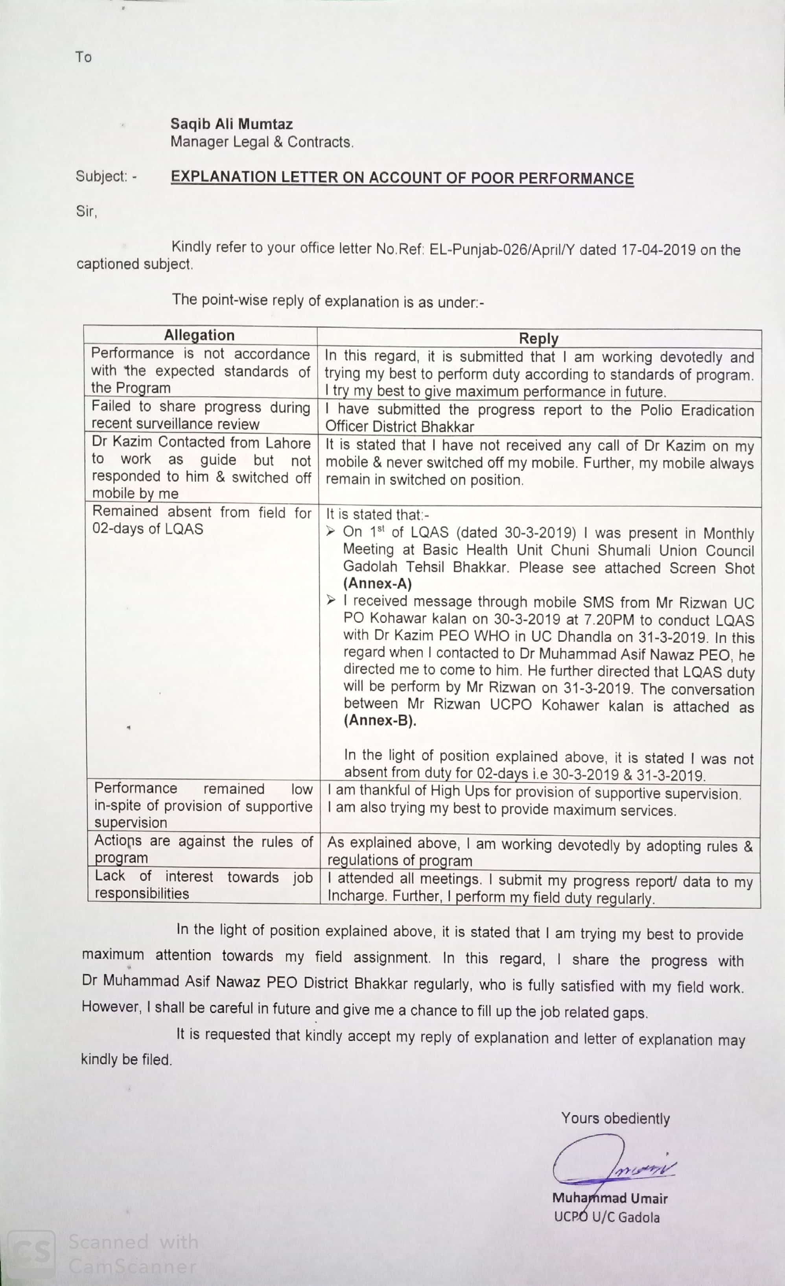

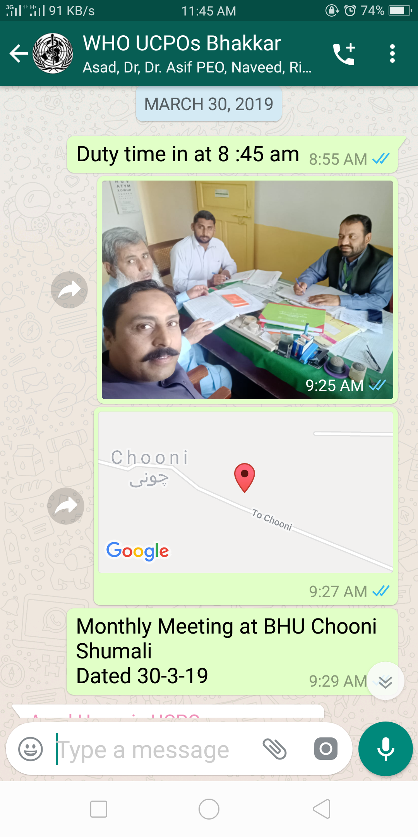

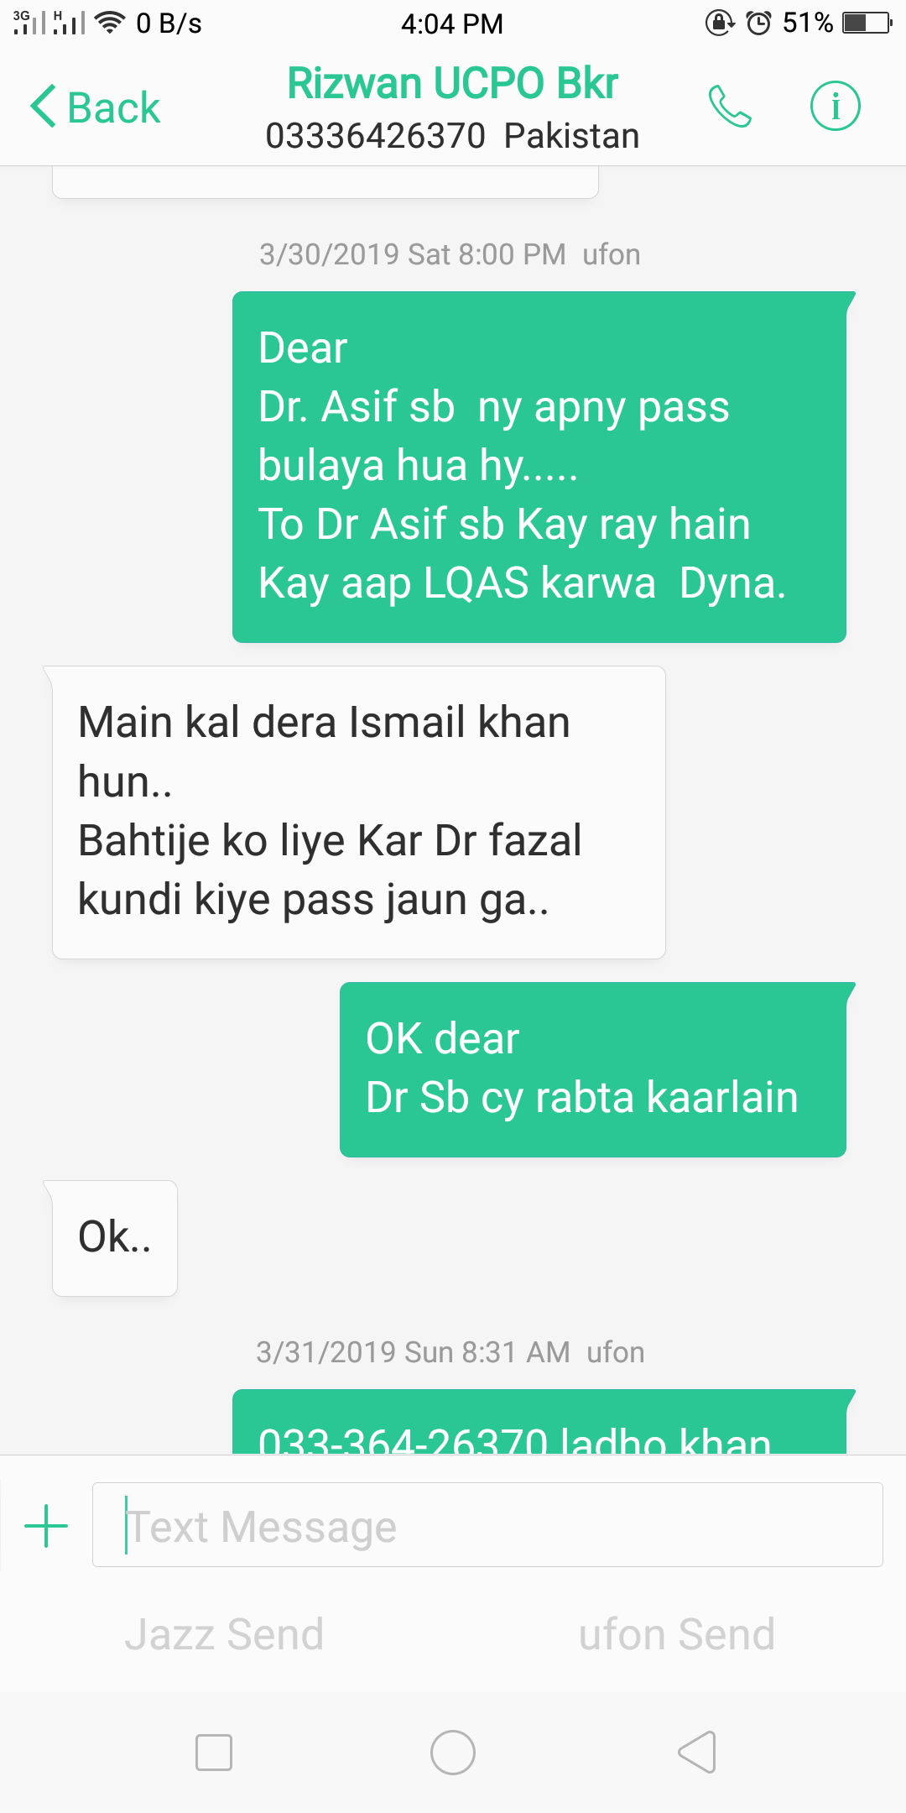

--

***Muhammad Umair***

***Karori***



