JUSTIFICATION of Performance Appraisal Disagreement

UBAID UR REHMAN UCPO MUZAFFERABAD-1

Landhi Town, Dist. Malir

**Justification of Disagreement of performance appraisal**

**Note:**

**I am going share screen shots with dates that has been taken from official group Landhi town where all UC Level staff sharing their activities on daily basis AND seen by town and district level supervisors.**

I am disagreeing this performance appraisal because I have worked day-night for the success of TCV and NID December-19 campaign specially in this transformation phase.By the Grace of Allah and support of EOC and DPCR with great team work we had been succeded with 92% coverage and submitted all the data to Data Support Center with out any failure.

The attached screen shots are the proves of them.We had Worked till **(1:29 am )** at baldia despensary for micro plan development first time on New formats in very short time frame for the completion.

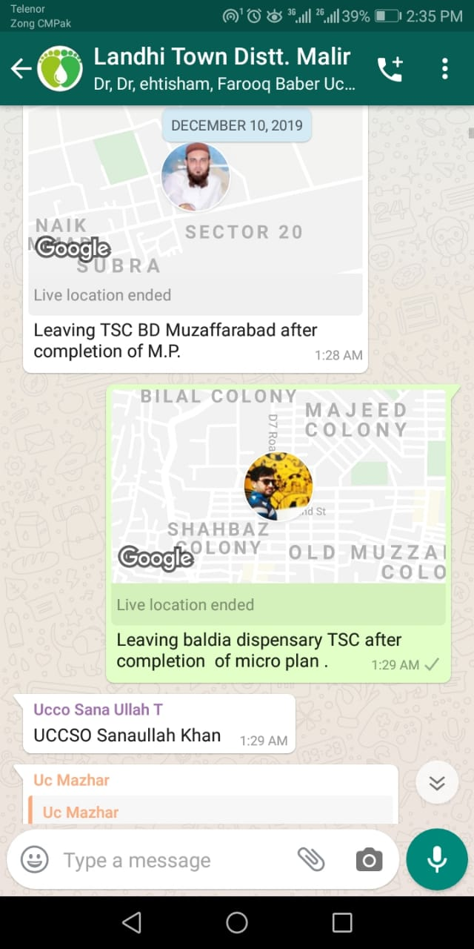

**Intra-Campaign Activities**

During Entra-Campaign we have done following activities:

* Morning Briefing and Teams Diployment
* Monitoring and Supervision
* Refusals Conversion Activity
* Refusals Madarsa and schools Conversion
* Taking Clusters
* Evening Meeting
* Data Collection and Compilation

After all these activities in day time we have done Special Refusal Conversion in Night under the directives of DPCR Malir till 10:10 pm. Screen shots of leaving time is given below:

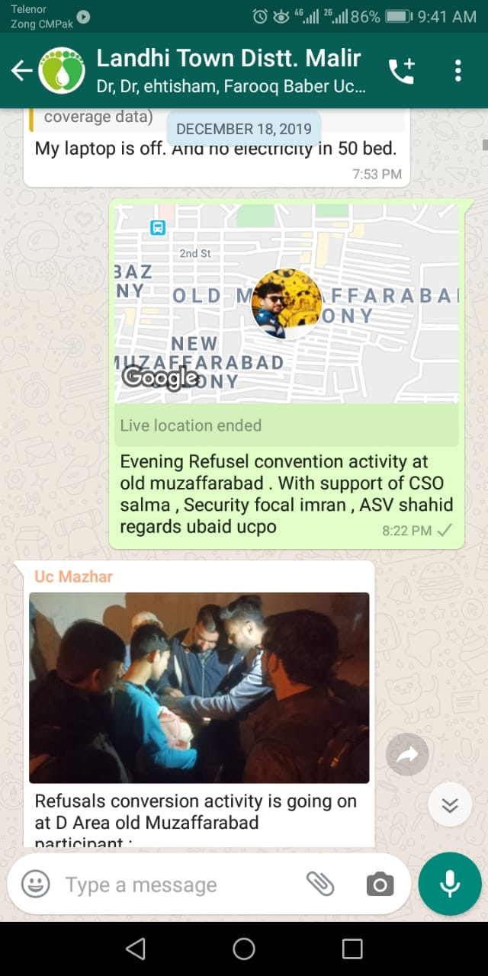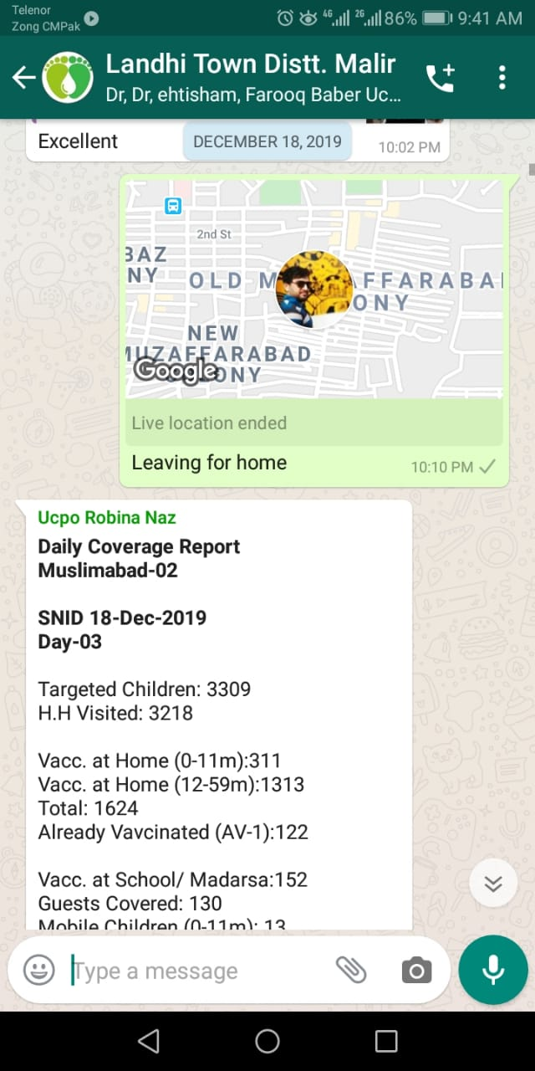

**Field Validation**

I have done field validation of Micro plane NID-Dec-2019 and submitted hard copy with Microplane to DPCR on dated of 11 December.

Note : During feild validation find following observation and also updated in Microplane.

1 ) ASV Shahid Team 24 day 3 first house owner name was not matching actual was abdul salam while in micro plan was Abdul Qayoom .

2 ) ASV Lubna Team no 39 day 1 first house owner actual name was Rafi ullah while in micro plan was written Ibrahim

Below is the screen shot and pictures:

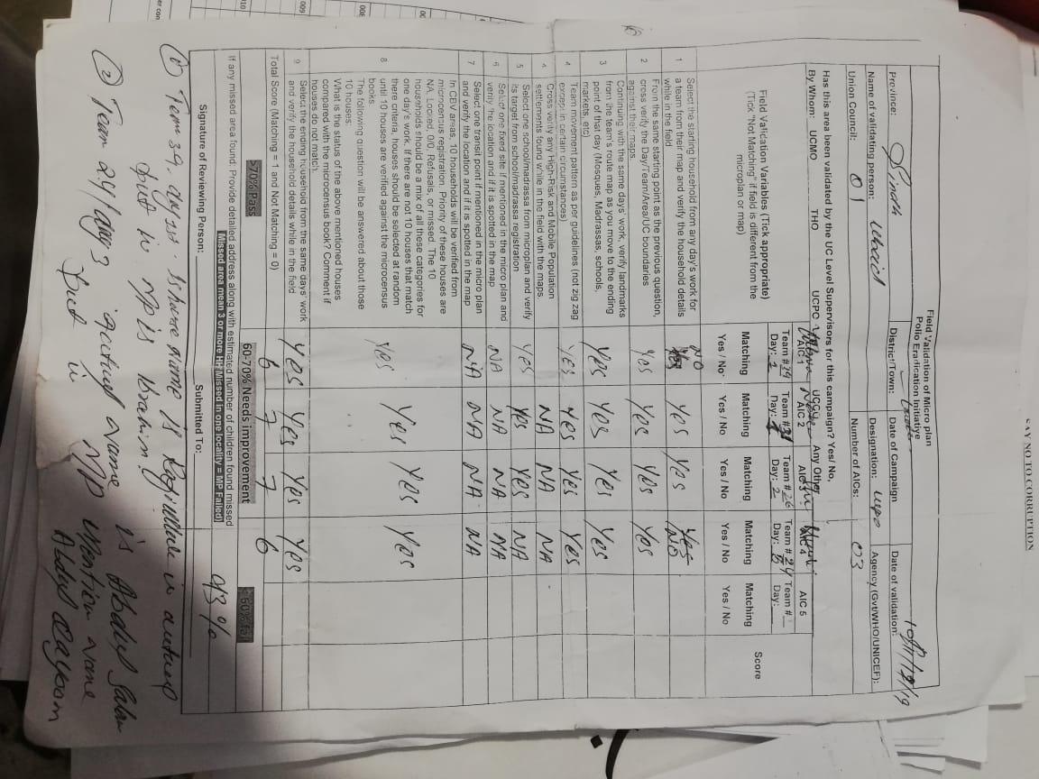

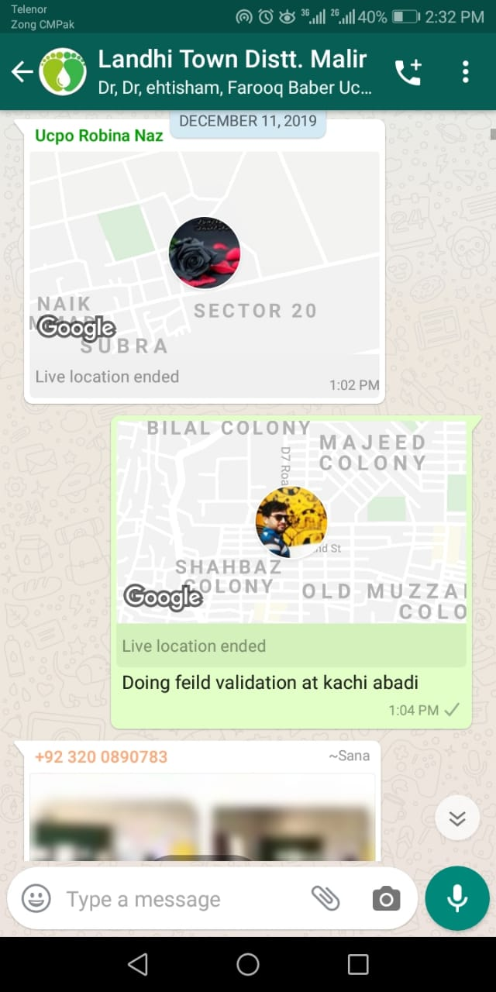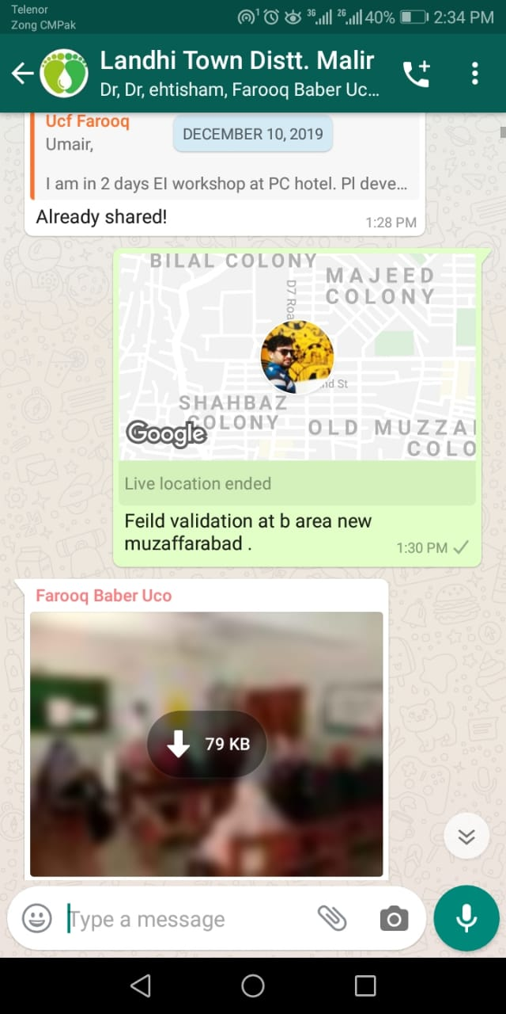

**Performance of Training Phase**

I am disagreeing the disatisfaction of my Supervisor about my performance during training because I had made many efforts in training phase. I have given training to ASVs and Vaccination teams on the topics which had been assigned to me by Master Trainer also given complete time. Screen Shots and Assigment of duties in training is given below:

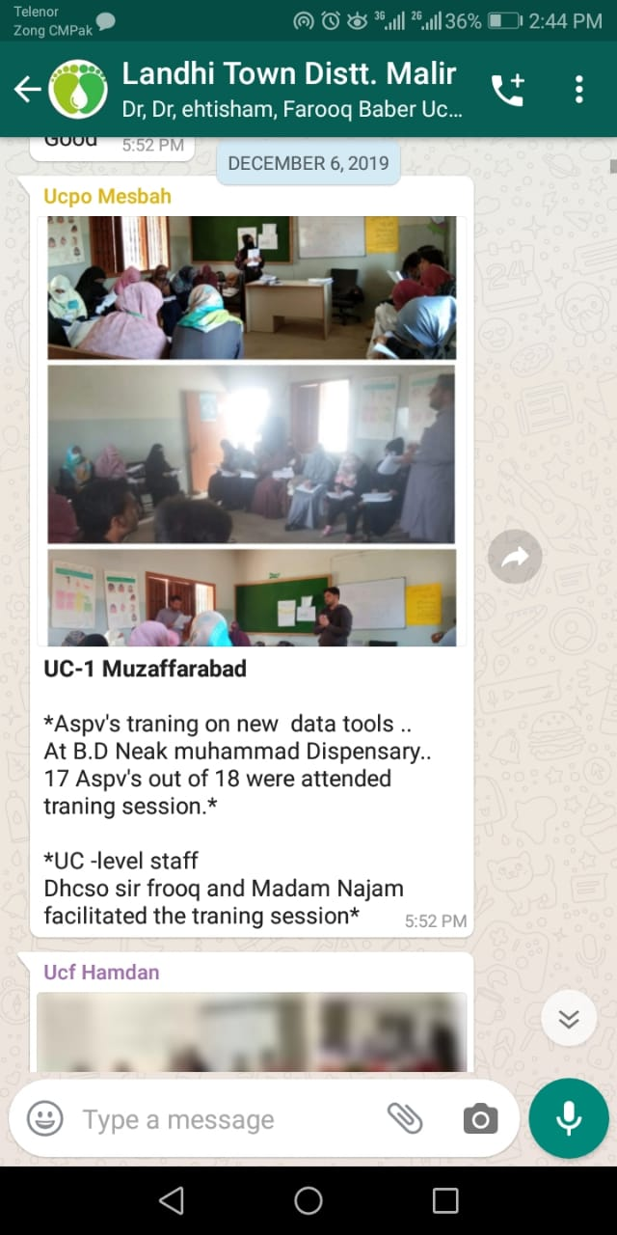

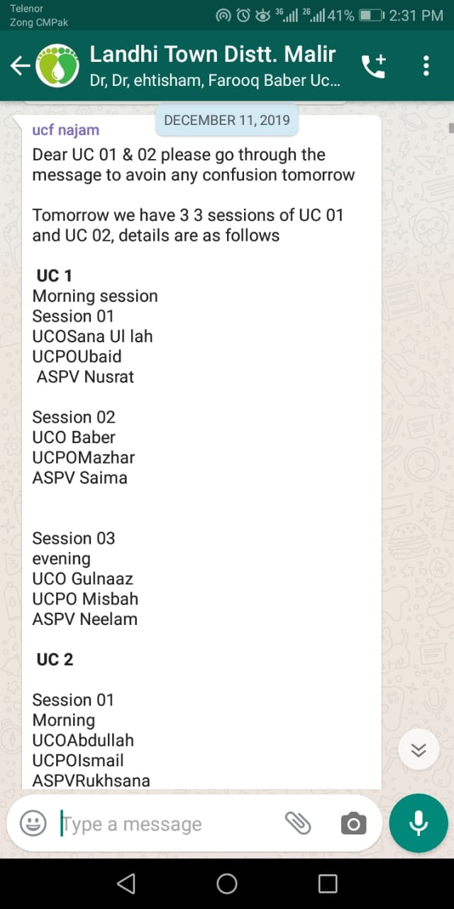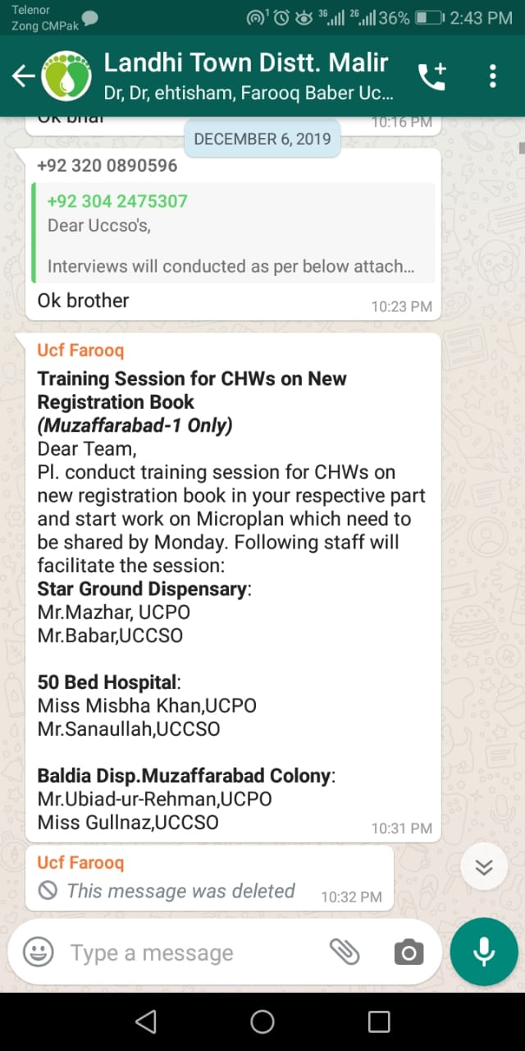

**Pre-Campaign Data Collection and Collation**

I have collected all the data related to Microplane in precampain from ASVs of Baldi Dispecery Muzaferabad. Also validated all schools/Madarsas target validation and compilation in online sheets, which has been shared to concern next level Supervisor on time.

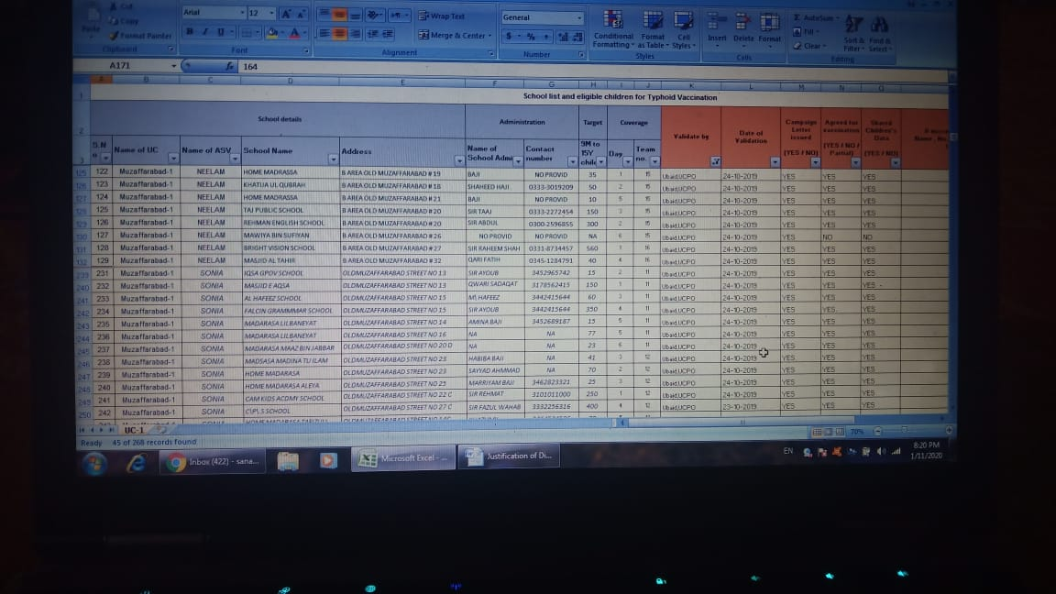

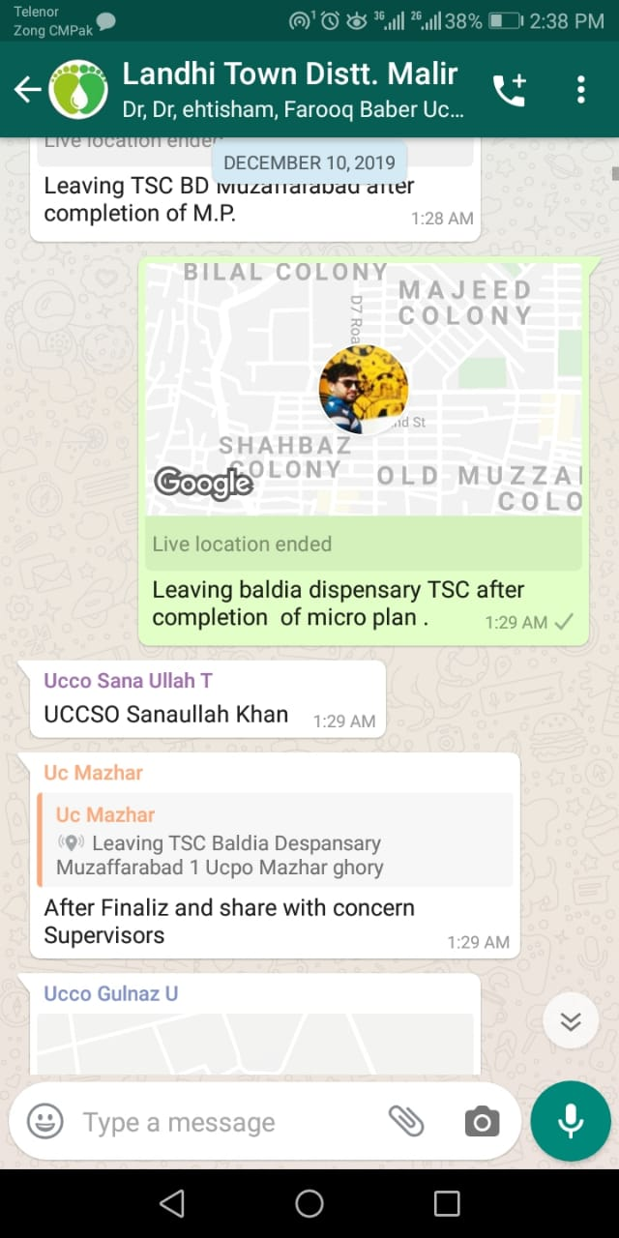

**Data collcetion During Campaign**

During campaign TCV NOV-2019 and NID Dec-2019 I had collected data and submitted in online sheet timely. Even all data has been submitted timely and successfuly without any failure still i would improve it further. Given below are the screen shots:

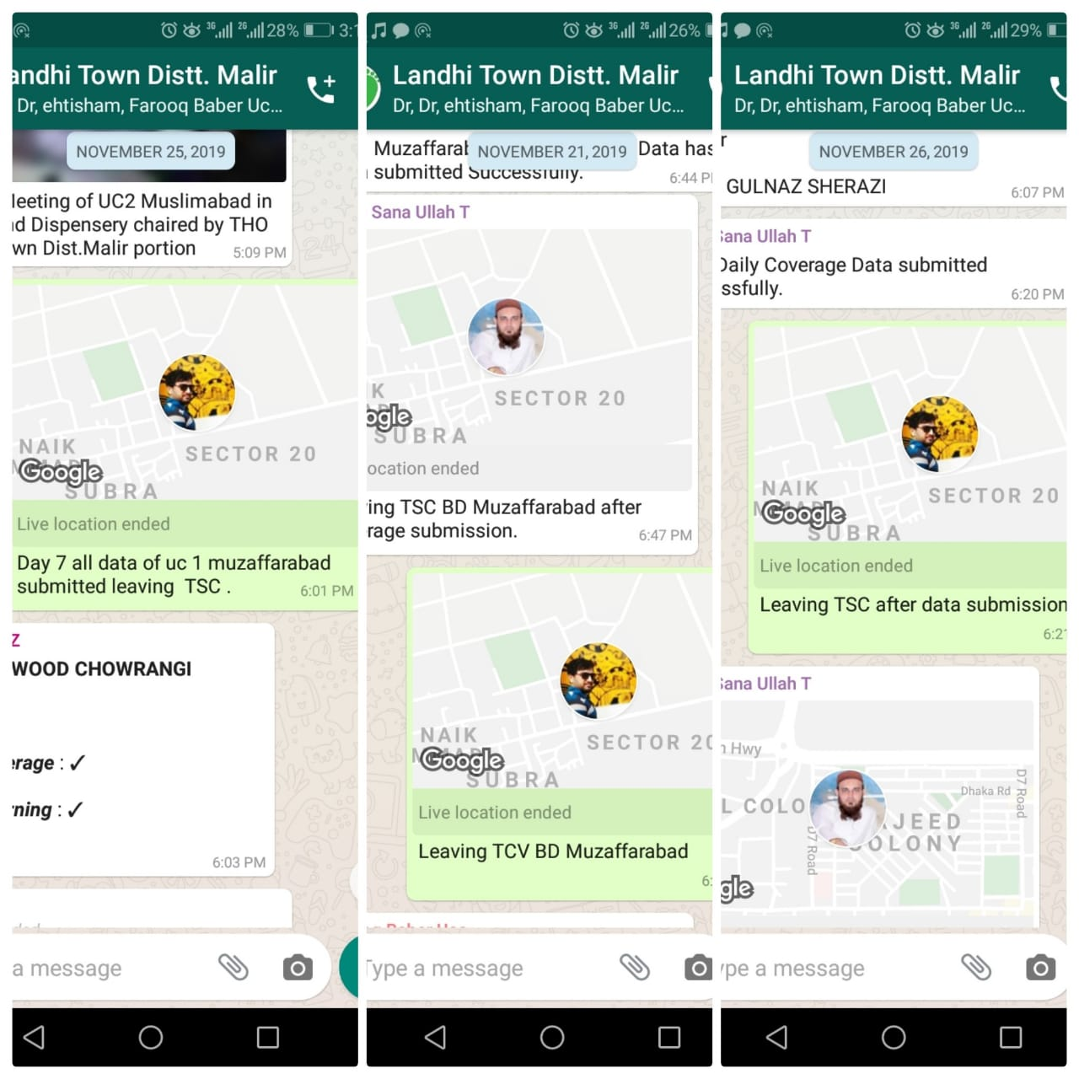

**Corrective Measures following Gap Identification**

I had Checked the HH Registration books found many gaps then identified to concern ASVs for corrrections.

Gaps Included:

* Zerodose coverage status was not as per given guaidlines.
* Ages were not updated
* Teams Maps were not updated

**Social Moblization**

In pre Campaign phase I have supported in Social Mobilization Activities Including

Doctors Meeting, School and Madarsa sessions, Influencers Meeting and engegment, Polio and TCV campaign Awareness walk. Banners Hanging and Religious Personalities meetings etc. Pictures are given below:

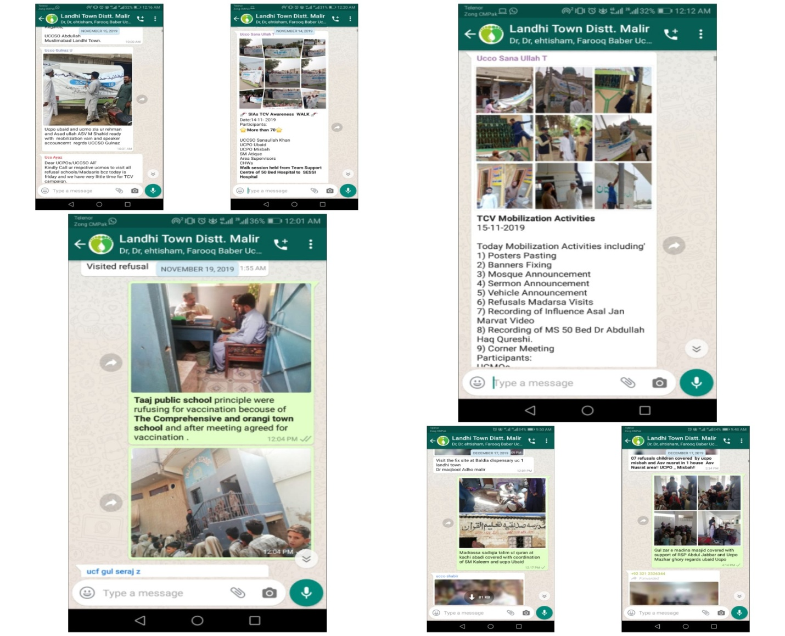

**Refusel Conversion activity**

During Campaign I had actively participated in Refusals conversion activities Day and Night Time. Pictures are given below:

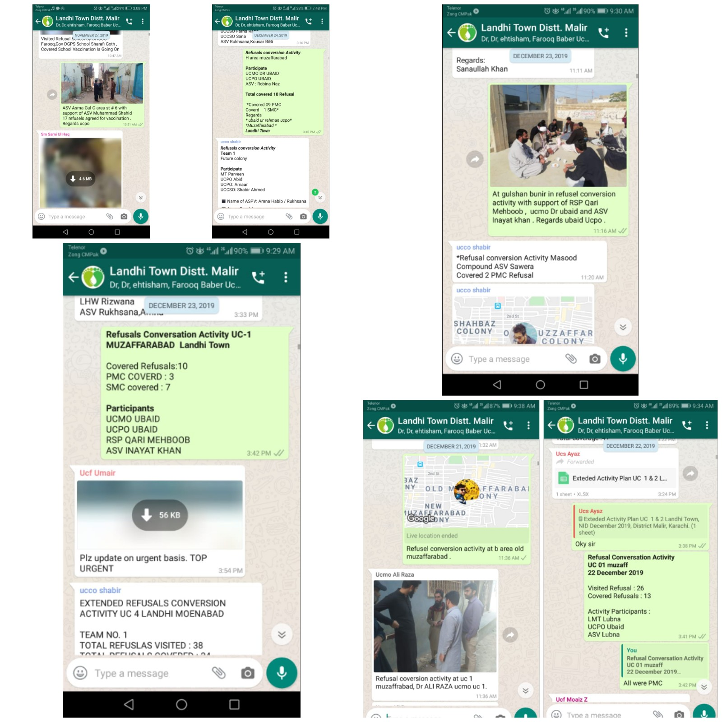

**Facilitation**

During campaign i had facilitated externel monitors. Pictures are given below:

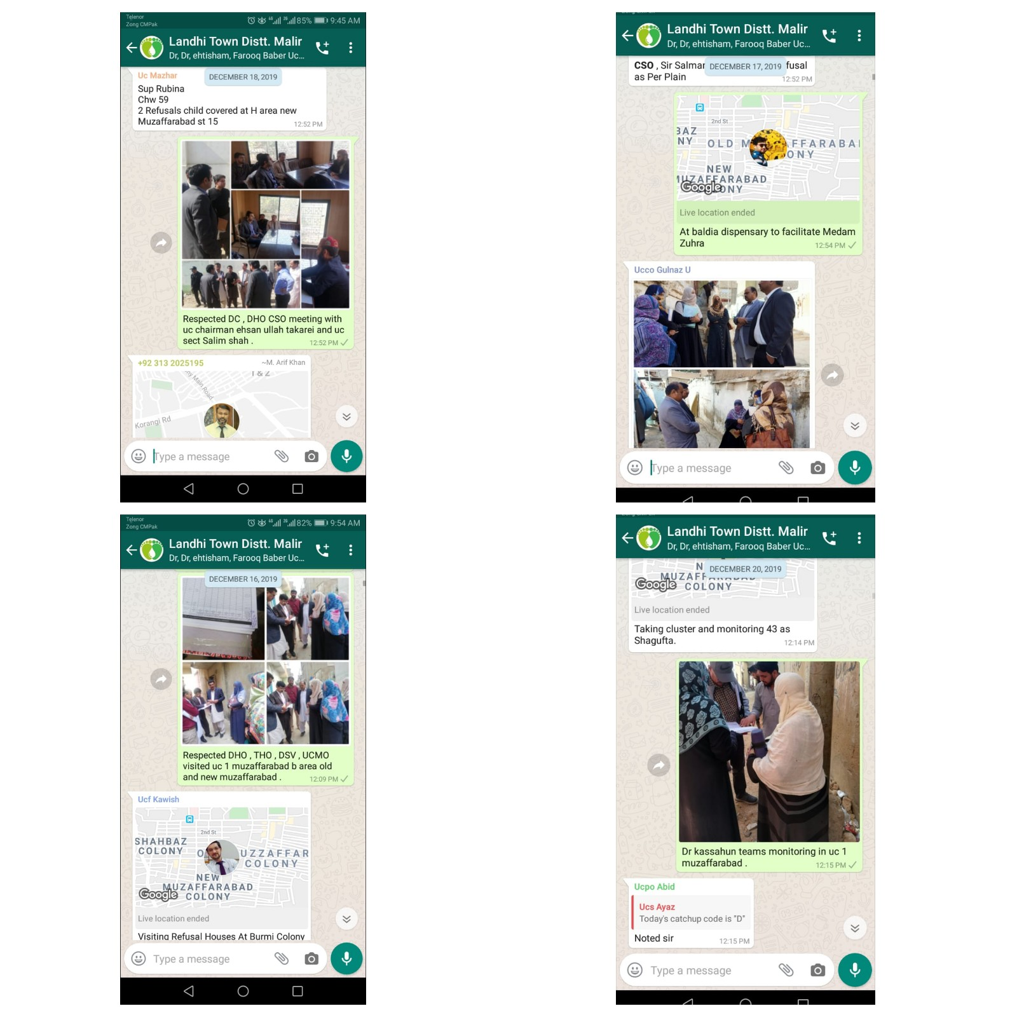

**Weekly Reports**

I have performed many other tasks given to me by concerns. Which has been shared on Google online sheet in weekly reports every week. Which can be seen in online sheet.