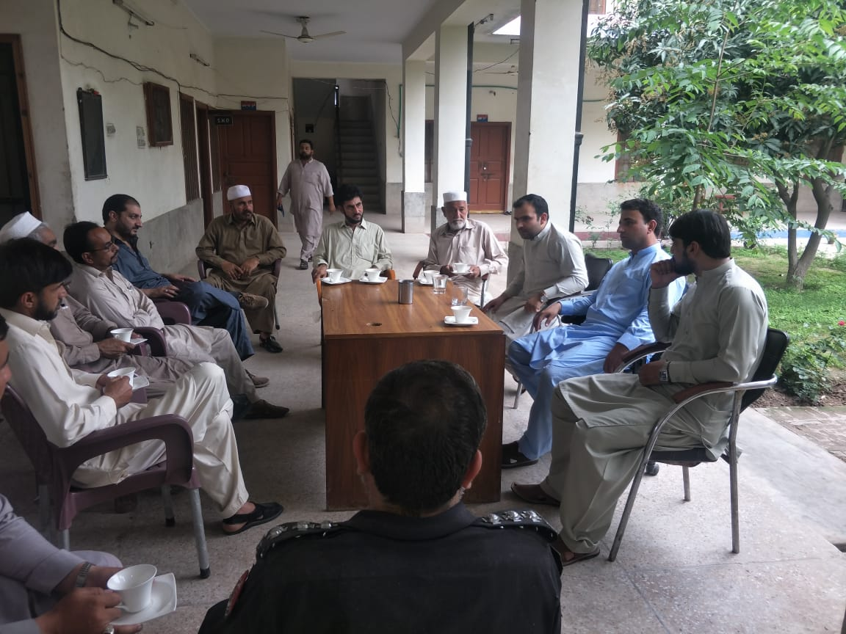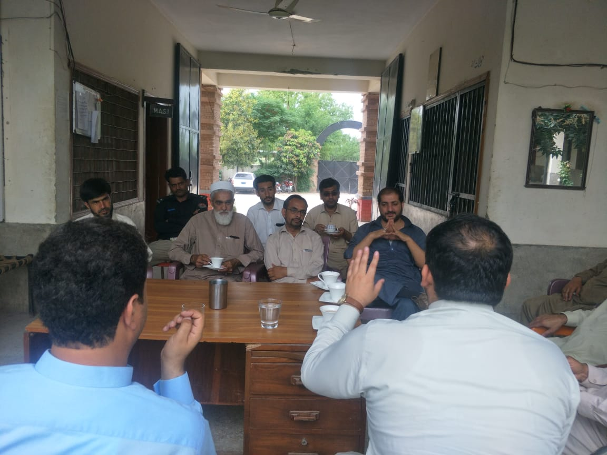 **Annex-5.**

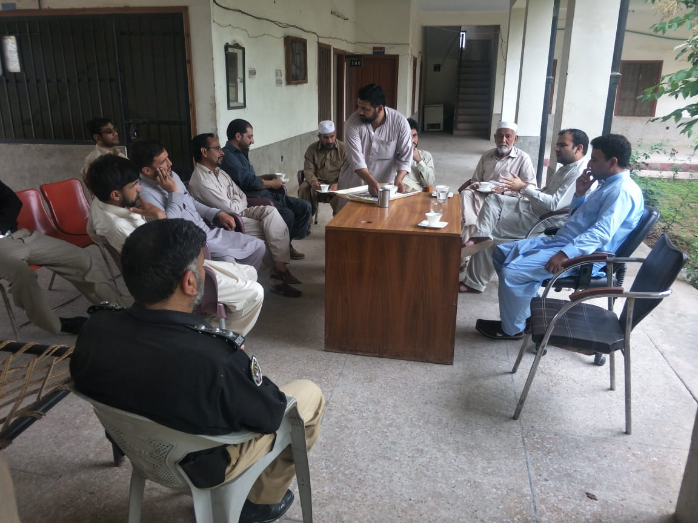Meeting between Assistant Commissioner Peshawar and Elected Members at Police station Regi dated 23rd April 2019.