SECTION 1: APPLICANT’S DETAILS
Employee Name | Iftikhar Khan
Designation | UCPO
CNIC No. | 17201-1056755-9
District/UC | Nowshera UC Pirsabaq
Leave application date | 07 oct, 11 oct, 17 oct, 23 oct, 2019

SECTION 2: DETAILS OF LEAVE
 | Reason of Leave Applied for (Tick in appropriate box)
 |  |  | Hajj |  |  |  |  | Umrah/Ziarat
 |  |  | Chillah, Tableegh, Ehtikaf |  |  |  |  | Christmas, Diwali
 | √ |  | Study/Exams |  |  |  |  | Maternity
 |  |  | Family Wedding |  |  |  |  | Self-Wedding
 |  |  | Immediate Family Death |  |  |  |  | Self-Sick Leave
 |  |  | Immediate Family-Sick Leave |  |  |  |  | Accident/Sickness-while at work
 |  |  | Accident/Sickness-while not at work |  |  |  |  | Emergency Leave
 |  |  | Vacations |  |  |  |  | Others
Number of Days Leave Applied for : 04
Leave start date: 07 Oct 2019 |  |  |  |  | Leave end date: 23 October 2019
OIC Name and designation:

Hameed Ullah (PEO Nowshera)

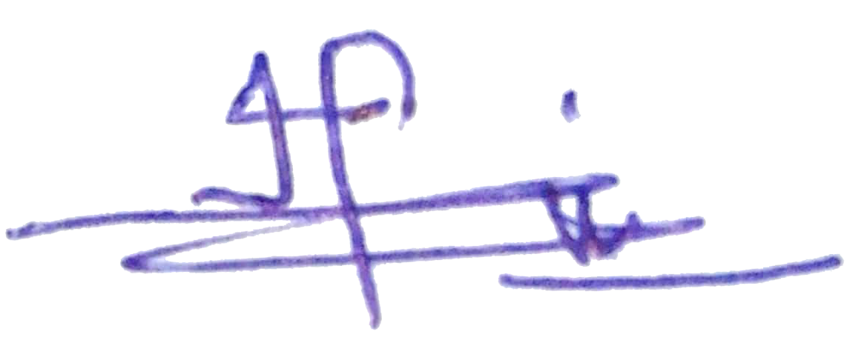  Employee signature:______________________________ |  |  |  |  |  |  |  |  | Date:__4-10-2019__________
PEO endorsement:___________________________________ |  |  |  |  |  |  |  |  | Date:____________________
PTL endorsement:__________________________________  For more than Two weeks |  |  |  |  |  |  |  |  | Date:____________________
CTC final approval:_________________________________ |  |  |  |  |  |  |  |  | Date:____________________

CTC Remarks, if any _________________________________________________________

NOTE: Leaves during campaign days are NOT allowed

