SECTION 1: APPLICANT’S DETAILS
Employee Name | Shaheen Shah
Designation | UCPO
CNIC No. | 17102-1147135-9
District/UC | UC Harichand Tesil Tangi District Charsadda
Leave application date | 11/02/2020

SECTION 2: DETAILS OF LEAVE
 | Reason of Leave Applied for (Tick in appropriate box)
 |  |  | Hajj |  |  |  |  | Umrah/Ziarat
 |  |  | Chillah, Tableegh, Ehtikaf |  |  |  |  | Christmas, Diwali
 |  |  | Study/Exams |  |  |  |  | Maternity
 |  |  | Family Wedding |  |  |  |  | Self-Wedding
 |  |  | Immediate Family Death |  |  | √ |  | Self-Sick Leave
 |  |  | Immediate Family-Sick Leave |  |  |  |  | Accident/Sickness-while at work
 |  |  | Accident/Sickness-while not at work |  |  |  |  | Emergency Leave
 |  |  | Vacations |  |  |  |  | Others(Brother is Coming from Hajj)
Number of Days Leave Applied for: 4
Leave start date: 11/02/2020 |  |  |  |  | Leave end date: 11/02/2020
OIC Name and designation: Dr Kamran Kamal PEO
Employee signature : 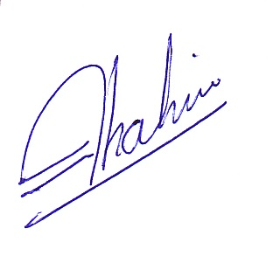 |  |  |  |  |  |  |  |  | Date: 11/02/2020
PEO endorsement:___________________________________ |  |  |  |  |  |  |  |  | Date:____________________
PTL endorsement:__________________________________  For more than Two weeks |  |  |  |  |  |  |  |  | Date:____________________
CTC final approval:_________________________________ |  |  |  |  |  |  |  |  | Date:____________________

CTC Remarks, if any _________________________________________________________

NOTE: Leaves during campaign days are NOT allowed

