|  |  |
| --- | --- |
| **SECTION 1: APPLICANT’S DETAILS** | |
| Employee Name | M.Aamir Masood |
| Designation | UCPO |
| CNIC No. | 3530257330993 |
| District/UC | Lahore/ |
| Leave application date | 20/2/2021 |

|  |  |  |  |  |  |  |  |  |  |  |  |  |
| --- | --- | --- | --- | --- | --- | --- | --- | --- | --- | --- | --- | --- |
|  | | **SECTION 2: DETAILS OF LEAVE** | | | | | | | | | | |
|  |  | | | Reason of Leave Applied for (Tick in appropriate box) | | | | | | | | |
|  |  | |  | | Hajj |  |  | |  |  | Umrah/Ziarat | |
|  | |  | | | | | | | | | | |
|  |  | |  | | Chillah, Tableegh, Ehtikaf |  |  | |  |  | Christmas, Diwali | |
|  | |  | | | | | | | | | | |
|  |  | |  | | Study/Exams |  |  | |  |  | Maternity | |
|  | |  | | | | | | | | | | |
|  |  | |  | | **Family wedding** |  |  | |  |  | Self-Wedding | |
|  | |  | | | | | | | | | | |
|  |  | |  | | Immediate Family Death |  |  | |  |  | Self-Sick Leave | |
|  | |  | | | | | | | | | | |
|  |  | |  | | Immediate Family-Sick Leave |  |  | |  |  | Accident/Sickness-while at work | |
|  | |  | | | | | | | | | | |
|  |  | |  | | Accident/Sickness-while not at work |  |  | |  |  | Emergency Leave | |
|  | |  | | | | | | | | | | |
|  |  | |  | | Vacations |  |  | |  |  | Others | |
|  | |  | | | | | | | | | | |
|  | | Number of Days Leave Applied for: 1 | | | | | | | | | | |
|  | | Leave start date: 20/2/2021 | | | | | | Leave end date:20/2/2021 | | | | |
|  | | OIC Name and designation:  Khurram Shahzad | | | | | | | | | | |
|  | |
|  | |
|  | |
|  | | Employee signature M.Aamir | | | | | | | | | | Date: 20/2/2021 |
|  | | PEO endorsement:___________________________________ | | | | | | | | | | Date:____________________ |
|  | | PTL endorsement:__________________________________  For more than Two weeks | | | | | | | | | | Date:____________________ |
|  | | CTC final approval:_________________________________ | | | | | | | | | | Date:____________________ |

CTC Remarks, if any _________________________________________________________

**NOTE: Leaves durin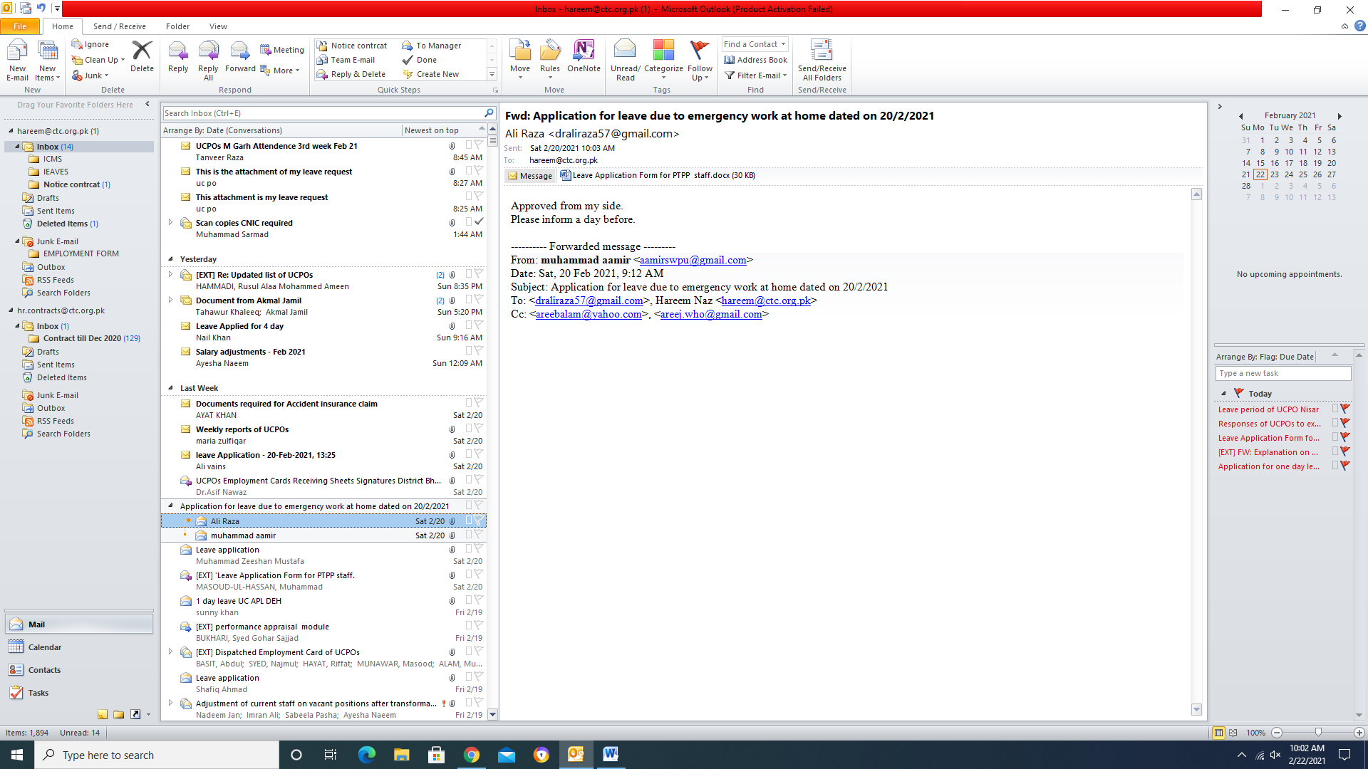 campaign days are NOT allowed**