The top Cosmetic science, Fragrance and Personal Care conferences to attend

**March**

**SOCMA / Specialty & Custom Chemicals America**

**Texas, USA**

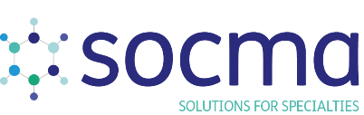

Omni Fort Worth Hotel will host the Specialty & Custom Chemicals Show from the 28th of February to the 3rd March. Many experts and industry leaders all across the globe will participate in the chemical’s commercial growth.

The event will require the physical appearance of the representatives of the food, fuel, cosmetics, and other 33 industries. The conference will be an amazing platform to explore products and technologies from these markets.

**Website:** [SOCMA](https://texas.chemicalsamerica.com/event-details/event-format-dates-times-tx)

**ACS Bonding Through Chemistry Spring 2022**

**California, USA**

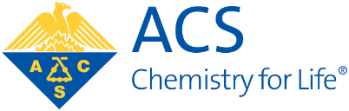

From 20th to 24th March, The American Chemical Society (ACS) Spring 2022 will meet under the name Bonding Through Chemistry. The five-day event will allow in-person and virtual appearance in San Diego Convention Center.

It will be an amazing event for chemical and toxicology researchers. The topics will be biochemical technology, energy, fuels, inorganic chemistry, and much more. There will be 37 different programs to share ideas and thoughts on particular topics.

**Website:** [ACS Spring 2022](https://www.acs.org/content/acs/en/meetings/acs-meetings/registration/why-attend.html)

**SOT (Exposure science)**

**California, USA**

SOT (Exposure science)

With 6000+ attendees, San Diego will host the 61st Annual Meeting and ToxExpo. The SOT annual conference will hold 70 scientific sessions in 5 days, from 27th to 31st March.

Moreover, the conference will have 250 exhibitors participating in more than 60 social activities. Hence, it will be amazing to learn from the scientific sessions of toxicology.

**Website:** [Society of Toxicology](https://www.toxicology.org/events/am/AM2022/index.asp)

May

**SETAC 32nd Annual Meeting (Exposure)**

**Copenhagen, Denmark**

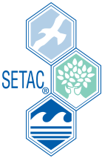

The SETAC 32nd Annual Meeting will be held from 15th to 19th May of this year. It will take place in Bella Centre Copenhagen. This five-day conference is both online and physical.

Furthermore, there will be 94 scientific sessions divided into 7 tracks. The event is beneficial for those seeking scientific advancements in Europe and thriving for innovation.

**Website:** [SETAC](https://europe2022.setac.org/)

**NonTarget Analysis for Environmental Risk Assessment Meeting (Exposure, SETAC)**

**North Carolina, USA**



Another SETAC meeting will be held from 22-26 May, on the environmental topic. Durham Convention Center will host the 2022 NonTarget Analysis for Environmental Risk Assessment. The meeting will be in-person.

The conference’s main objective is to connect chemical analysis experts and environmental chemists. So, it will be amazing for those concerned about the ever-degrading Earth’s atmosphere.

**Website:** [NonTarget 2022](https://nta.setac.org/register" \t "_blank)

June

**Bio Annual Meeting (Exposure)**

**California, USA**

BIO International Convention

The BIO International Convention will occur in the San Diego Convention Center from June 13th to 16th. The convention’s theme is “Limitless,” which will surely attract many researchers and leaders from the biotechnological industry.

Moreover, there will be more than 15000 biotechnology researchers and pharma leaders making new opportunities and sharing ideas. They will cover topics like drugs, biomanufacturing, biofuels, nanotechnology, and cell therapy.

**Website:** [BIO Annual Meeting](https://www.bio.org/events/bio-international-convention/registration)

**Cosmetics Europe Annual Conference 2022**

**Brussels, Belgium**

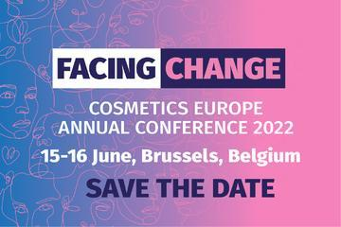

This event will be for those people who are always seeking skincare tips. Organizing on the 15th and 16th of June, the Cosmetics Europe Annual Conference 2022 will attract many industry leaders. The theme of the conference is “Facing Change.”

It will be a great platform to engage with skincare experts, policymakers, and stakeholders. There will be topics like the [necessity of cosmetics, animal testing alternatives](https://www.cremeglobal.com/cosmetics-fragrances/), and digital consumers’ information.

**Website:** [Cosmetics Europe](https://cosmeticseurope.eu/news-events/save-date-cosmetics-europe-annual-conference-2022)

July

**ACS Fall 2022 National Meeting & Exposition (Exposure)**

**Illinois, USA**



The American Chemical Society (ACS) conference will be held from August 21st-25th, 2022. The main theme of the meeting is “Sustainability in a Changing World,” where many chemists will participate. The meeting is hybrid (online as well as in-person).

The conference will open an opportunity for professionals to share their findings and advanced research. Also, it will be a great platform for new chemists to learn and explore different advanced techniques.

**Website:** [ACS Fall 2022](https://www.acs.org/content/acs/en/meetings/acs-meetings/abstract-submission/call-for-abstracts.html)

**September**

**IUTOX XVIth International Congress of Toxicology (ICT) 2022 (Exposure)**

**Maastricht, Netherlands**

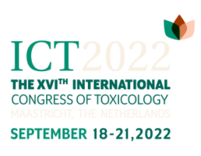

The XVIth ICT 2022 will take place from 18th-21st September. The International Union of Toxicology (IUTOX) and the European Union of Toxicology (EUROTOX) are collectively arranging this congress in Maastricht Exhibition & Conference Centre (MECC).

The theme of the congress is “Uniting in Toxicology.” So, it would be an excellent event to meet the best toxicological researchers and scientists. Additionally, the program will be categorized into 32 sessions.

**Website:** [XVIth ICT 2022](https://www.ict2022.com/" \t "_blank)

**ISES 2022 (Exposure)**

**Lisbon, Portugal**

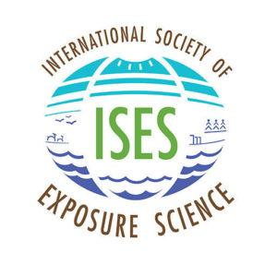

The International Society of Exposure Science will hold its 2022 Annual Meeting from September 25-29th. It will discuss various multidisciplinary issues and policies.

The discussion panel will share their point of view to understand the environmental health complexities. Also, it will be a fabulous source of information about the environmental exposure sciences and related fields.

**Website:** [ISES 2022](https://intlexposurescience.org/event/2022-meeting)

October

**The Global Produce & Floral Show**

**Florida, USA**

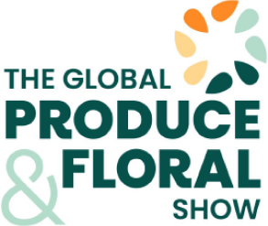

It is a conference and a floral show that will connect many producers and floral industry experts, food safety professionals, and retail buyers. The three-day event from 27-29 October will also attract importers and exporters from all over the world.

Orange County Convention Center will host this fragrant event where everyone has an opportunity to exhibit, sponsor, or advertise. It will be a fantastic platform to get the eyes of experts to grow business.

**Website:** [Global Floral Show](https://www.freshproduce.com/events/the-global-produce-and-floral-show)

China International Food Safety & Quality (CIFSQ) Conference

Sheraton Grand Shanghai Pudong Hotel | China

[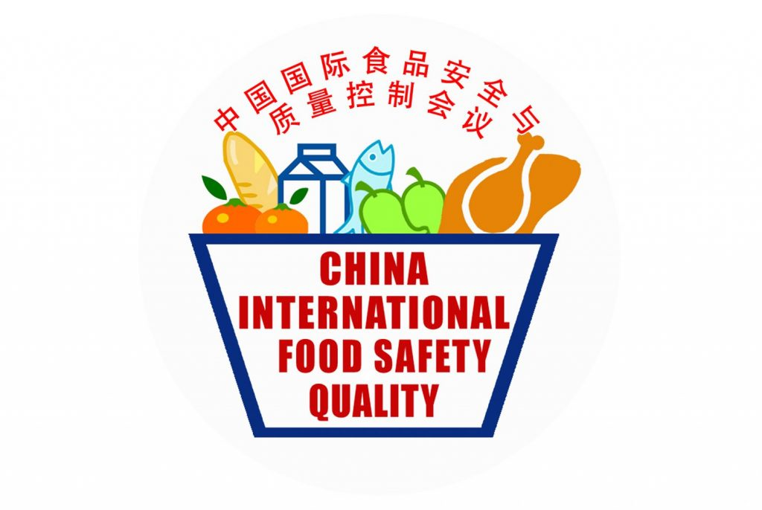](http://www.chinafoodsafety.com/)

From October 26 – 27, 2022 the China International Food Safety & Quality (CIFSQ) Conference brings a passionate community of global experts together to address critical issues and identify recent advances in science, intelligent technologies, and effective best practices that can make a difference towards improving food safety. At the upcoming event in Shanghai, up to 600 regulators, scientists, industry executives, technologists, and academics who are committed to protecting food and consumers are expected to attend physically or virtually, including 120+ talented food safety thought leaders who will take the stage to share their insights on the latest developments.

**Website:** [China International Food Safety & Quality (CIFSQ) Conference](http://www.chinafoodsafety.com/)

November

**SETAC North America 43rd Annual Meeting (Exposure)**

**Pennsylvania, USA**



From 13th to 17th November, there will be the 43rd Annual Meeting of SETAC North America. This five-day meeting will be held in Pittsburgh’s David L. Lawrence Convention Center. No further details are available on the website regarding the conference. Otherwise, it will be a must-attend event for the environment and nature lovers.

**Website:** [43rd SETAC Annual Meeting](https://www.setac.org/m/event_details.asp?id=1514444)

**December**

**SRA Annual Meeting 2022 (Exposure)**

**Florida, USA**

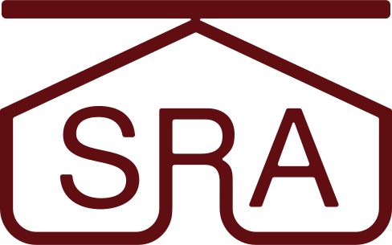

The SRA Society for Risk Analysis Annual Meeting of 2022 will be held in Tampa. The five-day event is scheduled to be held from 4th to 8th December. The venue for the meeting is Tampa Marriott Waterside Hotel. But yet, there are not many details on the programs.

**Website:** [SRA Annual Meeting](https://www.sra.org/event/2022-sra-annual-meeting)